Spotlight on: Siegfried Sassoon (1886 - 1967)
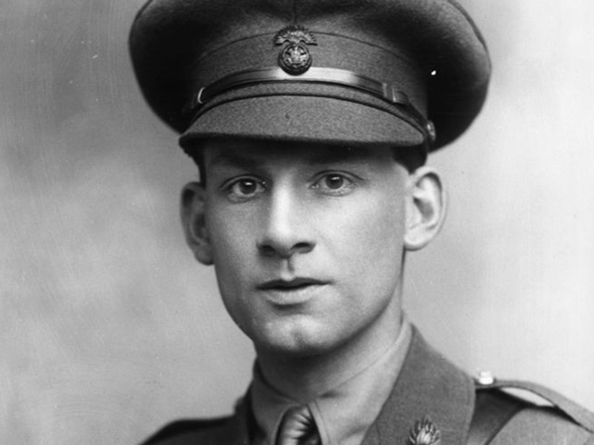
An English war poet, Sassoon was also known for his fictionalised autobiographies, praised for their evocation of English country life.

Siegfried Sassoon was born on 8 September 1886 in Kent. His father was part of a Jewish merchant family, originally from Iran and India, and his mother part of the artistic Thorneycroft family. Sassoon studied at Cambridge University but left without a degree. He then lived the life of a country gentleman, hunting and playing cricket while also publishing small volumes of poetry.

In May 1915, Sassoon was commissioned into the Royal Welsh Fusiliers and went to France. He impressed many with his bravery in the front line and was given the nickname 'Mad Jack' for his near-suicidal exploits. He was decorated twice. His brother Hamo was killed in November 1915 at Gallipoli.

In the summer of 1916, Sassoon was sent to England to recover from fever. He went back to the front, but was wounded in April 1917 and returned home. Meetings with several prominent pacifists, including Bertrand Russell, had reinforced his growing disillusionment with the war and in June 1917 he wrote a letter that was published in the Times in which he said that the war was being deliberately and unnecessarily prolonged by the government. As a decorated war hero and published poet, this caused public outrage. It was only his friend and fellow poet, Robert Graves, who prevented him from being court-martialled by convincing the authorities that Sassoon had shell-shock. He was sent to Craiglockhart War Hospital in Edinburgh for treatment. Here he met, and greatly influenced, Wilfred Owen. Both men returned to the front where Owen was killed in 1918. Sassoon was posted to Palestine and then returned to France, where he was again wounded, spending the remainder of the war in England. Many of his war poems were published in 'The Old Huntsman' (1917) and 'Counter-Attack' (1918).

After the war Sassoon spent a brief period as literary editor of the Daily Herald before going to the United States, travelling the length and breadth of the country on a speaking tour. He then started writing the near-autobiographical novel 'Memoirs of a Fox-hunting Man' (1928). It was an immediate success, and was followed by others including 'Memoirs of an Infantry Officer' (1930) and 'Sherston's Progress' (1936). Sassoon had a number of homosexual affairs but in 1933 surprised many of his friends by marrying Hester Gatty. They had a son, George, but the marriage broke down after World War Two. He continued to write both prose and poetry. In 1957, he was received into the Catholic church. He died on 1 September 1967.

