The daily life of a WW1 Nurse

At the outbreak of the First World War, women signed up to be nursing sisters and voluntary aid detachment nurses (V.A.D.s) on the frontlines for many different reasons. However, after they arrived in France, they would face the same ward routine, and the same horrors of war…

At the Order of St John hospital in Etaples near the frontline of the battle of the Somme nurses of all grades worked very long hours. Day duty began at 7:50am and finished at 8pm. When possible, nurses were given three hours off, usually during the afternoon between 2pm and 5pm. They were also given one half day off per week if workloads were not too heavy. Night nurses began their duty at 7:50pm and finished at 8am. All shifts began and ended with prayers and a Christian ethos underpinned all nursing and medical tasks.

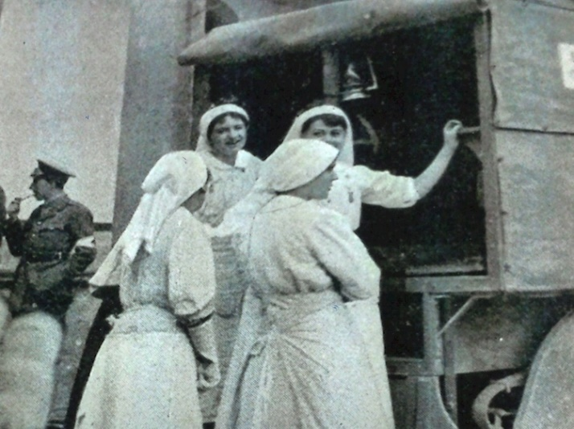
Nursing sisters were responsible for overseeing the work of ward staff and ensuring the wellbeing of patients in their care. They carried out the specific orders of medical staff, administered prescribed medicines at appropriate intervals, dressed wounds and meticulously recorded patients’ observations. Nursing tasks also included the supervision of patients’ meals, baths and the preparation of nursing treatments such as poultices, inhalations and cupping. V.A.D.s assisted trained nurses, but the nature of their work was initially limited. They were expected to perform menial tasks such as cleaning and tidying bedside lockers, making beds, and cleaning sluice rooms. V.A.D.s fetched and carried, mopped and dusted, helped to give out drinks and meals, rolled bandages, folded slings, sterilised instruments and tidied dressing rooms. Their tasks were often mundane and cumbersome. A Royal Army Medical orderly named Wilson Crewdson suggested several ways in which orderlies could assist nursing staff:

To carry food to the various wards and, as far as possible, assist in its distribution is a small matter that will suggest itself to everyone; but it may not at first be quite so obvious that in each ward there is throughout the day a constant accumulation of pails containing discarded dressings, all more or less septic, which require emptying and disinfecting. An inquiry at regular times in the ward will save many a struggle to a hard-worked nurse, who will bravely struggle with these heavy weights if left to herself.

Daily routine at the field hospital

Patients were normally given their baths during the morning, after they had devoured their breakfast and taken their medication. Some required bed baths and these were usually given by V.A.D.s, and male orderlies. Orderlies also performed intimate tasks, such as shaving men’s bodies in preparation for the operating theatre. Moreover, they were on hand to deal with fatalities. If a patient died during the day, then male orderlies would lay out the body and transport it to the mortuary. If a patient died during the night however, then it was up to the nursing sister to lay out the body.

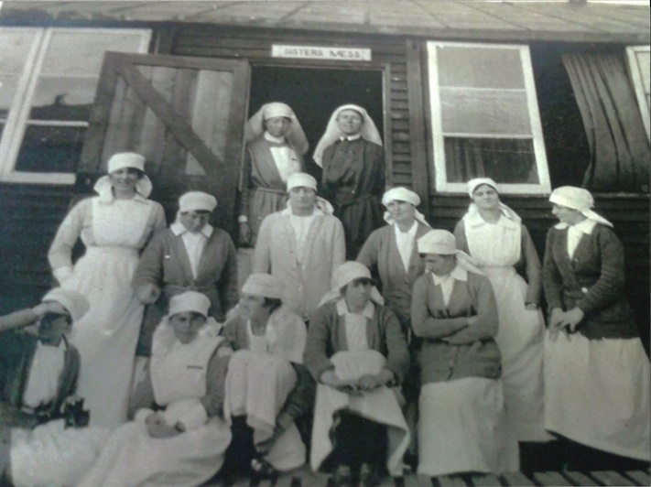
Every morning, once patients had been bathed, their wounds were carefully dressed. This process could take anything from ten minutes to an hour per patient, depending on the number and severity of wounds. Sisters aimed to get all dressing done by the end of the morning, but this was not always possible. Some wounds needed to be dressed twice a day or more. Workloads also needed to fit around doctor’s ward rounds. These were usually carried out in the morning but were dependent on the nature of medical caseloads and theatre waiting lists.

By the afternoon, if routines had not been disrupted by incoming wounded patients could receive visitors. Patients who did not receive visitors often asked V.A.D.s to assist them in writing letters to their loved ones back home. Other than baths, drug rounds, wound dressings and clinical observations, the basic rhythm of wards revolved around mealtimes, the clatter of the tea trolley, and the distribution of bedpans and urinals.

During their off-duty periods, nurses would often go for long walks or cycle rides, either to the coast, Etaples or neighbouring villages. Sometimes they would travel by bus into Boulogne to take tea in one of the many cafes. There was a recreation area within the hospital grounds where they could read, sketch or play board games such as chess. The Commanding Officer also established a drama club, classical music groups, a choir, sports teams, a debating society and a gymnastics league. These recreational activities were designed to boost staff and patient morale; and they became more important as the war progressed.

The Battle of the Somme

Once the Somme offensives began, there was no time to think of recreation. Official war diary records state that, between the 1 and 5 July 1916 St Johns admitted 1,400 soldiers.

There were piles upon piles of exhausted men, covering every inch of available hospital space. Here the severely injured lay, in excruciating pain, hovering between life and death—some praying for the latter. Their bodies viciously mutilated, blasted apart by relentless artillery and machine gun fire, their uniforms in shreds, their limbs blown away or shattered to pieces, they gazed at nurses with soulless, desolate eyes. Amidst an ever-extending carpet of blood and khaki, nursing sisters, V.A.D.s and orderlies attended to their vast array of patients. The place resembled a living hell. Henceforth there seemed to be no distinction between night duty and day duty. Everyone just worked to the point of exhaustion.

There was no time to express sympathy or mourn the dead, only to carry on tending the wounded by the sheer strength of will. Without exception every nurse worked until the point of collapse, skipping meals and rest periods to deal with the blood and guts of conflict. There was no typical, day, week or month, only a treadmill of relentless toil as they endeavoured to save lives and relieve suffering.

