Brian Darcy: Magistrate, Sheriff and Witchfinder in Essex

Darcy was a magistrate, Sheriff of Essex, witch-hunter and contributor to the 1582 “A true and just recorde of the information, examination and confession of all the witches, taken at S Oses [St Osyth]”. “This argued for harsher punishments for those found guilty of witchcraft, and Darcy was personally responsible for a number of deaths of people accused of witchcraft.

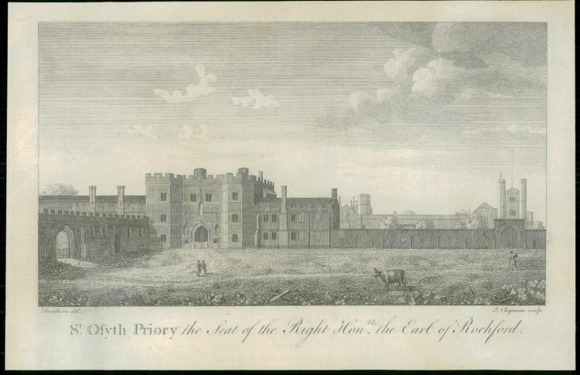
A little background information
If you live in the Maldon area, you will be very familiar with the D’Arcy name. It was this family that built the Moot Hall in the High Street in the fifteenth century. And why the village of Tolleshunt D’Arcy’s is so named – after the village’s estate that was in the hands of the D’Arcy family from the 15th century onwards. The family were a fabulously wealthy, powerful and influential family – not just in Essex, but in England too.

The D’Arcy family also became the owners of St Osyth’s Priory from 1553 and owned the Priory for the next hundred or so years. Brian D’Arcy was a lesser member of this great and powerful Essex family. He was born at Tiptree Priory sometime in the mid-sixteenth century.

By 1582, he was living in St Osyth’s Priory and “merely” the local JP/magistrate. Unfortunately for the local women of the village, he decided that he wanted to be as powerful as his famous D’Arcy relatives.

This he achieved with appalling results for the local population and by leading local witch hunts.

Witch hunts in Essex
The first witch hunt in Essex took place in St Osyth and was led by the D’Arcy family. The first person to be interrogated was the local midwife – Ursula Kemp. She immediately confessed to being a witch and confessed that she had caused the death of a baby.

This started a snowball effect with many women throughout St Osyth and nearby Great Clacton implicated in the alleged witchcraft activities. These activities had apparently taken place in the village and surrounding area.

By the end of Brian D’Arcy’s 1582 witch-hunt, at least 10 women – all from the village or the nearby area – were tried and executed in Chelmsford for murder by witchcraft. Many more were incarcerated in Colchester Castle (Essex’s county gaol) but released after being found not guilty during their trial.

It has been calculated that for the whole of the 1580s, the activities of Brian D’Arcy account for 13% of all trials for all crimes that took place in Essex that decade. That is a tremendously high number! St Osyth today is small. Back then, the population was tiny. Probably every single family or house in the village were under the shadow of this appalling witch-hunt.

After the witch trials were over, Brian D’Arcy got his wish to be all powerful. He became the Sheriff of Essex in 1585. On the back of his witch-hunting activities.

Many people have heard about Matthew Hopkins – the self-styled Witch-finder General. But few know about Brian D’Arcy. Essex’s (and England’s) first witchfinder. Who, for his own political ambitions, conducted England’s first ever witch-hunt – with devastating consequences for local St Osyth’s women.

Brian D’Arcy’s tactics in his investigations
In our research, we found that it could be argued that some of his tactics were found to be rather suspicious to say the least. Records of the investigation including interviews with those accused were tampered with where dates and times changed, questions and responses omitted and information missing. Although, it could be argued that these records have simply been lost over time. One of Brian’s personal tactics was that he would often question the children of those accused before questioning the accused. He would often mislead the children using traps to fool them into giving information and twist the meaning of their responses. The children would then be used against the parents. This was apparent in both the story of Ursley Kemp and then Cisley and Henry. In the later case, he deliberately played on heated and emotional moments within the family’s personal life for personal gain. Professor Marion Gibson highlighted that D’Arcy was particularly proud of his use of trick questions and his false promises of favourable treatment for those who confessed.

Magaret Simpson
During his investigation, D’Arcy would often call upon Maragret Simpson who so happened to be the wife of a local clergyman. (Who often did a lot of the accusing himself) Margaret’s role would be to strip search the accused looking for marks or imperfections which would indicate witchcraft. She would take specimens and notes, and the procedure was extremely traumatic for the accused. Her evidence was often used in trials.

D'Arcy’s investigations were used in detail in the publication of the pamphlet “A true and just recorde of the information, examination and confession of all the witches, taken at S Oses [St Osyth]” which was indeed written by an anonymous author “WW”. Interestingly, it was dedicated to Brian reading “To the right honourable and his singular good lord, he, lord D’Arcy WW wishes a prosperous continuous in their life to the glory of God and a daily preservation in gods fear to his endless joy.” Brian used this publication in his argument for there to be tougher and harsher punishments for those accused of witches. He believed them to be devil worshippers and wanted the punishment of hanging to be changed to burning.

Across today’s Maldon District, the legacy of the D’Arcy family is tremendous. The beautiful village bearing the family’s name. Maldon’s fabulous Moot Hall.

But less known is the legacy of Brian D’Arcy’s terrible witch-hunt of 1582.

Kindly supported by:   

