Ambulances in the First World War

The First World War created major problems for the Army’s medical services. A man’s chances of survival depended on how quickly his wound was treated. In a conflict involving mass casualties, rapid evacuation of the wounded and early surgery was vital.

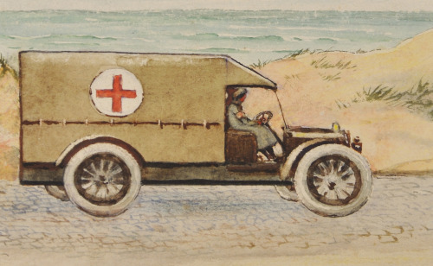
An artist drawing of Lady Dorothie driving one of the Ambulances

There were different ways in which injured soldiers were transported. In our research we used several key sources including the experiences of Lady Dorothie Feilding, the Munro’s Ambulance Corps and Sister Kate Luard QAIMNSR (Queen Alexandra’s Imperial Military Nursing Service Reserve) whilst serving on the Western Front 1914-1918.

Ambulance trains (AT)

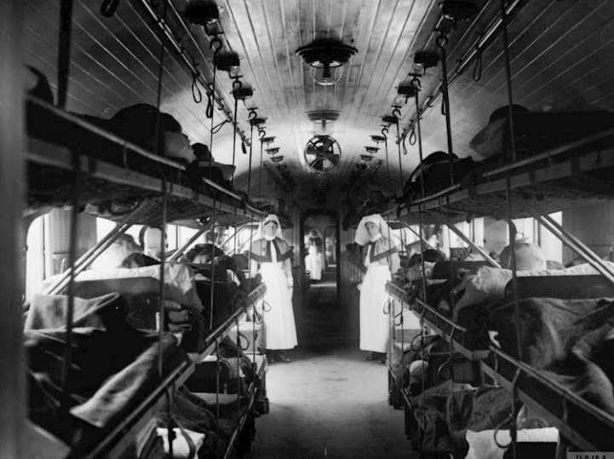
Trains were used to transport the wounded to base hospitals near or at one of the channel ports. In 1914 some trains were composed of old French trucks and often the wounded men lay on straw without heating and conditions were primitive. Others were French passenger trains which were later fitted out as mobile hospitals with operating theatres, bunk beds and a full complement of nurses, doctors and surgeons and medical orderlies. Emergency operations would be performed despite the movement of the train, the cramped conditions and poor lighting. Hospital carriages were also manufactured and fitted out in England and shipped to France.

In the early trains there was often a lack of passage between the coaches and with only a few nurses it was necessary for a nursing sister to pass from coach to coach, whether the train was in motion or not, usually carrying a load of dressings, medicines etc. on her back in order to tend to the wounded on each coach. During the night a nurse would also have a hurricane lamp suspended from her arm. The medical staff consisted of three medical officers of the RAMC including the Commanding Officer, usually a major, two lieutenants, a nursing staff of three or four with a sister taking on supervision of the whole train, complemented by 40 RAMC other ranks and NCO’s [non-commissioned officers].
An average load was 4-500 patients with a large number in critical condition. Often, they were transferred to the train still in full uniform in shocking condition caked with mud and blood and owing to the cramped conditions their uniforms had to be cut away. Many journeys were long and could take several days. There were deaths on all journeys. The nurses’ workload was heavy, and they worked under dangerous conditions with the barest necessities and no comforts.

Hospital barges

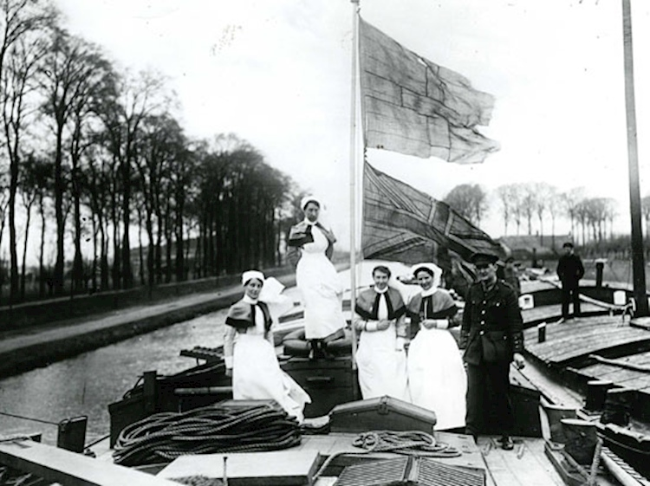
Many wounded were transported by water in hospital barges. Although slow, the journey was smooth, and this time allowed the wounded to rest and recuperate. The barges were converted from a range of general use barges such as coal or cargo barges. The holds were converted to 30 bed hospital wards and nurses’ accommodation. They were heated by two stoves and provided with electric lighting which would have to be turned off at night to avoid being an easy target for German pilots. Nurses would have to make their rounds in pitch dark using a small torch. Outside the barges were painted grey with a large red cross on each side with the flag poles flying the Red Cross to signify they were carrying wounded soldiers. The interior was painted white with ventilators in the side roofs and later skylights built into the barge. There would normally be at least one Sister, a staff nurse and an orderly per barge but with a full load of patients an RAMC sergeant, corporal, three nursing sisters, two orderlies, a cook & cook’s assistant. The skipper of each barge was usually a Royal Engineer [RE] sergeant and the barge would be towed by steam tugs.

As the war progressed many soldiers were evacuated straight onto the barges from the trenches and battlefield and were ridden with lice and filthy. Due to the lack of ventilation there were problems with gas attacked patients with the smell of gas remaining on their clothing and breath which caused sickness, sore eyes and breathing problems to the nurses and patients.

Motorised ambulances

The first ever motorised ambulances to transport wounded people were used in the First World War. On 12 September 1914, a small meeting was held at the Royal Automobile Club, at which a few members offered to place themselves and their cars at the disposal of the Red Cross. The Red Cross established the motor ambulance department, which sent 3,446 motor vehicles, including 2171 motor ambulances, to various destinations throughout the war. In total, 94 ambulances were destroyed by the enemy and subsequently scrapped by the Joint War Committee.

Before the motorised ambulances were introduced horse and cart ambulances were used. Horse drawn Ambulances were give the numbers of Mark 1 to 6.

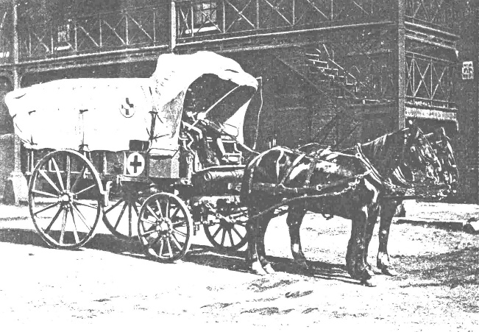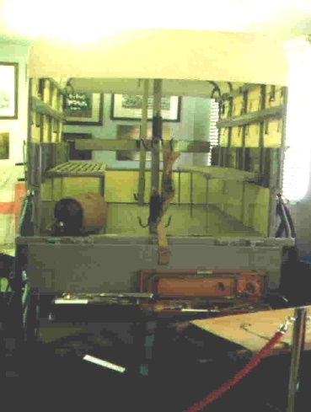

During WWI cars were donated by individuals for the war effort to be fitted with ambulance bodies. (Some wealthy families sometimes included their chauffeurs as well, the man joining the army). Financial donations for ambulances were received from various organisations and businesses like Breweries, Trade Unions, charities, hunts, worshipful companies, and the Silver Thimble Fund.
Manufacturers of ambulances included Rolls-Royce, Daimler, Albion, Morris, Vulcan, Austin, Sunbeam-Rover, Wolseley, Siddeley-Deasy, Renault, Buick, Crossley, Vauxhall, Argyll, Sunbeam, Lanchester, Ford Model T, Fiat and Star.

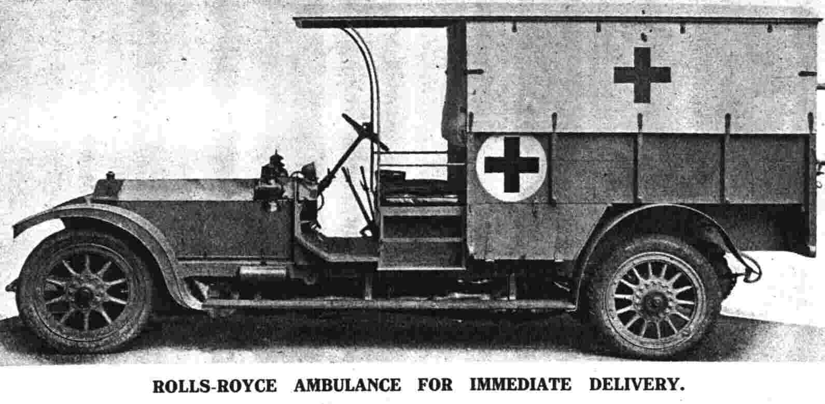

Ambulance drivers

A very high standard was expected from ambulance drivers. Many people remarked on their professional attitude and high standard of work. Though the ambulances were mainly used for base work, drivers were sometimes placed in the line of fire when transporting wounded men from the Front.
Many ambulance drivers were taken from male VADs. Men at home often divided their time between working as local ambulance drivers and acting as night orderlies in auxiliary hospitals. However, as more men enlisted, many women volunteered as ambulance drivers. One example of this was the development of the Munro Ambulance Corps created by Dr Hector Munro.

