Women’s Suffragettes Community Project
Character study: Annie Kenney

“The changed life into which most of us entered was a revolution in itself. No home life, no one to say what we should do or what we should not do, no family ties, we were free and alone in a great brilliant city.”
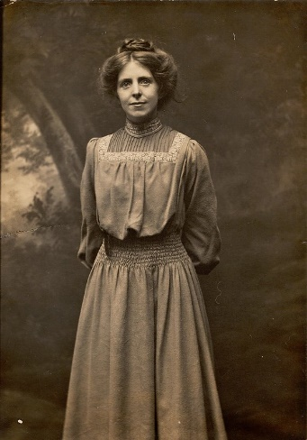
Annie Kenney helped run the East End London branch of the Women’s Political and Social Union. This is the fourth and final blog post in the Remember the Suffragettes blog series, looking at the lives of four suffrage campaigners from our Women’s Library.

Annie Kenney was born in Lancashire to parents who worked in the textile industry. Annie started work at a cotton mill at the age of 10, losing one of her fingers in an accident with machinery.

Annie became involved with the Suffragette movement after she heard Christabel Pankhurst speak at an Independent Labour Party meeting in 1905. As one of the few working-class members of the WSPU, Annie was asked to leave her mill work and help run the organisation’s East End branch in London.

Her first militant action happened in 1905 when, on being expelled from a Liberal rally for constantly shouting “Will the Liberal Government give votes to women?”, she and Christabel kicked and spat the police officers.

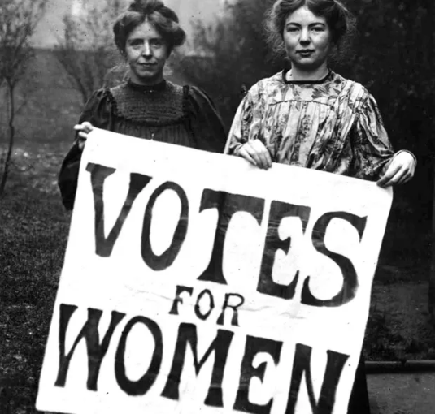
In 1912, she defended herself in court with the speech “The Right to Rebel” where she shone light on the injustice of the Suffragette sentences for property damage by pointing out the leniency of sentences levied against men guilty of sexual violence.

In total Annie Kenney was sent to prison 13 times for her Suffragette activism. She retired from politics after the vote was won in 1918 but recorded her experience in her autobiography Memories of a Militant.

