Daily routine at the field hospital

Patients were normally given their baths during the morning, after they had devoured their breakfast and taken their medication. Some required bed baths and these were usually given by V.A.D.s, and male orderlies. Orderlies also performed intimate tasks, such as shaving men’s bodies in preparation for the operating theatre. Moreover, they were on hand to deal with fatalities. If a patient died during the day, then male orderlies would lay out the body and transport it to the mortuary. If a patient died during the night however, then it was up to the nursing sister to lay out the body.

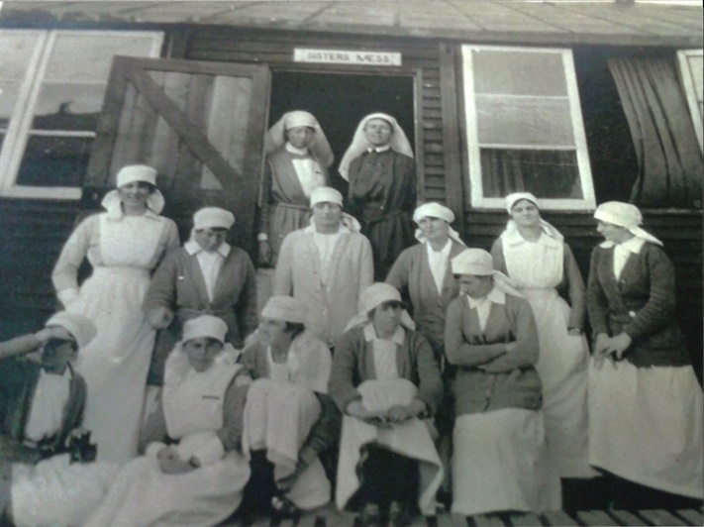
Every morning, once patients had been bathed, their wounds were carefully dressed. This process could take anything from ten minutes to an hour per patient, depending on the number and severity of wounds. Sisters aimed to get all dressing done by the end of the morning, but this was not always possible. Some wounds needed to be dressed twice a day or more. Workloads also needed to fit around doctor’s ward rounds. These were usually carried out in the morning but were dependent on the nature of medical caseloads and theatre waiting lists.

By the afternoon, if routines had not been disrupted by incoming wounded patients could receive visitors. Patients who did not receive visitors often asked V.A.D.s to assist them in writing letters to their loved ones back home. Other than baths, drug rounds, wound dressings and clinical observations, the basic rhythm of wards revolved around mealtimes, the clatter of the tea trolley, and the distribution of bedpans and urinals.

During their off-duty periods, nurses would often go for long walks or cycle rides, either to the coast, Etaples or neighbouring villages. Sometimes they would travel by bus into Boulogne to take tea in one of the many cafes. There was a recreation area within the hospital grounds where they could read, sketch or play board games such as chess. The Commanding Officer also established a drama club, classical music groups, a choir, sports teams, a debating society and a gymnastics league. These recreational activities were designed to boost staff and patient morale; and they became more important as the war progressed.

