The Witchcraft Trials
Trials and punishments
During our Essex Witches Community Heritage Project, we explored how those accused of witchcraft were investigated, put on trial and punished. The project was supposed by the Heritage Lottery Fund, Essex Records office and Professor Marion Gibson.
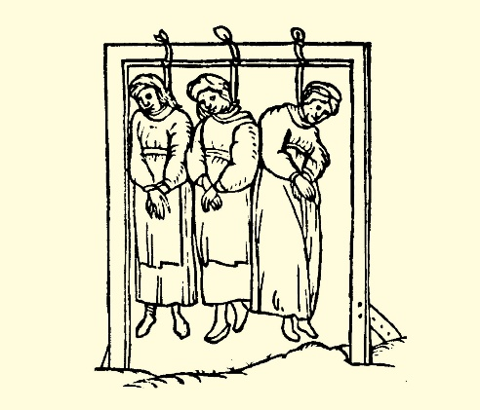
The Witchcraft Act 1563 introduced the death penalty for any sorcery used to cause someone's death. The Witchcraft Act 1603 reformed the law to include anyone to have made a Pact with Satan.

The witch trials
The typical victim of an English witch trial was a poor old woman with a bad reputation, who was accused by her neighbours of having a familiar and of having injured or caused harm to other people's livestock by use of sorcery.

About 500 people are estimated to have been executed for witchcraft in England. It didn't take too much to be accused of witchcraft. In difficult times, such as years when crops failed or disease was widespread, communities would often look for supernatural causes. Witches were seen as one such supernatural cause.

Anyone who had become ill or suffered a sudden misfortune might look for a magical reason among the people around them. Accusations of witchcraft usually came from within the suspect's community. Often, they involved a dispute or argument, after which one of the people involved suffered some ill health or misfortune.

A small community, where people really know each other, is a place where small grudges and disagreements come to light. For St. Osyth, this was a small community who was ready to unleash those disagreements by sharing them with a judge, such as Justice Darcy, to gain something more from their peers. Many early English villages at this time depended on the barter system due to the poverty they were enlisted to, which is an explanation as to why begging was a part of many trials. People were so well versed in these skills, living them day to day, that they were ready to squabble in a court as they would have done in a market. Accusing someone as a witch was a quick and easy way to get back at someone who was resented by another.

When someone was accused of witchcraft, they were often investigated by someone seen as having authority within the community. In St Osyth this was often the local Magistrate Brian Darcy. Evidence and interviews with local neighbours, clergymen were undertaken. One of Darcy’s common tactics was to interview the young children or family members of those accused. Evidence was then often twisted and used to trap and force a confession. Research shows that dates and descriptions were often changed to best fit an outcome. Those accused would be summoned to see the Magistrate for questioning. They would be sent for and marched through the streets in plain view of everyone to see. They would be strip searched by associates such as Margaret Simpson who would search their bodies for markings, scars, body features which were not deemed to be normal. Specimens were taken and it was not a very comfortable procedure. People who were of the poor and vulnerable were often picked on as they lacked the power or ability to defend themselves. Another common attribute was women who had born children out of wedlock which was seen as a sin in the eyes of the local clergymen.

Torture:
Although torture was not supposed to happen, it often did. Those accused were often submitted to often degrading, painful and dangerous forms of torture. Darcy would often put those accused in a dark room for hours without food, drink or any knowledge of what will happen and observe their behaviour. He would also keep the accused awake for long periods of time – often many days. This technique was called “Waking the witch.” Matthew Hopkins often used forms of torture to ‘test’ to see whether people were witches. The Swimming test was one example where a woman is tied and lowered into water. If she floats, then she will be deemed to be a witch. If sinks (and often drowns) she is seen to be innocent.

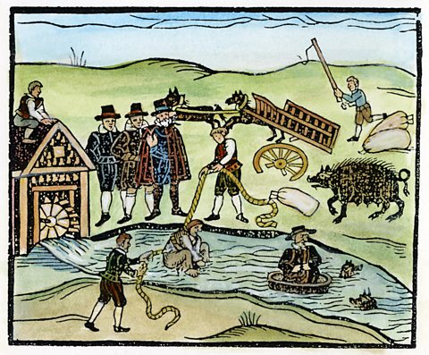
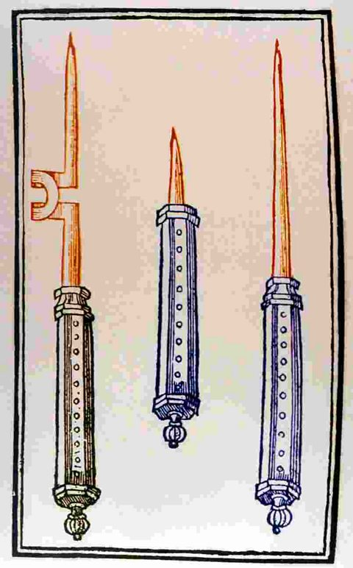
The Devil’s mark was another test. It was thought that when a witch pledged herself to the Devil, he marked them with a sign of their loyalty. This Devil’s Mark was an area on a witch's bodies that would not respond to pain. Witchcraft investigators used sharp tools to prick the skin of suspected witches to see if the Devil’s Mark could be found. Some people worked as professional witch prickers.

This was painful and highly distressing, and, although not originally intended as a form of torture, it may have been used as torture to bring about a confession. Even finding a birth mark or a mole on the skin could be enough to accuse a person of being a witch.

Another example is Ursula Kemp from St Osyth who went through many accusations and ended up being hanged. She was known to reside in "the cage" during her trial. In medieval times, "the cage" which is a type of prison, was often a form of public humiliation and confinement used to punish criminals. The structure was typically a small, barred enclosure, sometimes suspended in public places like market squares or outside castles, where individuals were left exposed to the elements. It was not only a form of physical restraint but also served to publicly shame the prisoner, reinforcing the societal power dynamics of punishment and authority.

Assizes:
The Assizes ‘trials’ were held in quarterly sessions throughout the year. Judges from London would travel to lead these court proceedings. The streets would often be filled with people who had come out to see the trials take place. People would be selling souvenirs, food and drink. Witchcraft was a crime that came to Assize courts regularly, but only after a new Witchcraft Act had been passed by Parliament in 1563. The new Act stated that witches who were convicted of lesser offences – like making farm animals sick – would be punished with one year in prison. Witches who were convicted of killing a person, however, were to be hanged.

“The Chelmsford Assizes was an open-sided building, with eight oak columns supporting upper galleries and a tiled roof. The galleries, which overlooked the open “piazza” below, were lit by three dormer windows in the roof… the magistrates and justices sat in open court, which measured only 26 feet by 24 feet, with the officers of the law, counsel and clerks, plaintiffs and defendants, jurors, sureties, witnesses and prisoners, before and around them, while spectators, hangers-on, and those awaiting their turn, crowded into the galleries above or thronged the street outside.”

Those accused would be brought through the streets wearing shackles and ragged clothes. They would be dirty from my time in the prison cell awaiting trial. They would e traumatised and frightened. They would be mocked, faced with insults and have things such as rotten food thrown at them by passers-by.

The trial itself would be in front of a judge, magistrates and jury. The evidence would be heard and, in some cases, those accused would come face to face with the people who had accused them. Often, they would have confessed beforehand to the crime.

Many of those accused were executed. This was most commonly done by strangling the alleged witch and then burning their body.

Destroying a witches body made sure that it could not be brought back to life by the devil or be used for evil magic. It also meant those found guilty of witchcraft could not receive a Christian burial.

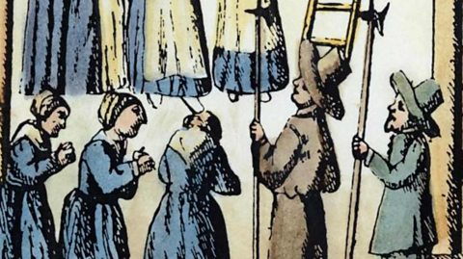

Kindly supported by:   

