Women’s roles on the home front
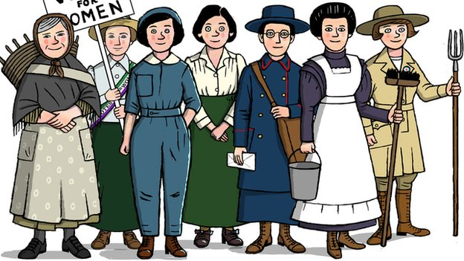

Before World War One began, men were thought of as the 'breadwinners', bringing in the weekly wage. The jobs they did were often tiring and required a lot of strength.

Women worked hard too, but their jobs were often done in their own or someone else's home. Only about 30% of the workforce was female and the majority of unmarried, working women were servants.

Piece work
Working class women also took in paid 'piece work' at home, as they had for generations. Carrying out piece work meant that women were paid depending on how much they produced. They undertook tasks such as washing, ironing, sewing, lace-making and assembling toys or boxes. Women also worked hard as housewives, taking care of their families and homes. Women carried out many jobs in the countryside, supporting men on farms by milking cows and helping with the harvest. They also often kept chickens and sometimes geese.

Outside work
Many employers refused to let married women work for them, so single and widowed women were more likely to have a job outside the home. Women worked in a variety of roles but their jobs were less manual than those carried out by men. Some women worked as school teachers or as governesses, teaching children at home. Well-off families would employ a nursemaid to care for their babies, a nanny to look after children and a governess to teach them until the boys went away to boarding school. Girls usually continued to be educated at home in these types of families.

Women workers
Some women worked as nurses before the war and a very small number worked as doctors. Many more women began to train and work in medicine and education during the war.

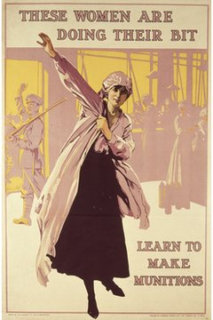
In the early 1900s, there was a rise in the number of women taking jobs in offices. Their duties were mainly limited to small administrative tasks. Other women worked in cotton factories where some of the roles involved labour-intensive work. Women prepared the cotton fibre for spinning and worked on weaving machines. The larger machines were thought to be too heavy for women to operate and were mostly worked by men.

Dramatic changes:
Life for women changed dramatically during the war because so many men were away fighting. Many women took paid jobs outside the home for the first time. By 1918 there were five million women working in Britain. The money they earned contributed to the family's budget and earning money made working women more independent. Many enjoyed the companionship of working in a factory, office or shop rather than doing 'piece work' at home.

Changes for women:
With men away at war, many women ran their homes alone. They cared for children and older relatives, managed money and often had a job as well. Shopping during wartime was hard with food and coal shortages and higher prices. The average food bill for a family of four rose from less than £1 a week in 1914 to over £2 in 1918.

Women's pay was lower than men's, even when they were doing the same work. However, many working women were better off than they had been in the past. Women who took jobs in munitions factories, for example, were better paid than they had been in their previous jobs sewing clothes or cleaning houses.

War's end: opportunities lost
For some, life after the war offered new opportunities. The Sex Disqualification (Removal) Act of 1919 made it illegal to exclude women from jobs because of their gender. Educated, middle class women found that doors to the professions previously closed to them were suddenly opening. Moreover, the 1918 Representation of the People Act enfranchised 8.5 million women, giving them a voice in Britain's government for the first time.

Economic hardship
But there was an economic downside. With the troops’ victorious return, many women found themselves surplus to requirements at work. The 1919 Restoration of Pre-War Practices Act forced most women to leave their wartime roles as men came home and factories switched to peacetime production.

For some, the clock was turned back, ushering in a time of economic hardship and low expectation at home, where women found themselves grieving or caring for injured male relatives or husbands.

Despite their pioneering contribution, thousands of women were dismissed from their jobs, particularly in engineering; those who objected to standing aside were met with public anger. And old ways reasserted themselves, as newly unemployed women war workers were pressured into becoming domestic servants.

Electoral Inequality
The Suffragette movement finally received the recognition it had been seeking after over a decade of campaigning. But it was a partial victory, as only women over the age of 30 were allowed to vote, outnumbered in an electoral system which gave all men over 21 the right to cast their ballots. Just one woman was elected to parliament in the General Election of December 1918.

Despite their invaluable wartime contribution, most women were expected to return to business as usual at home.

The Suffragettes Movement

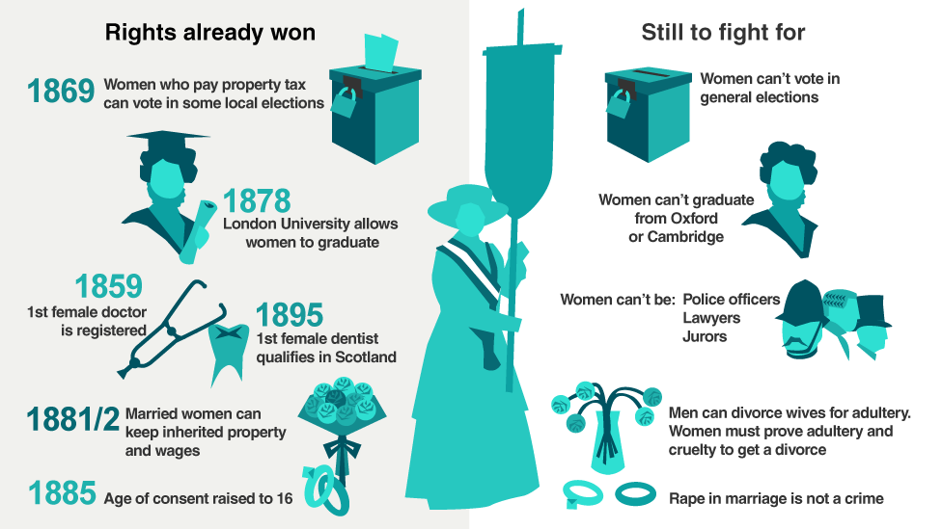

Women had argued for – and won – new rights in the 19th Century. However, without the vote campaigners thought there was little incentive for politicians to improve the lot of women further. They believed MPs only cared about issues that affected the men who were able to vote for them.

How WW1 changed women's fortunes
By 1914 it was clear women would eventually get the vote. Years of peaceful protest had convinced an increasing number of MPs to support female suffrage. Other countries including Australia had extended voting rights to women, making Britain look behind the times.

However, World War One had a huge impact on the ongoing struggle. Many suffragettes gave up campaigning to support the war effort. When peace returned, Britain felt like a very different place.

Rethinking British democracy
Millions of British men fought in World War One, but a third of them had no right to vote. Women, who had proved they could do the same jobs as men in factories, offices and on the land, also had no representation. David Lloyd George's coalition government knew it was time for a fundamental rethink of who had access to the ballot box. MPs from different parties who supported female suffrage could now band together to support such a decision.

Women win a partial victory
In 1918 the Representation of the People Act extended the vote to all men over 21, and to some groups of women over 30. However, this was not simply a reward for the vast sacrifice that women had made for the war effort. Some historians have suggested the government intended these women to be a 'moderating' influence on radical younger male voters. It had the added advantage of taking the heat out of the female suffrage movement.

Yet more than half of women still did not have a say in electing their government. Moderate campaigning would continue until 1928 when women were finally granted the vote on equal terms to men.

Votes for women

The First World War provided the first opportunity for women to take on traditional male jobs so it isn't surprising that in 1918 women over 30 were given the same political rights as men. But this change was not just a result of war - women had been campaigning for decades to be given the right to vote.

The campaign - the basics
Votes for women was part of a gradual improvement in women's rights that had been going on throughout the 19th century. The movement also campaigned for the right to divorce a husband, the right to education, and the right to have a job such as a doctor. Many women, however, saw the vote as the vital achievement that would give them a say in the laws affecting their lives.

The National Union of Women's Suffrage [Suffrage: The right to vote in political elections. ] Societies - the Suffragists [Suffragists: a member of the NUWSS who wished to obtain the vote through peaceful means - led by Millicent Fawcett ] - was formed in 1897 and led by Millicent Fawcett. The group was made up of mainly middle-class women and campaigned peacefully. The organisation built up supporters in Parliament, but private members' bills to give women the vote all failed.

The Women's Social and Political Union - the Suffragettes [Suffragettes: Members of the women's suffrage movement, which fought to win British women the right to vote. ] - was formed in 1903 and led by Emmeline Pankhurst. Although this group was also middle class, it heckled politicians, held marches, members chained themselves to railings, attacked policemen, broke windows, slashed paintings, set fire to buildings, threw bombs and went on hunger strike when they were sent to prison. One suffragette, Emily Davison, ran out in front of the king's horse during the Derby of 1913 and was killed.

The East London Federation of Suffragettes - formed in 1914 by Sylvia Pankhurst - was made up of working-class women. This group concentrated on social reform and rejected the violence of the WSPU.

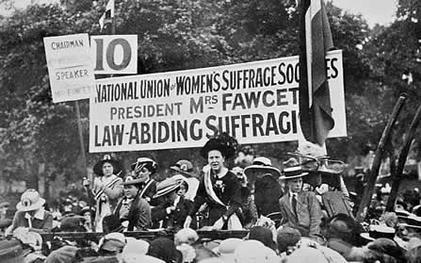

Women were not given the vote before the war. At the end of the war, in 1918, however, the Representation of the People Act gave women over 30 the vote, and in 1928 this was extended to all women over the age of 21.

Votes for women - for and against
It is important to realise that these arguments are not necessarily true, or what we would say today - they are what people said at the time.

The arguments for and against women's suffrage

For | Against
Women are equal before God. | A woman's place is in the home; going out into the rough world of politics will change her caring nature.
Women already have the vote in local elections. | Many women do not want the vote and would not use it if they got it.
Women pay taxes. | Women do not fight in wars.
Some women (eg doctors and mayors) are far better than some men (eg convicts and lunatics) who have the vote. | The vast mass of women are too ignorant of politics to be able to use their vote properly.
Other countries have given women the vote. | If women are given the vote, it will not be the gentle intelligent women who will stand for Parliament, but the violent Suffragettes. Parliament will be ruined.

Why did women get the vote?
The Suffragettes
At the time, the Suffragettes caused a lot of anger and it has been argued that they lost support for the cause. Certainly, women had not been given the vote by 1914, even after a lot of Suffragette violence. However, some historians argue that, although they could not be seen to give in to Suffragette violence, politicians could not face a return to Suffragette violence after the war, and that is why they gave women the vote.

The War
During the war, women served the nation and did men's work in many ways. When they were given the vote in 1918, almost every person who supported the motion in Parliament said that they deserved it because of their conduct during the war - they had proved that they could go to war' with the men. The problem with this argument is that only women who were householders over the age of 30 (6 million women) got the vote in 1918; women over 21 did not get the vote until 1928. Yet the 1918 Representation of the People Act gave the vote to all men over the age of 21 so the war did not bring women equality.

Sylvia Pankhurst
In June 1914, she famously took a delegation of working class women to lobby Prime Minister Asquith who did not think that working-class women were intelligent enough to have the vote. This proved to Asquith that working-class women were intelligent enough to vote.

The Suffragists
Some historians argue that the long-term persuasion of the Suffragists won the vote. In 1916, Lloyd George, who supported women's suffrage, replaced Asquith as prime minister, and many pro-suffrage MPs who had been young men before 1914 now held influential places in the government. So, the women won by patient persuasion, after all.

