Setting the scene:
The history of the Essex Witchcraft Trials

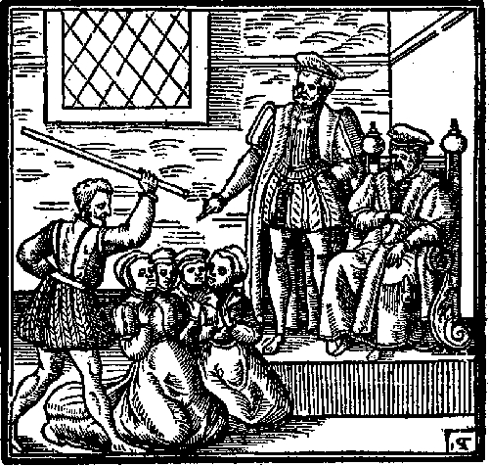
Medieval folk had long suspected that the Devil was carrying out his work on earth with the help of his minions. England – and Essex in particular – was in the grip of witch fever. Between 1560 and 1680, 317 women and 23 men were tried for witchcraft in Essex alone, and over 100 were hanged.

Witchcraft as a crime
Practising witchcraft was not a capital offence to begin with. However, in 1484 Pope Innocent III declared witchcraft as heresy, and this was a capital offence. Despite this capital punishments for witchcraft were extremely rare; between 1066 and 1560 only six people had been executed for witchcraft in England, the preference being to exorcise evil spirits.

In 1542, under Henry VIII, a bill called “The Bill Against Conjurations & Witchcrafts and Sorcery and Enchantments” was created. This meant that for the first time in English history, witchcraft was now a crime to be tried in normal courts - the same ones used for all other crimes such as murder and theft. It was punishable by death and forfeiting of property, land and possessions.

The Witchcraft Act (1542) also removed the benefit of clergy for witchcraft crimes. Benefit of clergy allowed clergymen to claim exemption from secular courts, instead being tried in ecclesiastical courts.

However, The Witchcraft Act (1542) was repealed by Edward VI, Henry VIII’s son, in 1547.

The Witchcraft Act
In 1563, during the reign of Elizabeth I, The Witchcraft Act (1563) was passed: “An Act Against Conjurations, Enchantments and Witchcrafts”. The Act stated that, in cases where witchcraft resulted in death, it is punishable by death. However, in lesser cases (i.e. not resulting in death), it is punishable by a term of imprisonment.

After the 1563 Act convictions for homicide caused by witchcraft began appearing. Out of 1158 homicide victims 228 were suspected to be caused by witchcraft. 157 people were accused of killing with witchcraft, of which around half were acquitted. Only nine of the accused were men.

The Death Penalty Scope Widens
Perhaps the most well-known Witchcraft Act is the one passed in 1604 under James I. “An Act Against Conjuration, Witchcraft and Dealing with Evil and Wicked Spirits”, also made invoking evil spirits and communing with familiars punishable by death. It also changed the penalty for ‘lesser’ cases of witchcraft, as mentioned above, to one year imprisonment, and afterwards one day in the pillory on market day once a quarter. Anyone found to be a second-time offender, even of ‘lesser’ witchcraft, will be put to death. This was the act that Matthew Hopkins, the infamous self-styled Witchfinder General, enforced.
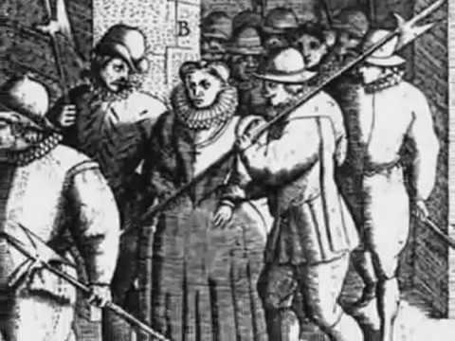
Setting the scene in Essex
Witches appeared to be more prevalent in the Eastern counties, particularly in isolated communities. Most were individuals, though some larger groups were found in Maldon, Hadleigh, and Coggeshall, although they were not organised enough to have been covens. Between 1560 and 1675, over 650 Essex men and women were accused of being or consorting with witches. Some were hanged, others died whilst awaiting trial, but many were found not guilty. Granted, the experience wasn’t going to be pleasant, life after acquittal was probably also going to be rough, and the chances of you being accused again were high, but many of the accused were acquitted.

It is unlikely that there were actually more cases of ‘witchcraft’ in East Anglia compared to the rest of England. Instead, the high figures are likely due to Matthew Hopkins and his associates, and the methods they used to get confessions. As part of the confession suspects were usually forced to accuse many others, creating a snowball effect.

For the people of Essex, times were very tough. Poverty was high and living standards were very poor. Disease and illnesses were common. People couldn’t afford doctors back then so they would go to local people with knowledge of herbal and spiritual remedies. Living in the villagers such as St Osyth, Coggeshall, Clacton and Manningtree were particularly hard where folk depended upon working the land and were dependent upon their crops or livestock. Many villages ran a barter system which often created arguments between neighbours. Law and order were upheld by the local landowners of power (Who were often local Magistrates) such as Brian Darcy and local clergymen.

The word of witchcraft spread fast, and people quickly began blaming bad crops, disease and bad times upon witchcraft. People became paranoid and were influenced by stories and started accusing their neighbours, friends and even family members.

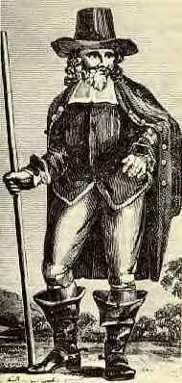
How Did the Witch Hunts Actually Come About?
Well, James I had a lot to do with it, as did Matthew Hopkins. It’s safe to say that King James I was obsessed with witches. He travelled to Scotland to attend trials and wrote books on the subject, perhaps the most famous being Daemonologie (1597 - Scotland, 1603 - England). In it King James I pitches witchcraft against Christianity, outlining the reasons to persecute witches under canonical law and endorsing witch-hunting in Christian society.

Matthew Hopkins, self-appointed Witchfinder General, and John Stearne, his associate, used the ideas from Daemonologie to hunt and track-down witches in East Anglia. Hopkins holds the record for the most ‘witches’ hanged, with his investigations making up an estimated 20% of witchcraft executions in England from the 15th to 18th centuries…and he was only in ‘business’ for three years.
Kindly supported by:   

