Colchester Castle Prison

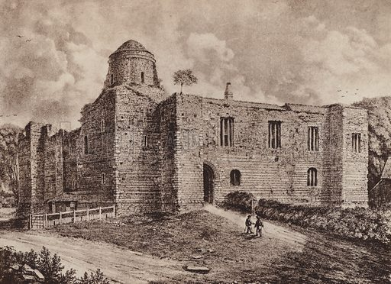

Colchester Castle was a key landmark in the Essex witch trials. In the 1500s and 1600s, hundreds of people were imprisoned inside its walls suspected of being a witch

The county became well known for its persecution of suspected witches, the first person in England to be executed under a Witchcraft Act was Elizabeth Lowys who lived in Great Waltham. Five hundred years later, many of the stories of victims like Elizabeth are at risk of being lost – overshadowed by tales of people like the famous Witchfinder General, Matthew Hopkins.

The Castle’s relationship with the Witchcraft Trials
Colchester Castle was the first of the great keeps and the largest built by the Normans in Europe. But by 1645, it had fallen into such a state of disrepair that it was only fit for one purpose: a prison.

Conditions in the gaol were dire.

Accused witches were thrown into prison while awaiting trial, and this was nothing like our modern-day idea of prison. The accused could be held for days, weeks, months and even years in some cases waiting for a trial date. Conditions were unsanitary and the prison cell was the perfect environment for disease to spread. Colchester Castle was first used as a prison in 1226, was the county prison until 1667 and was used until 1835. Many of Hopkins’ victims were held here and the Castle gives us a good idea of how accused witches were treated.

Part of the roof had collapsed a decade prior and exposed prisoners to the elements. Male and female prisoners were separated into two cells and kept shackled. They slept on straw or bare stone. Food was poor and basic cleanliness impossible. Many prisoners, including some of the women accused as witches, died of exposure, malnutrition, or disease.

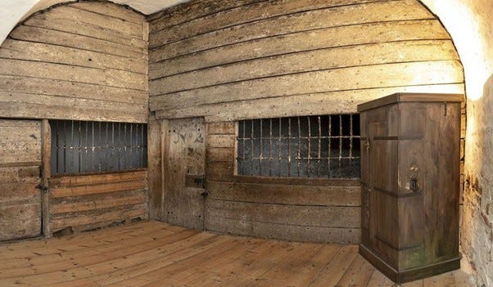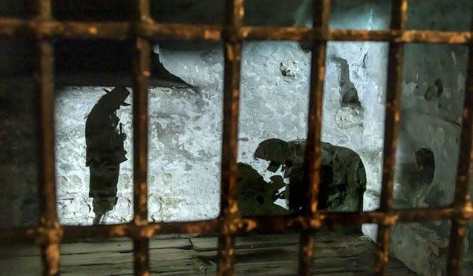

The story of Rebecca West
Whilst researching, we came across another story of one woman accused of witchcraft by Matthew Hopkins.

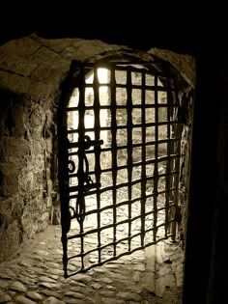
In mid-April 1645, Matthew Hopkins visited Colchester Castle. At approximately twenty-five years old, he was the most junior of a team of men who had taken it upon themselves to hunt down witches in Essex. Sir Harbottle Grimston, 1st Baronet, in his seventies, and Sir Thomas Bowes, estimated in his forties, were magistrates with a duty to investigate witchcraft and other crimes. John Stearne was a landowner in his mid-thirties who apparently involved himself in the investigation out of curiosity or civic duty. Hopkins had become involved initially through his stepsister who believed herself cursed by Elizabeth Clarke, but he soon showed an interest in pursuing witches throughout Essex. The unpleasant task of going to Colchester Castle may have been assigned to him as the youngest witchfinder or he may have eagerly volunteered for the task to prove his capability.

Hopkins’ target was Rebecca West.

Rebecca had already confessed and accused her mother, Anne, of witchcraft —Hopkins saw her as a weak point by which he might unmask the Manningtree “coven”. Hopkins isolated Rebecca from the other women and coerced a more elaborate confession from her. Rebecca now accused the other imprisoned Manningtree women of being witches and, shockingly, claimed she was married to the Devil.

Rebecca West’s coerced confession was damning for the women she accused. All the alleged Manningtree coven, including Anne West, were found guilty of witchcraft and executed, except Rebecca. She was freed due to her turning prosecution witness and her age — she was likely only in her early or mid-twenties. It is unknown what became of Rebecca West after the trials.

Kindly supported by:   

