How deadly was the poison gas of WW1?

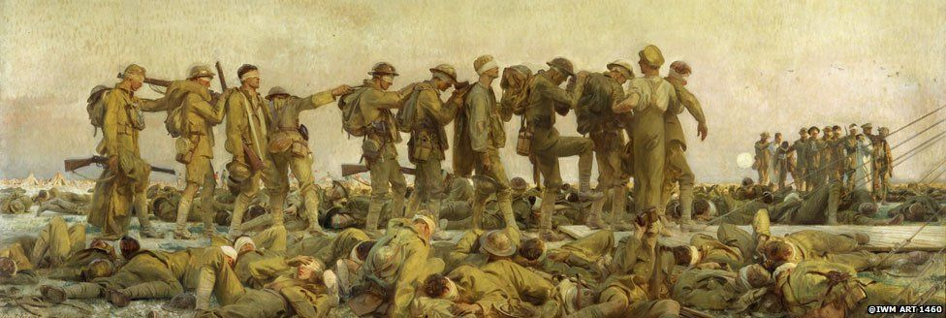

Brief Introduction:
The use of toxic chemicals as weapons dates back thousands of years, but the first large scale use of chemical weapons was during World War I. They were primarily used to demoralize, injure, and kill entrenched defenders, against whom the indiscriminate and generally very slow-moving or static nature of gas clouds would be most effective. The types of weapons employed ranged from disabling chemicals, such as tear gas, to lethal agents like phosgene, chlorine, and mustard gas. This chemical warfare was a major component of the first global war and first total war of the 20th century. The killing capacity of gas was limited, with about ninety thousand fatalities from a total of 1.3 million casualties caused by gas attacks. Gas was unlike most other weapons of the period because it was possible to develop countermeasures, such as gas masks. In the later stages of the war, as the use of gas increased, its overall effectiveness diminished. The widespread use of these agents of chemical warfare, and wartime advances in the composition of high explosives, gave rise to an occasionally expressed view of World War I as "the chemist's war" and also the era where weapons of mass destruction were created.

The use of poison gas by all major belligerents throughout World War I constituted war crimes as its use violated the 1899 Hague Declaration Concerning Asphyxiating Gases and the 1907 Hague Convention on Land Warfare, which prohibited the use of "poison or poisoned weapons" in warfare.

How were they used?
Poison gas was initially released from cylinders, but this required ideal weather conditions and could be very risky. In the first British gas attack, at Loos in September 1915, much of the gas was blown back into the faces of the British troops. From 1916, gas was employed in shells instead, which allowed attacks from a much greater range.

Gases used included chlorine, mustard gas, bromine and phosgene, and the German Army was the most prolific user of gas warfare.

Gas did not prove as decisive a weapon as was anticipated but it was effective in clearing enemy forward positions. As a result, anti-gas measures became increasingly sophisticated. Primitive cotton face pads soaked in bicarbonate of soda were issued to troops in 1915, but by 1918 filter respirators using charcoal or chemicals to neutralise the gas were common.

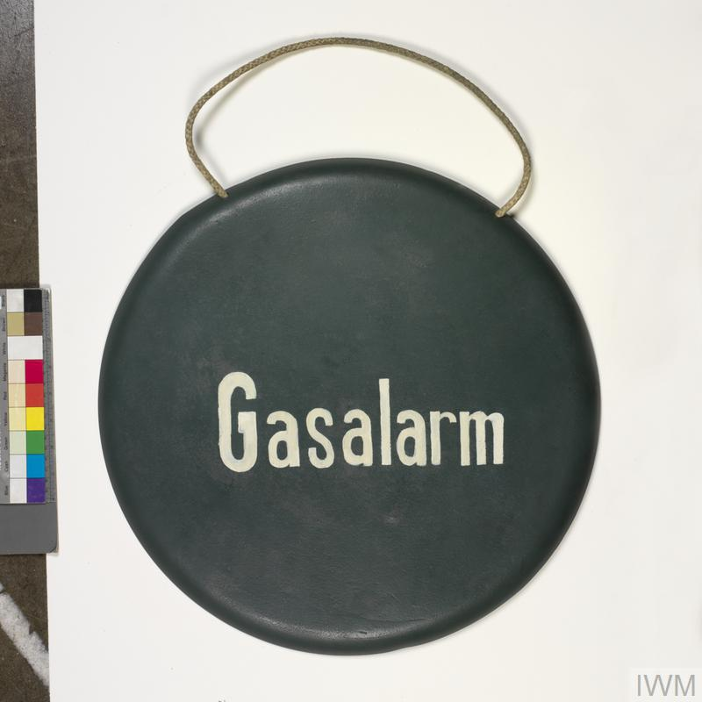
EQUIPMENT
GAS ALARM GONG
German Army gas alarm gong used during the First World War. Gongs and bells were positioned along the front lines so that sentries could raise the alarm in the event of a gas attack.

The physical effects of gas were agonising, and it remained a pervasive psychological weapon. Although only 3 per cent of gas casualties proved immediately fatal, hundreds of thousands of ex-soldiers continued to suffer for years after the war.

Gas Attack Images

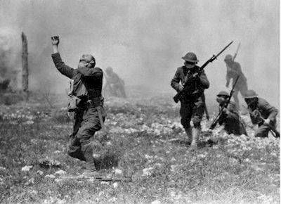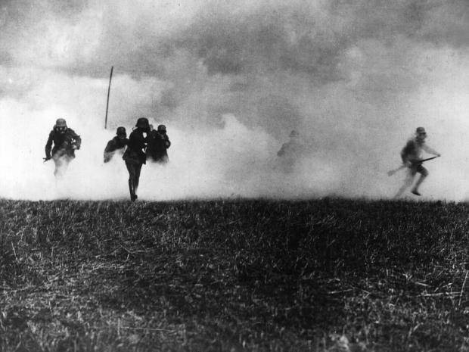

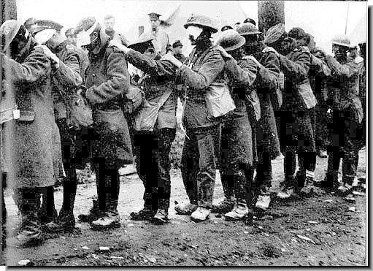

Dulce et Decorum Est
BY WILFRED OWEN

Bent double, like old beggars under sacks,
Knock-kneed, coughing like hags, we cursed through sludge,
Till on the haunting flares we turned our backs,
And towards our distant rest began to trudge.
Men marched asleep. Many had lost their boots,
But limped on, blood-shod. All went lame; all blind;
Drunk with fatigue; deaf even to the hoots
Of gas-shells dropping softly behind.

Gas! GAS! Quick, boys!—An ecstasy of fumbling
Fitting the clumsy helmets just in time,
But someone still was yelling out and stumbling
And flound’ring like a man in fire or lime.—
Dim through the misty panes and thick green light,
As under a green sea, I saw him drowning.

In all my dreams before my helpless sight,
He plunges at me, guttering, choking, drowning.

If in some smothering dreams, you too could pace
Behind the wagon that we flung him in,
And watch the white eyes writhing in his face,
His hanging face, like a devil’s sick of sin;
If you could hear, at every jolt, the blood
Come gargling from the froth-corrupted lungs,
Obscene as cancer, bitter as the cud
Of vile, incurable sores on innocent tongues,—
My friend, you would not tell with such high zest
To children ardent for some desperate glory,
The old Lie: Dulce et decorum est
Pro patria mori.

