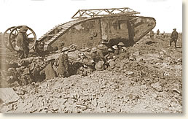

The Battlefield Debut

of the Tank, 1916

Bert Chaney was a nineteen-year-old signal officer and had a front-row seat as three of the new weapons made their appearance in his sector of the battlefield. We join his story as the tanks lumber into position before the attack:

"We heard strange throbbing noises, and lumbering slowly towards us came three huge mechanical monsters such as we had never seen before. My first impression was that they looked ready to topple on their noses, but their tails and the two little wheels at the back held them down and kept them level. Big metal things they were, with two sets of caterpillar wheels that went right round the body. There was a huge bulge on each side with a door in the bulging part, and machine guns on swivels poked out from either side. The engine, a petrol engine of massive proportions, occupied practically all the inside space. Mounted behind each door was a motor-cycle type of saddle, seat and there was just about enough room left for the belts of ammunition and the drivers.

