Hope and Glory Community Heritage Project
Museum Visits Blog

Written by Dibbie Shoniwoe
Volunteer Researcher on The Hope and Glory Project

Working on the Hope and Glory Community Heritage project has been a lot of fun. Our recent visits to the Redbridge Museum have been highly informative. A real education experience!

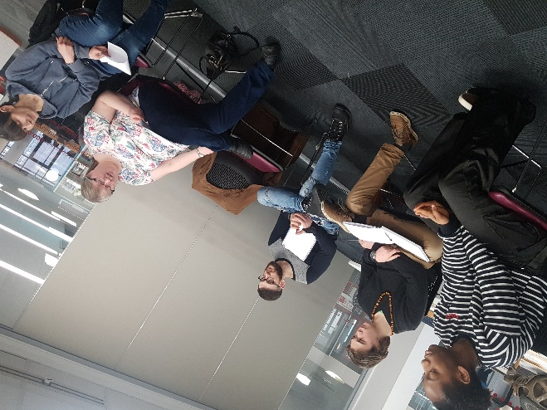
The group of researchers and performers came together to learn new ways of researching about the past and to explore what life was like in Redbridge during the Second World War. At the beginning of the session we set out to:

1. Develop an understanding of how to use archives in researching about the past.
2. Explore techniques of gaining the most from a museum visit.
3. Develop an understanding of how to use artefacts in researching about the past.
4. Learn about what life was like in Redbridge during the Second World War from local stories, newspaper articles, photographs, maps, diaries, and films.

The staff at the Museum gave us a talk identifying ways of using the museum resources, teaching us how to use archives and artefacts. What to look out for, how to focus our enquiry skills, questions in order to gage the best result. We looked at how to use maps, newspaper archives and photographs. We were then given a tour around the museum before being allowed to roam around freely to explore the museums resources.

At the start we did find it was difficult researching and using all of the different materials. We knew that we needed to stay focused otherwise we'd keep going off task and wouldn't fully use the materials effectively. We separated ourselves into groups to research what life was like under the following headings:

1. The Blitz - where were the bombs dropped during the Second World War in Redbridge?

2. How were children evacuated in Redbridge and what was lifelike for children growing up in Redbridge in WW2?

3. How did people left behind pass time socially?

4. How was Rationing managed in Redbridge?

5. How has the landscape and skyline changed from the War and today's Redbridge?

With each topic area we focused upon exploring real life stories of how the War impacted upon the local community and people. What were their roles? How did people cope with the challenges seen?

We were able to find out where local bombs were dropped, read people’s reactions to the air raids, what it was like to be an air raid warden and the reaction to the children being evacuated. We were able to find out about the social activities from the advertisements in the newspapers and peoples recounts.

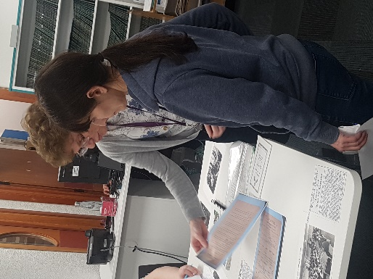
The museum visits also gave us the opportunity to research more into the information given to use from our interviews from relatives and recounts offered. We were able to explore further into the story of the POW camp at Beale School, the different German planes which crashed....what happened when one pilot ejected too late and all what was left of him was an ear on a lamppost. The story of the Spy living in Ilford and the homeless man and his donkey.

The research collected helped to form both our displays, education materials and our play. It’s all been really invaluable.

*We would like to thank both the Museum staff and our Researchers for their time.

