The Essex Witches Community Heritage Project
Exploring the stories of people accused of witchcraft in Essex

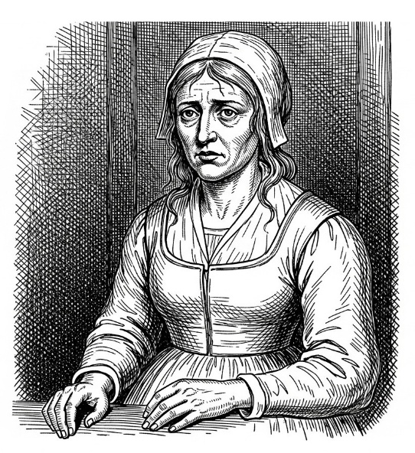

FREE EDUCATONAL RESOURCE PACK



Contents page

Page 1: Front cover
Page 2: Contents page
Page 3: Acknowledgements
Page 4-6: Introduction – The Witches of Essex community heritage project
Page 7-8: Setting the scene - The history of the Essex Witchcraft Trials
Page 9-10: Working with The Essex Records Office: A participant’s blog
Page 11-12: Why were people accused of witchcraft – The motives
Page 13: How did literature influence the Witchcraft witch hunts?
Page 14-16: Who was accused of witchcraft? Common Traits of a Witch
Page 17-19: Focused character workshop: What were people’s views of witchcraft in the 1500-1600s Essex and how did it feel to be accused?
Page 20-21: Witches imps and familiars
Page 22-24: The trials and punishments
Page 25-27: The Cage of St Osyth
Page 28-29: The caged bird: A monologue inspired by Ursley Kemp
Page 30-31: The Castle prison & the story of Rebecca West
Page 32-33: Alice Prestmary of Dunmow: A monologue inspired by her time in the Colchester Castle prison
Page 34-36: The Trial of Anges Waterhouse: A short play
Page 37-38: Familiar characters in the Witchcraft Trials: Brian Darcy & Maragret Simpson
Page 39-40: Maragret Simpson: A monologue
Page 41-43: Familiar characters in the Witchcraft Trials: Matthew Hopkins the Witchfinder General
Page 44-45: My name: A monologue inspired by Matthew Hopkins
Page 46: Local stories: Professor Marion Gibson
Page 47-56: Ursley Kemp of St Osyth: A short play
Page 57-64: Cisley and Henry of Clacton: A short play
Page 65-67: Elizabeth Clarke of Manningtree: A short story
Page 68-74: Annis of Little Oakley: A short play
Page 75-77: Joan Prentice of Sible Hedingham: A short story
Page 78-83: The Tragic story of Dummy from Sible Hedingham: A short play
Page 84-87: Lucky penny: A short story inspired by Dummy from Sible Hedingham
Page 88-95: Sharing what we have learned

Acknowledgements

Our project could not have gone ahead without the support of the following people:

-The Heritage Lottery Fund
-The Essex Records Office
-Professor Marion Gibson
-The Essex Witches Museum
- Victoria West
-Kate O’Neill
-The staff at The Hythe Community Centre
-The staff at the Oak Tree Community Centre / St Annes Hall
-The Kelvedon Institute
- Andrew Forsyth
-Madeliene Ockendon
-Barry Ockendon
- Danni Minnican
-Kitty Whitley
- Charlie Whytock
- Pauline Warren
-Gill Adams
-Elsa Annushka Nigro
-Philip Antony
-CK Norman
- Ed Willcox
- Ian Russell
-Keith Norman
- James Cartmell
-University of Essex
-Kelvedon Players

This project and free learning pack was put together to offer a free resource pack to support others by Alfie James. We own no rights to the archive images used or external articles used in our research. No profits were made at any time.

An introduction
Our Witches of Essex community heritage project

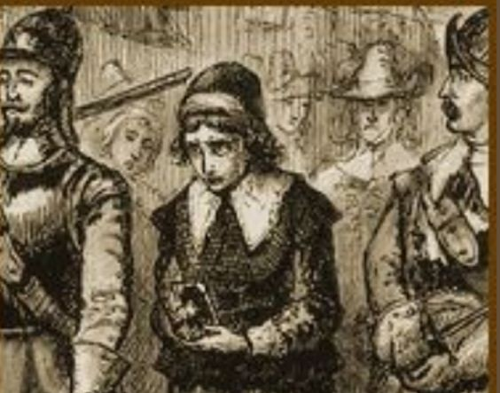

The Witches of Essex community heritage project was a six-month project bringing members of the local community together to explore the stories of the witchcraft trials locally which took place during the 15th and 16th centuries. We worked with the Essex Records Office, Professor Mation Gibson and the Essex Witches Museum to learn how to research as Historians, access and use artefacts and archives before creating a set of short plays, stories and monologues bringing to life the stories of those accused and the accusers. We recorded these as audio performances to be shared and preserved as a new database for the Essex Sound Archives. We also created a free education resource to share with the community. The project was supported by the Heritage Lottery Fund.

What did we set out to do?

We strongly believe in bringing history alive and inspiring our local community to learn more about the past. Our main core aim in this project will be to “Explore stories the witches of Essex and particularly, of St Osyth, where a series of ‘Witch’ accusations spread in the 1580s.” Who were they? Why were they accused? How were they treated by the local community and those accusing them? Their trials and punishments. How have these stories impacted our community today?

We will follow a similar structure as that of our previous two successful WW1 projects. Participants will be invited to attend a weekly workshop held at The Hythe Community Centre, the Colchester Community 360 Hub, Kelvedon Institute, online Zoom and The Essex Records Office. These workshops will be used to develop historical enquiry skills, exploring, and answering historical questions and developing an idea of why these accusations came about, who were the people accused, their individual stories, how they were treated and their trails and punishments injured. In developing this project, we have taken advice from both Professor Marion Gibson and Archivist Victoria West who have encouraged us to use what we have learnt from exploring and using archives and artefacts in our previous project to learn about our local history and in this case; how the treatment of the witches has impacted, and opinions changed locally over time and how this has impacted our modern society.

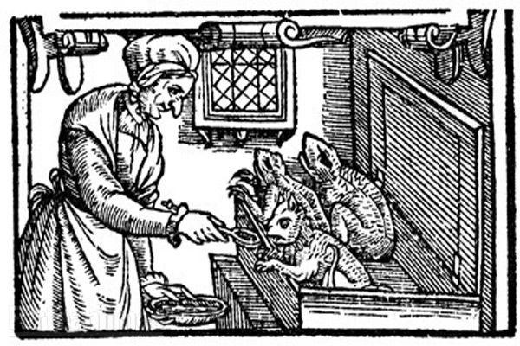
During our evaluation workshop at the end of our Victorian project, many of our members also highlighted their interest in learning about how audio archives are created and how we can use these more effectively in our own research. So, we have teamed up with Kate O’Neill, the Sound Archivist at the Essex Records Office who has confirmed that she is happy to lead a workshop for us to introduce us to the world of sound archives. During these initial workshops, an interest will be placed upon learning how to use artefacts and research and in particular; the materials held at the Essex Records Office. In preparation this project, we have already created a link with The Essex Records Office (Victoria West and Kate O’Neill) who have confirmed that they will support the project and provide access to both the museums, its resources and training in using archives and artefacts and an insight into the stories of the Witches. Professor Marion Gibson who has kindly offered to lead a special workshop and Q&A session about the Witches of St Osyth. Professor Gibson is a local historian and author specialising in witchcraft and has published two books about the subject. We will then use these skills to develop a series of focused questions to further develop our enquiry skills to learn more about local stories of Witchcraft in St Osyth and in Essex, their trials held in Chelmsford and the change in opinions and the impact which these stories have had upon our society today. We will build an impression of who these people were who were accused, who and why they may have been accused by and how they were treated. We will highlight specific examples of events, stories, people which will serve to support both our educational resources and our theatrical piece to share with others.

In our last project, we created a new link with the Essex Records Office. Their support was invaluable, and we learnt so much from our workshops with them and from their resources provided. We are keen to continue building upon their new partnership and they have been extremely supportive in helping us to ensure that we are setting clear, manageable goals to further develop our historical enquiry skills whilst also providing a clear introduction for new members joining us for their project. We have also developed a new link with the newly formed Essex Witches Museum who have agreed to help us with our research sharing materials which they have. We will then use our research as well as artefacts including photographs, letters, diaries, visits and real-life experiences (drama, roleplay), poetry/songs and newspaper artefacts, primary and secondary sources to develop short role-play and short scripted and improvised scenes, movement, and pieces of creative writing to explore and to bring to life what we have learnt in fun and enjoyable ways.

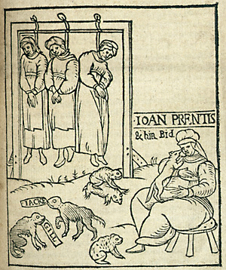
The second part of the project will be used to ‘apply’ this new knowledge by working together and devise a series of audio stories and short plays which retell the real-life stories of local people accused and tried for witchcraft inspired by Professor Marion Gibson’s book “The Witches of St Osyth.” We will incorporate a range of audio descriptions, primary and secondary sources, and pictures to capture what life was like locally whilst creating an interactive piece to inspire and share what we have learnt. These will then be ‘shared’ with schools, professionals, and the public through our YouTube channel, a special ‘sharing evening’ and via our social media and website. In our past two projects we’ve learnt that although people like our talk back sessions; it has been suggested that we try to open the talk back sessions out interactively encouraging discussions how the stories are brought to life in our audio pieces and allow our participants to share knowledge about what they have learnt as well sharing some of our stimuli used and gained from our research.

What were our project aims?

Our core aim in this project is to: “Explore stories the witches of Essex and particularly, of St Osyth, where a series of ‘Witch’ accusations spread in the 1580s.” We have broken down this core aim down into objectives which will in turn, be used as part of generating and evaluating our intended guaranteed outcomes.

1.Become more aware of generating questions whilst enquiring about the past, using archives and investigating artefacts.
2. Work with the Essex Records Office (Essex Archives) to develop an understanding of how to use museums, artefacts, and archives as a rich learning resource to learn about the past.
3.Explore how sound archives can be used as a rich learning resource for preserving heritage digitally with Kate O’Neill, the Sound Archivist at the Essex Records Office and sharing knowledge about the past.
4.Develop an understanding of the stories of the Witches in Essex and more specifically St Osyth working alongside Professor Marion Gibson and the Essex Records Office to build an impression of who was accused, why and how they were treated.
5. Consider a range of both primary and secondary evidence/materials to generate opinions, discussions, and conclusions about the stories of Witchcraft locally.
6. Use theatre and performance skills to create a series of audio monologues/scenes bringing to life what we have learnt about local stories of witchcraft inspired by Professor Gibsons book “The Witches of St Osyth” to share what we have learnt.
7. Inspire others to learn about the past.
8. Explore how the stories of local witches are still remembered in our local community today.

Kindly supported by:   

Setting the scene:
The history of the Essex Witchcraft Trials

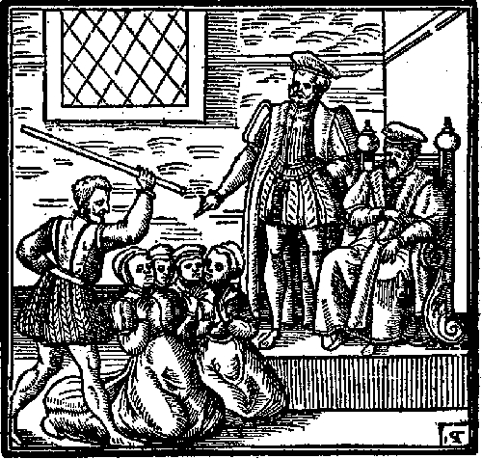
Medieval folk had long suspected that the Devil was carrying out his work on earth with the help of his minions. England – and Essex in particular – was in the grip of witch fever. Between 1560 and 1680, 317 women and 23 men were tried for witchcraft in Essex alone, and over 100 were hanged.

Witchcraft as a crime
Practising witchcraft was not a capital offence to begin with. However, in 1484 Pope Innocent III declared witchcraft as heresy, and this was a capital offence. Despite this capital punishments for witchcraft were extremely rare; between 1066 and 1560 only six people had been executed for witchcraft in England, the preference being to exorcise evil spirits.

In 1542, under Henry VIII, a bill called “The Bill Against Conjurations & Witchcrafts and Sorcery and Enchantments” was created. This meant that for the first time in English history, witchcraft was now a crime to be tried in normal courts - the same ones used for all other crimes such as murder and theft. It was punishable by death and forfeiting of property, land and possessions.

The Witchcraft Act (1542) also removed the benefit of clergy for witchcraft crimes. Benefit of clergy allowed clergymen to claim exemption from secular courts, instead being tried in ecclesiastical courts.

However, The Witchcraft Act (1542) was repealed by Edward VI, Henry VIII’s son, in 1547.

The Witchcraft Act
In 1563, during the reign of Elizabeth I, The Witchcraft Act (1563) was passed: “An Act Against Conjurations, Enchantments and Witchcrafts”. The Act stated that, in cases where witchcraft resulted in death, it is punishable by death. However, in lesser cases (i.e. not resulting in death), it is punishable by a term of imprisonment.

After the 1563 Act convictions for homicide caused by witchcraft began appearing. Out of 1158 homicide victims 228 were suspected to be caused by witchcraft. 157 people were accused of killing with witchcraft, of which around half were acquitted. Only nine of the accused were men.

The Death Penalty Scope Widens
Perhaps the most well-known Witchcraft Act is the one passed in 1604 under James I. “An Act Against Conjuration, Witchcraft and Dealing with Evil and Wicked Spirits”, also made invoking evil spirits and communing with familiars punishable by death. It also changed the penalty for ‘lesser’ cases of witchcraft, as mentioned above, to one year imprisonment, and afterwards one day in the pillory on market day once a quarter. Anyone found to be a second-time offender, even of ‘lesser’ witchcraft, will be put to death. This was the act that Matthew Hopkins, the infamous self-styled Witchfinder General, enforced.
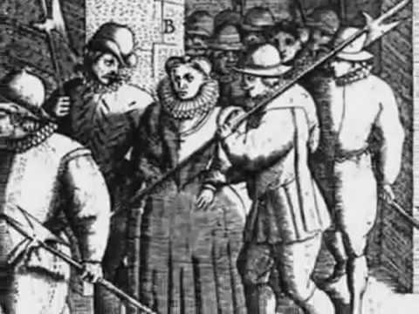
Setting the scene in Essex
Witches appeared to be more prevalent in the Eastern counties, particularly in isolated communities. Most were individuals, though some larger groups were found in Maldon, Hadleigh, and Coggeshall, although they were not organised enough to have been covens. Between 1560 and 1675, over 650 Essex men and women were accused of being or consorting with witches. Some were hanged, others died whilst awaiting trial, but many were found not guilty. Granted, the experience wasn’t going to be pleasant, life after acquittal was probably also going to be rough, and the chances of you being accused again were high, but many of the accused were acquitted.

It is unlikely that there were actually more cases of ‘witchcraft’ in East Anglia compared to the rest of England. Instead, the high figures are likely due to Matthew Hopkins and his associates, and the methods they used to get confessions. As part of the confession suspects were usually forced to accuse many others, creating a snowball effect.

For the people of Essex, times were very tough. Poverty was high and living standards were very poor. Disease and illnesses were common. People couldn’t afford doctors back then so they would go to local people with knowledge of herbal and spiritual remedies. Living in the villagers such as St Osyth, Coggeshall, Clacton and Manningtree were particularly hard where folk depended upon working the land and were dependent upon their crops or livestock. Many villages ran a barter system which often created arguments between neighbours. Law and order were upheld by the local landowners of power (Who were often local Magistrates) such as Brian Darcy and local clergymen.

The word of witchcraft spread fast, and people quickly began blaming bad crops, disease and bad times upon witchcraft. People became paranoid and were influenced by stories and started accusing their neighbours, friends and even family members.

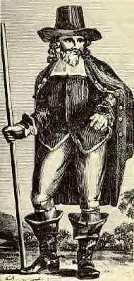
How Did the Witch Hunts Actually Come About?
Well, James I had a lot to do with it, as did Matthew Hopkins. It’s safe to say that King James I was obsessed with witches. He travelled to Scotland to attend trials and wrote books on the subject, perhaps the most famous being Daemonologie (1597 - Scotland, 1603 - England). In it King James I pitches witchcraft against Christianity, outlining the reasons to persecute witches under canonical law and endorsing witch-hunting in Christian society.

Matthew Hopkins, self-appointed Witchfinder General, and John Stearne, his associate, used the ideas from Daemonologie to hunt and track-down witches in East Anglia. Hopkins holds the record for the most ‘witches’ hanged, with his investigations making up an estimated 20% of witchcraft executions in England from the 15th to 18th centuries…and he was only in ‘business’ for three years.
Kindly supported by:

Participant blog
Our visit to Essex Records Office
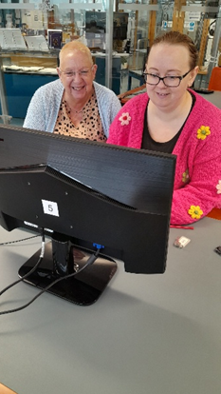
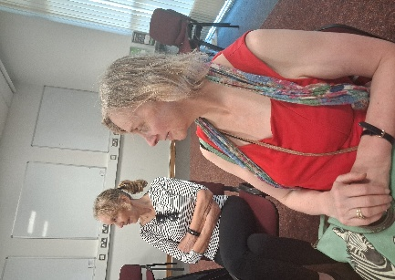
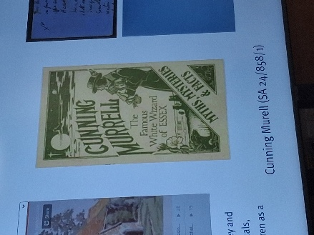
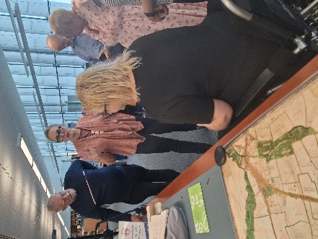

I don’t mind admitting that the thought of researching at the Essex Records Office was a little daunting! As someone who has never done anything history or research wise since they were at school, I was worried that I was going to be out of my depth. I could not have been any more wrong!

We visited the Essex Records Office for our project exploring the Essex Wildcraft stories. We were met by Vicky, one of the Archive team members who introduced us to the world of archives at the Essex Records Office. Vicky then gave us a really interesting background talk setting the scene of what life was like here in Essex during the time. She showed us maps and spoke about the illnesses, hardship particularly in the villages such as St Osyth and Manningtree and Clacton. This gave us a really good feel for what life was like and an introduction to why people may have been accused of witchcraft by their neighbours. We then spoke about the language and how much of the stories left behind are written in old English or in some cases, Latin. We looked at some diaries and old last Will and Testimony written at the time and tried to understand what they were writing about. The swirling use of writing reminded me of how my own mother used to write. We played a game of matching up pictures to text and finding the names of things.

Vicky then showed us how to access the archives online through the computers using the search engines on their website and how to pin-point and narrow down our search by using specific key words and phrases. I was able to look up the story of Elizebeth Clarke and the three ‘Joans’ who were put on trial in Chelmsford Market Square and hanged. Accessing the archives was a lot easier than I first thought it would be. Vicky was amazing and really supportive. It’s something which I’m pleased to say that I will be going again. I’d love to return to do more research in my own time and even look up my own family tree.

Kate then showed us the sound archives and wow! Just wow! I loved listening to some of the examples of people talking about what Chelmsford and Essex used to be like in the past. It was great fun matching up the different dialects. Who would have thought there would be so many different types of “Essex speech”. It did make us appreciate the importance of considering the use of dialects and accents in own recordings. The radio recordings were a favourite of mine. Although they weren’t specific to our study theme, they were really useful to give us great ideas of how we can create our own sound archive recordings to share what we have learnt about the Witch Trials. Kate also showed us how to create transcripts and the details which go into making them. It was an eye opener but a really positive experience. I’m quite excited to have our own sound archives added once we are finished. We were also shown a mixture of different pieces of sound equipment and recorders. It was fascinating to see how recorders have evolved over time.

Both visits were really interesting and worthwhile, and I thoroughly enjoyed coming along. The staff are incredibly helpful and encouraging. You never feel like a wally like me!

Kindly supported by:   

Why were people accused of witchcraft – The motives

There are many reasons as to why people were accused of witchcraft. Some were due to personal reasons including arguments amongst neighbours, fear or even acts of revenge. While other reasons were more generalised across the whole country and Europe. In our research, we set out to identify some of these motives.

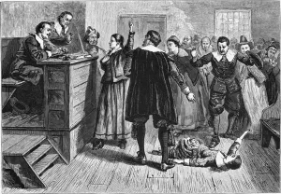
The Monarchy and the church
Medieval folk had long suspected that the Devil was carrying out his work on earth with the help of his minions. England – and Essex in particular – was in the grip of witch fever. We know that there had also been a heavy influence from other countries across Europe and the world. Both the monarchy and the church were strong believers in the fight against what they perceived as evil. It also posed as a great way of manipulating others, spreading fear and then gaining control and power. Laws such as the Witchcraft Act were passed, King James even wrote the Daemonologie book about witchcraft and clergymen would regularly give sermons.

Literature and word of mouth
One of the biggest contributors to the increase in persecutions of suspected witches was the development of mass printing. This technology allowed new ideas to be spread far and wide, with those able to read being exposed to a whole new world of ideas. It also created stories and rumours which were then spread from word of mouth throughout towns and villages.

Looking for someone to blame
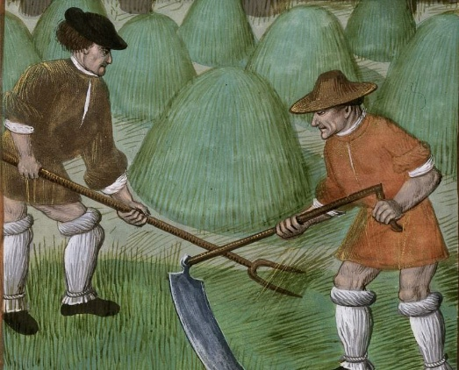
Much of the local villages depended upon working the land. Poverty and disease were ripe amongst the villages and towns. Sanitary conditions were poor. Money was scarce and barter systems were part of everyday life. Disagreements often erupted among neighbours, and law and order was upheld by local estate owners such as Brian Darcy, the clergymen and magistrates. One way of getting back at your neighbours was to start vicious rumours about them being a witch or even put in a complaint to the local Clergyman or Magistrate.

Morale was often low particularly when disease outbreaks and poor harvests caused further hardship. Often wiping out families. People were often looking for something or someone to blame. Professor Marion Gibson highlighted this area in her book “The Witches of St Osyth” when writing about the story of Cisley and Henry. Many thought that disease and bad luck was caused by the devil himself or by wrongdoing. Who better to blame than someone who appeared to be in touch with spirits.

Manipulation and self-gain
Another common reason as to why someone would accuse another person of witchcraft was because they were looking to gain something for themselves. This could be social status within the community, power or financial / land ownership gain. Indeed, it is strongly argued that both Brian Darcy and Matthew Hopkins motives were simply to climb the social status and financial wealth.

Kindly supported by:

How did literature influence the Witchcraft witch hunts?
An information page created as part of our Essex Witches Community Heritage Project supported by The Heritage Lottery Fund

One of the biggest contributors to the increase in persecutions of suspected witches was the development of mass printing. This technology allowed new ideas to be spread far and wide, with those able to read being exposed to a whole new world of ideas.

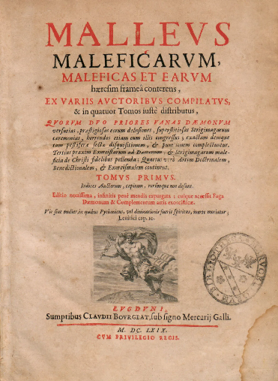
One of the first and key publications that arguably brought about the greatest changes regarding attitudes towards suspected witches, is the Malleus Maleficarum. This was one of the first documents created that specifically identified ways to hunt and test suspected witches. It was hugely influential in the creation of later books, such as Matthew Hopkins’ the Discovery of Witches.

Matthew Hopkins, the notorious self-appointed ‘Witchfinder General’, wrote his book The Discovery of Witches having brought around 300 women from across East Anglia and Essex to trial and execution. The book was written during the English Civil War, when the country had already been divided between royalist or parliamentary supporters. Hopkins took advantage of the divisions already within society to bring about the deaths of people suspected of witchcraft.

The third publication was The Case of Witchcraft at Coggeshall, Essex in the year 1699 was written by a local clergyman. At the time accusations and executions of suspected witches were starting to decline. Despite increasing awareness that many of the methods for identifying and convicting suspected witches were false, there were some who still feared and punished anyone who they believed might be causing harm through magic.

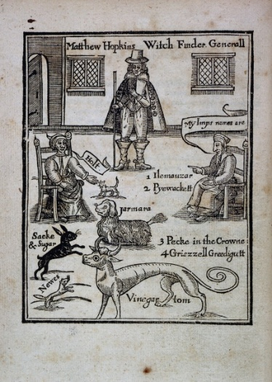
Imagery such as the woodcut depicting women offering poppets or babies to the devil was often printed in pamphlets, to heighten the fears of the general public. These shocking images were particularly
effective as many people could not read.

It caused mass fear and created isolation dividing whole communities and turning people against their own neighbours making people feel paranoid and suspicious. People even turned against members of their own families and friends.
Kindly supported by:   
Who was accused of witchcraft?
Common Traits of a Witch

Typically, those accused of witchcraft were predominantly women, often marginalized individuals such as the poor, elderly, or those who did not conform to societal norms.

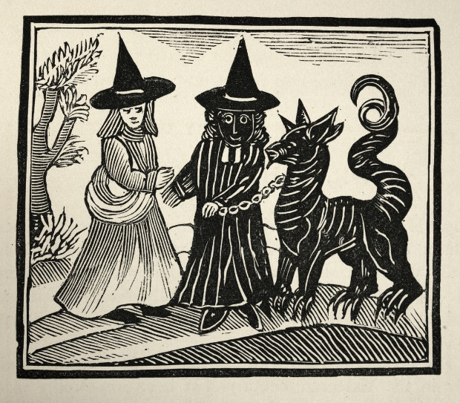
In Europe as a whole, more than 70% of those accused of witchcraft were women. In Essex, between 1560 and 1680, 317 women and 23 men were tried for witchcraft and over 100 were hanged. To begin with our research began pointing towards the following common traits of those accused:

1.Most were women
The facts and numbers do indeed speak for themselves. Most of those accused were women. They were often labelled as ‘witches’ due to their non-conforming attitudes. Often those accused had lived hard lives and had born illegitimate children which was seen as a sin in the eyes of the church. The wives or families of those whose husbands strayed the field would happily see the other parties accused of witchcraft as an act of revenge.

2.Vulnerability and disability
We found that in many of the stories about those accused, they were vulnerable people. They lived either alone, elderly or in poverty or were one-parent families. They often did not have the knowledge or the money to seek legal defence. Some did not have the confidence to fight back. We also found that there were several cases such as that of Elizabeth Clarke and Dummy who had disabilities and this was seen as a weakness and an ideal opportunity to take advantage of them by fooling them into making confessions for things they had not done wrong.

3.Social outcasts
Those who were marginalized or lived on the outskirts of society. People like Ursley Kemp who were believed to have lived ‘colourful lives’ against the norm of the church. It could even be as simple as that they lacked confidence in social situations, were homeless, poor, elderly or just lonely. Professor Marion Gibson highlighted that the fear of witchcraft often intensified during times of social upheaval such as wars, famine or disease. People were often looking for someone else to blame. Joan Prentice was hanged because she had a pet ferret!

4. Ordinary people
Some people were just ordinary folk trying to mind their own business. Many accusations stemmed from family feuds or arguments between neighbours. We found this to be a common factor in many of the stories read. Both Cisley and Henry and Anges Waterhouse were prime examples. These arguments could be about livestock, money owed or even as daft as feuds over who borrowed a jug of milk to who. This reflected how the local dynamics could lead to witchcraft accusations.
However, the further we researched, we did find that there was a general misconception amongst common belief that all women accused were from poor backgrounds. In fact, 64% of those accused in Scotland alone were from middle class backgrounds. This was mirrored across Europe.

What is clear, is that those in power believed that women were weaker and more easily tempted than men. In the bible story of Adam and Eve, it is Eve who is tempted by Satan to eat the forbidden apple. Woman are considered more of a risk of being influenced by the Devil.

Examples of those accused
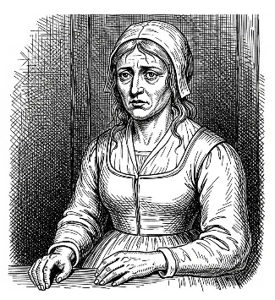
Ursley Kempe of St Osyth was an English cunning woman and midwife who in 1582 was tried for witchcraft and hanged. Kemp was accused of (and apparently confessed to) using familiars to kill and bring sickness to her neighbour. She was the first person to be investigated by local Magistrate Brian Darcy. She was reportedly imprisoned in the famous ‘cage’ prison in St Osyth before her trial.

Joan Prentice or Joan Prentis from Sible Hedingham was executed after being accused of witchcraft with Joan Cunny and Joan Upney in Chelmsford in Essex in 1589. It’s said that she was accused after a neighbour had overheard her talking to her pet ferret. When asked, she told investigators about her pet who she said was a ferret named "Satan" or "Bid". The ferret was said to have fed by biting and sucking her blood from her left cheek.
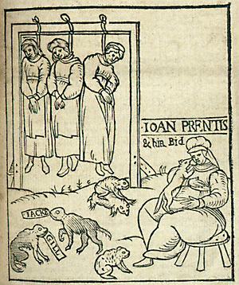
Elizabeth Clarke or Bedinfield of Manningtree was the first woman accused by the Witchfinder General, Matthew Hopkins, in 1645, marking the beginning of a series of witch trials in by him in Essex, England. It was reported that Elizabeth only had one leg. She was accused by local tailor John Rivet. Hopkins and John Stearne took on the role of investigators, stating that they had seen familiars while watching her. During the process, she was deprived of sleep for multiple nights before confessing and implicating other women in the local area. She was tried at Chelmsford assizes, before being hanged for witchcraft.

Anges Waterhouse, also known as Mother Waterhouse of Hatfield Peverel, was accused of witchcraft along with two other women: Elizabeth Francis and Joan Waterhouse. She confessed to having been a witch and that her familiar was a cat (later turned into a toad) by the name of Satan. Agnes was put on trial in Chelmsford, Essex, England, in 1566 and executed for using witchcraft to cause illness to William Fynne. She was also charged with using sorcery to kill livestock, cause illness, as well as bring about the death of her husband. It’s said that her testimony saved her daughter, Joan from being executed.

Cisley and Henry from Clacton in 1570 were accused by their neighbours of witchcraft over a bitter feud. They had been accused of causing death to their livestock and a fire which burnt down their corn. They were investigated by Brian Darcy and Margaret Simpson. Darcy used Cisley’s own two young sons against her by questioning and twisting their words and abusing heightened emotions within the family. Cisley was accused of speaking to spirits and feeding ‘imps’ or familiars. She was then accused of sending these familiars to hurt her neighbour’s maid. Cisley was found guilty, but Henry was spared the guilty sentence.

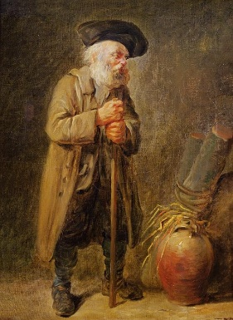
Dummy of Sible Hedingham was an unidentified elderly man who was one of the last people to be accused of witchcraft in England in the 19th century. He was beaten and thrown into a river by locals Emma Smith and Samuel Stammers It was said that Dummy was deaf and could not speak. He was an eccentric, but harmless character who liked to wear different kinds of hats and coats and kept several dogs and was known as a fortune teller. Smith accused him of bewitching her and making her ill. After the attack upon him, he was taken to the workhouse in Halstead where he died shortly after due to his injuries. Both Smith and Stammers were found guilty of causing his death and were sentenced to six months hard labour.

Kindly supported by:

Focused character workshop: What were people’s views of witchcraft in the 1500-1600s Essex and how did it feel to be accused?

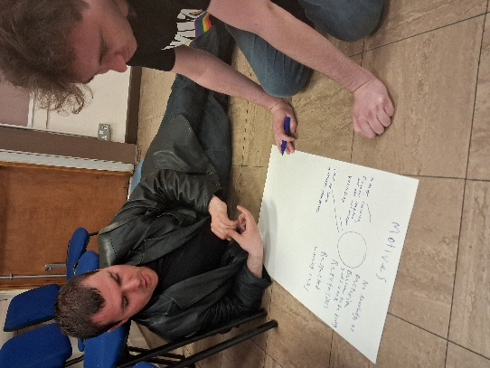
As part of our research application work, we used our research from the Essex Records Office and Professor Marion Gibson to explore the attitudes towards witchcraft in Essex during the 1500-1600s particularly in rural communities. This helped is to set the scene as a starting point in our research. We knew that there were many external factors which affected people’s views and making them far more suspicious and easily persuaded in their conclusions. These included:
-Economic hardship
-Disease and death rate
-Problems in farming and land
-Religious influence
-Expanding literature and reporting. (Media and scaremongering)
We also used from our visits to the Essex Records office where they gave us an introduction to what life was like living locally during this time period and living conditions were especially for the working-class families in rural areas of Essex.

During our workshop we used group work, discussions and performance techniques to explore societies attitudes towards witchcraft in the community at the time. We quickly realised that these attitudes were heavily influenced by external beliefs and opinions. We set out to answer the following key questions:

1.What were societies views towards witchcraft at the time?
2. Why were people accusing their neighbours of witchcraft?
3. How did it feel to be accused of witchcraft?
4.What were the possible motives behind the investigators and how did this affect the outcomes of the accusations?

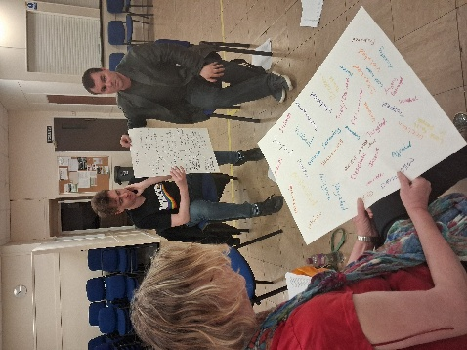
We knew that times were hard, and many local people were living on the breadline in poverty. Disease and illness were poorly treated and living conditions were tough. Communities were governed by a strict religious influence, and people’s views were being affected by the growing literature print which often spread bias and misinformed views which were often uneducated. Still, people were believing what they were being told which led to innocent people being blamed for things which weren’t their fault.

We used roleplay activities to re-create some of the stories and characters featured in the stories written by Professor Marion Gibson’s book “The Witches of St Osyth” as well people and events from research collected from the archives and newspaper stories to explore how it felt to be accused at the time and why people were turning against their own neighbours. We used hot-seating and improvisations to better understand. We discussed the common language used to describe and, in some cases, bully those accused. Common words such as “naughty” appeared in many cases in evidence.

In smaller groups, we created charts to mind-map feelings and emotions to describe how it felt to be accused, why neighbours were accusing one another and the possible motives behind the investigators at the time. We split into small groups recording our ideas. We then shared these to create a large chart which generated positive discussions about how people were feeling in the Witchcraft Trials. These included:

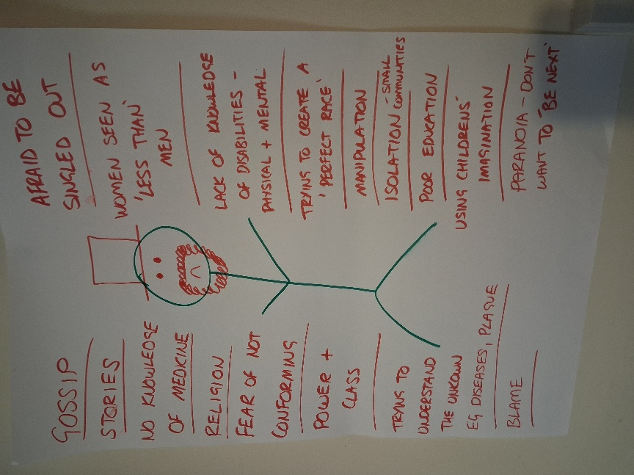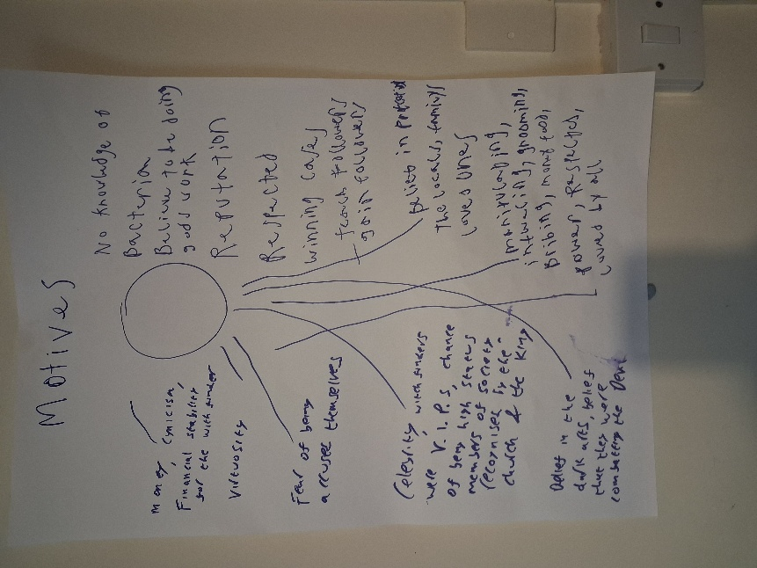

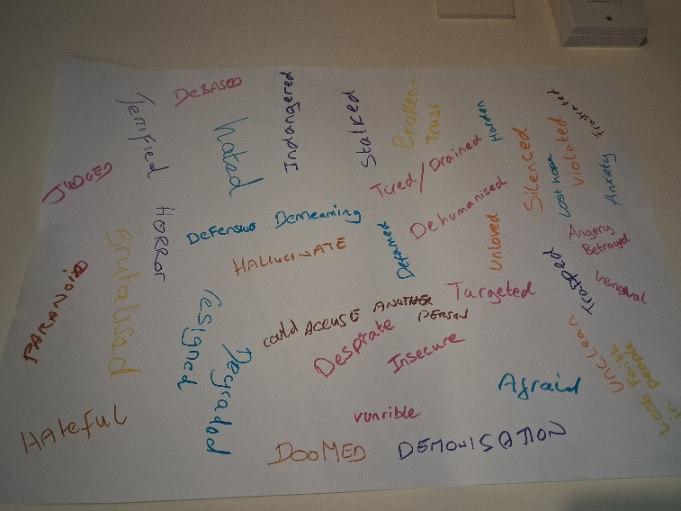

Common words which came up to why people were accusing others included:
-Fear
-Frustration
-Anger at their hardships
-Lack of understanding / misinformation
-Revenge / breakdown of relationships

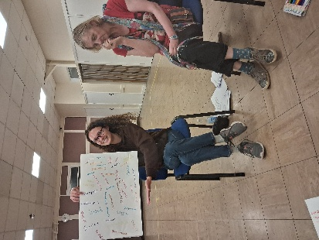
We found that there were common traits in those being accused of witchcraft. Many were poor, had children out of wedlock, had disabilities, were spiritual or creative women. We compared this to how society is today and asked the question of whether we have made any progress or whether we are still prejudice towards people who are different or vulnerable in the community.

People were accused of witchcraft were made to feel more vulnerable, afraid, defensive, isolated, paranoid, desperate, angry and judged. They were investigated unfairly and often tortured until they gave in to believing what their investigators wanted. It was clearly an unfair and unjust society. It some ways, it still mirrors parts of our own society today. It gave us an insight into how it felt to be one of those people accused which helped us to gain a stronger sense of empathy whilst re-creating their stories for our learning resources.

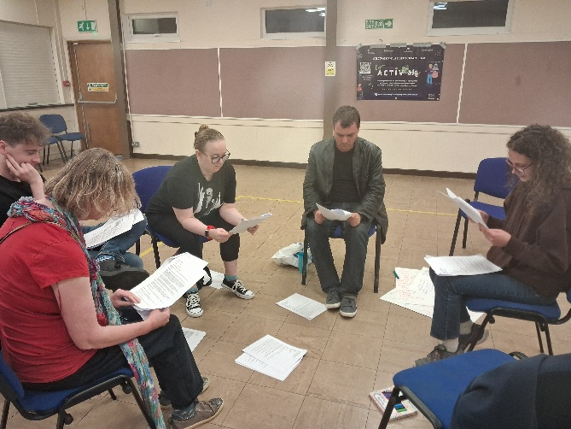
Probably the most interesting discussion point was exploring the possible motives behind those doing the investigating. Greed, power and corruption were the common words which arose straight away. Followed by the talk of fear of being investigated themselves. It is clear that many of these investigators possessed narcissistic traits and enjoyed playing their roles as vile bullies and acting out their fantasies in being God-like creatures. One of our members commented out loud with a sigh of disbelief… how on earth did these people get away with it and why didn’t anyone question their behaviour...indeed?!

Kindly supported by:

Witches and their imps and familiars

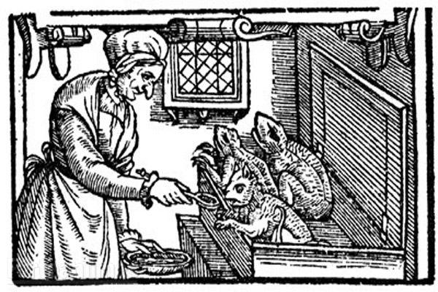
Familiars are mystical companions often associated with witches, serving as guides, protectors, and assistants in magical practices, with a rich history that spans folklore and modern witchcraft.

In 1604, James I introduced a new Witchcraft Act that included “the occult rituals of diabolic witchcraft” (Voltmer 2017: 110). This made working with evil spirits a capital offence. The act also referenced familiars, believed to be “the witches’ helpful demonic companions” (Voltmer 2017: 110). The Act really made an effort to clarify types of witchcraft. It also turned communicating with spirits and practicing magic with body parts into capital offences (Voltmer 2017: 110).

By the time we reach the witch hunts of the 17th century, these familiars were more “popularly referred to as ‘imps'” They manifested as small animals and a witch’s power could pass to another person through the familiar.
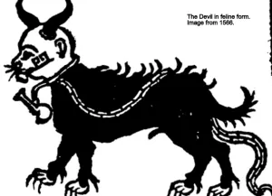
Familiars in our Essex Witchcraft stories
They were mentioned as key pieces of evidence against many of those accused in the Essex witchcraft trials. Joan Prentices was said to have a ferret named Satan or Bid while Cisley of Clacton was reported to have familiars who would feed upon her blood. In many of the stories, those accused were said to have used their familiars to cast nasty spells upon their victims often resulting in death. Many of the accounts came from this area thanks to the activities of Matthew Hopkins, the self-proclaimed witchfinder general. In East Anglian folklore, witches either got their familiar direct from Satan, or they inherited them from someone else. Surprisingly, these imps still appear in court records in the area as late as the early twentieth century.

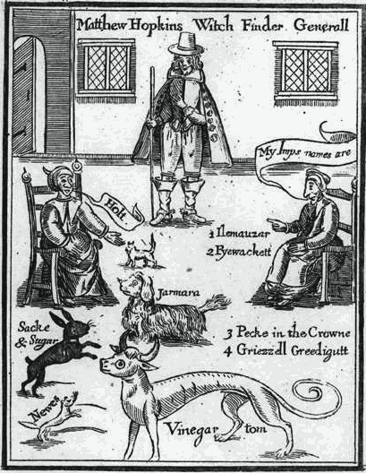
People believed familiars were evil spirits.
They fed on the blood of ‘their’ witch and acted as servants. Many think the word comes from famulus, a Latin word for servant. The famed ‘witch’s mark’, sought during investigations, was believed to be the teat where the witch suckled her familiar.

Familiars also taught witches how to do magic and dispensed advice. Witches used them as spies thanks to their shapeshifting abilities. Cats, dogs, owls, toads, and mice all fell under suspicion.

Examples of familiars
Paddock  Toad Companion | Harpier  Owl Guide | Grimalkin  Cat ally | Holt  White kitling
Farmara  Spaniel helper | Vinegar Tom  One-headed greyhound | Sack and sugar  Black rabbit | Newes  Polecat spirit
Elimanzer  White dog | Pyewacket  Cat companion | Peckin the crown  Unknown | Grizel Greedigut  Unkbown
Pygine  Mole familiar | Russol  Grey cat | Dunsott  Dun dog | Minny  Red and white dog
Tyffin  White lamb | Elva  Dog ally | Robin  Black dog | Sathan  White cat
Gille  Black cat | Ginnie  Kitling spirit | Philip  Rat familiar | Tyttey  Grey cat
Pigine  Black toad | Lacke  Black cat | Robbin  White colt | Robbyn  Toad ally
Tom  Toad spirit | Lierd  Red lion | Lightfoot  Cat companion | Lunch  Toad ally
Makeshift  Weasel spirit | Inges  White spotted cat | Gibbe  Black cat | Tewhit  Yellow bird
Fillie  White cat | Hoult  White dog | Jarama  White dog | Wynowe  Black kitling
Jeso  Black kitling | Panu  Black kitling | Jesus  Unknown | Jockey  Unknown

Kindly supported by:   
The Witchcraft Trials
Trials and punishments
During our Essex Witches Community Heritage Project, we explored how those accused of witchcraft were investigated, put on trial and punished. The project was supposed by the Heritage Lottery Fund, Essex Records office and Professor Marion Gibson.
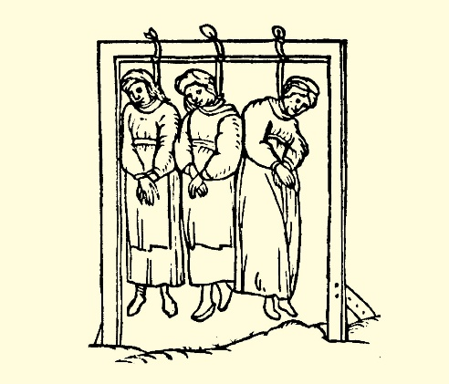
The Witchcraft Act 1563 introduced the death penalty for any sorcery used to cause someone's death. The Witchcraft Act 1603 reformed the law to include anyone to have made a Pact with Satan.

The witch trials
The typical victim of an English witch trial was a poor old woman with a bad reputation, who was accused by her neighbours of having a familiar and of having injured or caused harm to other people's livestock by use of sorcery.

About 500 people are estimated to have been executed for witchcraft in England. It didn't take too much to be accused of witchcraft. In difficult times, such as years when crops failed or disease was widespread, communities would often look for supernatural causes. Witches were seen as one such supernatural cause.

Anyone who had become ill or suffered a sudden misfortune might look for a magical reason among the people around them. Accusations of witchcraft usually came from within the suspect's community. Often, they involved a dispute or argument, after which one of the people involved suffered some ill health or misfortune.

A small community, where people really know each other, is a place where small grudges and disagreements come to light. For St. Osyth, this was a small community who was ready to unleash those disagreements by sharing them with a judge, such as Justice Darcy, to gain something more from their peers. Many early English villages at this time depended on the barter system due to the poverty they were enlisted to, which is an explanation as to why begging was a part of many trials. People were so well versed in these skills, living them day to day, that they were ready to squabble in a court as they would have done in a market. Accusing someone as a witch was a quick and easy way to get back at someone who was resented by another.

When someone was accused of witchcraft, they were often investigated by someone seen as having authority within the community. In St Osyth this was often the local Magistrate Brian Darcy. Evidence and interviews with local neighbours, clergymen were undertaken. One of Darcy’s common tactics was to interview the young children or family members of those accused. Evidence was then often twisted and used to trap and force a confession. Research shows that dates and descriptions were often changed to best fit an outcome. Those accused would be summoned to see the Magistrate for questioning. They would be sent for and marched through the streets in plain view of everyone to see. They would be strip searched by associates such as Margaret Simpson who would search their bodies for markings, scars, body features which were not deemed to be normal. Specimens were taken and it was not a very comfortable procedure. People who were of the poor and vulnerable were often picked on as they lacked the power or ability to defend themselves. Another common attribute was women who had born children out of wedlock which was seen as a sin in the eyes of the local clergymen.

Torture:
Although torture was not supposed to happen, it often did. Those accused were often submitted to often degrading, painful and dangerous forms of torture. Darcy would often put those accused in a dark room for hours without food, drink or any knowledge of what will happen and observe their behaviour. He would also keep the accused awake for long periods of time – often many days. This technique was called “Waking the witch.” Matthew Hopkins often used forms of torture to ‘test’ to see whether people were witches. The Swimming test was one example where a woman is tied and lowered into water. If she floats, then she will be deemed to be a witch. If sinks (and often drowns) she is seen to be innocent.

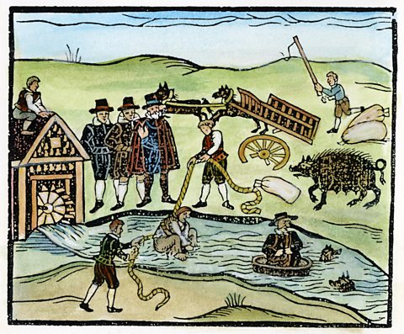
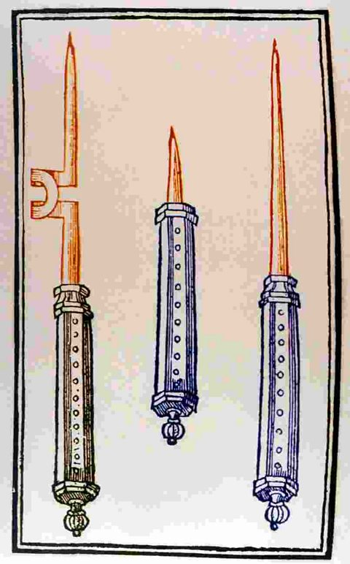
The Devil’s mark was another test. It was thought that when a witch pledged herself to the Devil, he marked them with a sign of their loyalty. This Devil’s Mark was an area on a witch's bodies that would not respond to pain. Witchcraft investigators used sharp tools to prick the skin of suspected witches to see if the Devil’s Mark could be found. Some people worked as professional witch prickers.

This was painful and highly distressing, and, although not originally intended as a form of torture, it may have been used as torture to bring about a confession. Even finding a birth mark or a mole on the skin could be enough to accuse a person of being a witch.

Another example is Ursula Kemp from St Osyth who went through many accusations and ended up being hanged. She was known to reside in "the cage" during her trial. In medieval times, "the cage" which is a type of prison, was often a form of public humiliation and confinement used to punish criminals. The structure was typically a small, barred enclosure, sometimes suspended in public places like market squares or outside castles, where individuals were left exposed to the elements. It was not only a form of physical restraint but also served to publicly shame the prisoner, reinforcing the societal power dynamics of punishment and authority.

Assizes:
The Assizes ‘trials’ were held in quarterly sessions throughout the year. Judges from London would travel to lead these court proceedings. The streets would often be filled with people who had come out to see the trials take place. People would be selling souvenirs, food and drink. Witchcraft was a crime that came to Assize courts regularly, but only after a new Witchcraft Act had been passed by Parliament in 1563. The new Act stated that witches who were convicted of lesser offences – like making farm animals sick – would be punished with one year in prison. Witches who were convicted of killing a person, however, were to be hanged.

“The Chelmsford Assizes was an open-sided building, with eight oak columns supporting upper galleries and a tiled roof. The galleries, which overlooked the open “piazza” below, were lit by three dormer windows in the roof… the magistrates and justices sat in open court, which measured only 26 feet by 24 feet, with the officers of the law, counsel and clerks, plaintiffs and defendants, jurors, sureties, witnesses and prisoners, before and around them, while spectators, hangers-on, and those awaiting their turn, crowded into the galleries above or thronged the street outside.”

Those accused would be brought through the streets wearing shackles and ragged clothes. They would be dirty from my time in the prison cell awaiting trial. They would e traumatised and frightened. They would be mocked, faced with insults and have things such as rotten food thrown at them by passers-by.

The trial itself would be in front of a judge, magistrates and jury. The evidence would be heard and, in some cases, those accused would come face to face with the people who had accused them. Often, they would have confessed beforehand to the crime.

Many of those accused were executed. This was most commonly done by strangling the alleged witch and then burning their body.

Destroying a witches body made sure that it could not be brought back to life by the devil or be used for evil magic. It also meant those found guilty of witchcraft could not receive a Christian burial.

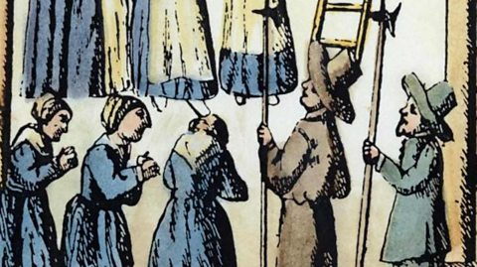

Kindly supported by:

The Cage
The history behind the famous lock up in St Osyth

The Cage is a former village lockup where drunks and villains would be kept overnight. It is claimed that Ursula Kempe was detained here in 1582 whilst being interrogated over false accusations of witchcraft. We know of no evidence to support this, but she certainly was interrogated at St Clere's Hall. Ursula was hanged in Chelmsford together with another St Osyth woman Elizabeth Bennett.

The history of the Cage
St Osyth, a charming village nestled on the Essex coast, whispers tales of a past far richer and, at times, far darker than its idyllic present suggests. Among its historical treasures, one structure stands out, a stark reminder of a bygone era of injustice, fear and oppression: The Cage. More than just a building, The Cage is believed to have ties to St Osyth’s dark history, particularly its infamous witch trials and the role it would play as the town’s lock-up. The building has also built a reputation amongst paranormal investigators, with many claiming it to be one of the UK’s most haunted houses.
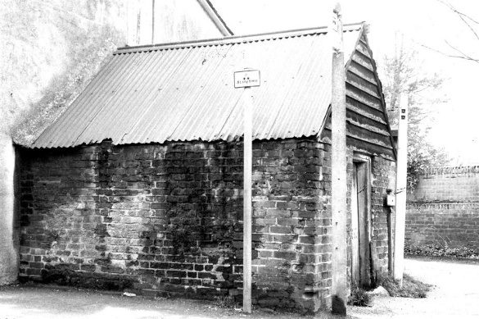
The Town Lockup (c. 1500 – 1908)
The story of The Cage, in its earliest iterations, likely began as a functional necessity for the small village. Before it earned its chilling reputation, this rudimentary structure was believed to have served as the town lock-up – a place where minor offenders, vagrants, or those awaiting transport to larger courts would be held. It was a means of ensuring order within the community, a visible deterrent, and a temporary holding space for those who disrupted the peace or broke the law. The structure itself would have been a cold place of isolation, where many undoubtedly spent times reflecting on their past indiscretions.

In the 19th century, legislation was introduced placing pressure on local councils to establish more orderly police forces leading to many Cages across England becoming disused or repurposed, though many were still in use after this time, particularly in small, regional towns like St Osyth. A plaque added to The Cage during its reconstruction in the 20th century suggests that The Cage may have been used as late as 1908, now serving as an important record of the building’s former use. To this day, the role of The Cage serving as the town lockup continues to be upheld by local historians, the St Osyth Historic Society and the St Osyth Museum.

The St Osyth Witch Trials (1582)
Ursula Kemp, a local woman known for her healing skills, used herbal and spiritual methods to treat the ill in her community. Despite being seen as a healer, she was later accused of witchcraft by her neighbour, Grace Thurlow. Initially, Grace sought Ursula’s help when her son, Davey, became sick. After Ursula treated the boy using what Grace believed were spells, he recovered fully. However, Grace’s relationship with Ursula soured during her second pregnancy. Following a disagreement, Grace grew convinced that Ursula had cursed her family. When Grace’s infant daughter tragically died after falling from her crib and breaking her neck, the community immediately blamed Ursula for the death.

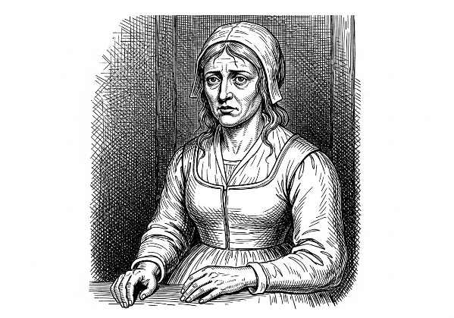
Even while imprisoned for her alleged crimes, members of the community continued to seek advice form Ursula. During the subsequent witch trials, Ursula, possibly under duress or misled by promises of leniency, implicated numerous other women. This confession fuelled a severe outbreak of hysteria that spread to nearby areas, including Little Oakley, The Soken’s, and Little Clacton, leading to the accusation of many others including Ales Newman, Elizabeth Bennet, Ales Hunt (Barnes), Margerie Sammon (Barnes), Annis Glascock, Joan Pechey, Cisley Selles, Henry Selles, Ales Manfield, Margaret Grevell, Elizabeth Ewstace, Margaret Ewstace, Joan Robinson, Annis Herd (Heard) and Anne Swallowe (Eswell). Out of all those accused, Ursula Kemp and Elizabeth Bennet were ultimately executed, and several other individuals sadly perished while incarcerated.

The witch hunt and initial interrogations were supervised by Brian Darcy. Unfortunately, Ursula’s seven-year-old son was pressured into testifying against his mother. He declared that she practiced witchcraft and maintained four familiars: Jacke (a black male cat), Tyffin (a grey female cat), Pygine (a black female toad), and Tyttey (a white male lamb), the latter of which was specifically blamed for the death of a child. Although Ursula confessed hoping to receive mercy, she and Elizabeth Bennet were convicted of witchcraft and hanged in Chelmsford in 1582. The suffering caused by the trials was widespread; Ursula’s young son, approximately seven years old at the time, was abandoned, and his subsequent fate remains unknown.
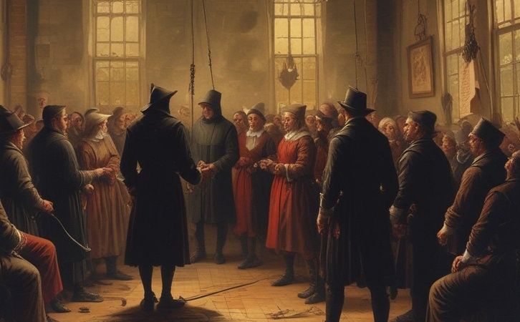
Although the specific location where the women were first held before their transfer for trial and execution is undocumented, it is widely assumed to have been “The Cage” based on its established function as the town lockup. Following her initial detention, Ursula would have been moved to Colchester Castle for imprisonment while awaiting trial. Her final trial and subsequent execution took place in Chelmsford.

Recent History (20th century)
The Cage itself was reconstructed sometime in the 20th century, adjoining it to the neighbouring property to become a living space, and extended to include an additional upstairs bedroom and adjacent kitchen. As such, the Cage is not heritage listed – Many cages (such as The Bardfield Cage) weren’t grade listed until much later in the 1980s, long after The Cage was believed to have been reconstructed. Despite this, the Tendring District Council to this day still identifies The Cage as a non-designated heritage asset in their annual conservation appraisal, and the home remains an iconic and culturally significant landmark in the town.

The location of the lockup has been disputed in the past mainly due to lack of records that date back to 1582. However, hand drawn surveyor maps dating back as early as 1772 are detailed enough to feature The Cage. When overlayed with modern satellite imagery there is a building consistently marked across multiple surveyor maps spanning throughout the 18th century through to today, dispelling any doubt about its location in recent times.

Paranormal Claims
The Cage is highly regarded within the paranormal community, with many claiming to have had paranormal experiences. When the house was briefly made available to paranormal investigators, many reported standard haunting phenomena. However, one particularly striking incident involved an investigator named Debbie: CCTV footage reportedly captured her face morphing into an “evil-looking grin.” Furthermore, Debbie suffered a painful burning sensation on her back, resulting in four distinct, deliberate-looking finger-like burn marks. Other visitors have reported various activities such as poltergeist occurrences, unexplained noises and voices, mysterious mists, moving doors, phantom footsteps, and strange smells, with a previous owner even claiming to have been violently forced out of the house by something dark.

The home has mysteriously changed ownership multiple times, and new owners never seems to remain in the home for long. Even its most recent sale was made under strange circumstances – with the previous owner beginning making renovations but selling the home prior to finishing. They would never make it as far to live in the property. The home has remained largely unoccupied since 2018 until its most recent acquisition.

References:
https://thecage.co.uk/the-history-of-the-cage/

https://www.stosythmuseum.co.uk/buildings/the-cage

Kindly supported by:

THE CAGED BIRD
A monologue created as part of our research in the Essex Witches Community Heritage Project supported by The Heritage Lottery Fund. The following piece is based on the true story of Ursley from St Osyth who was accused of witchcraft and was imprisoned in the Cage in St Osyth before her trial in Chelmsford.

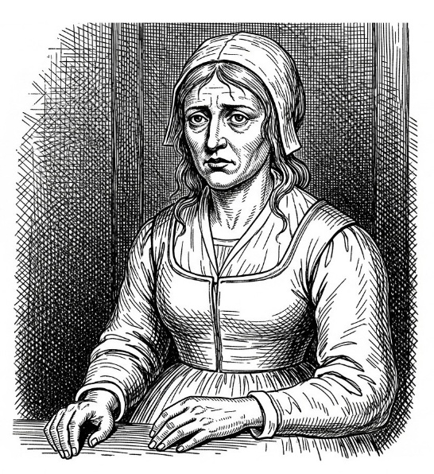

Chink.
Chink.
Chink
Each movement I make, the chains chink and tighten around my wrists and dig into my skin. I should probably feel the pain. I should feel the cold bitter wind howling through the bars on the cage door and blistering my face. But I feel nothing. All I hear is the chinking of the chains. Chink. Chink. Chink.

They say that I am a witch. They say that I am naughty sort. That I bewitched and caused a baby to fall from its cradle. They used my own son against me. They told him that I was evil. I did not want to confess. I was tired. So tired. The relentless of questions in the darkened room. The twisting and turning of answers. I told them. I told them that it wasn't true. Over and over again. But that man. Mr Darcy. He wouldn't listen. They turned their backs on me each time I spoke. They talked over me and scribbled their notes. There was no use in arguing. I was scared. That's when he promised me that if ... if I confessed it would be all over. They would be lenient on me. That I could see my son. I could hold him in my arms and tell him not to be afraid. I didn't know that it would be a trap. I believed him. He was a man of status. A pillar of the community. I trusted him.

Chink.
Chink.
Chink.

I see you. I see how you look at me as you walk by. Laughing, shouting, throwing stones and spitting at me. I see how you look at my ragged clothes and assume that I am a rough sort. When in truth I am just a poor woman like most. You know me. I have lived here all my life. I've tendered many of your children and illnesses. Yet, my face has become repainted. Repainted with a new image. My pale complexion and red eyes are from the tiredness and old age. My back is slightly bent from sitting over a spinning wheel. My teeth are quickly rotting away. I admit, my temper is rather thin these days. Yet you assume that I am a witch because I fit your image of what a witch should look like. What happened to my friends? My neighbours who relied on me and came to me for help so often? What happened to the men who would tilt their hats at me and the wives that would happily pass their babes to me to look after? Has my face changed that much?

Chink
Chink
Chink.

Each chink that sounds is one chink closer to the end. Won't any one listen to me? I beg of you, let me see my boy just one last time. Let me hold him before the last chink chimes.
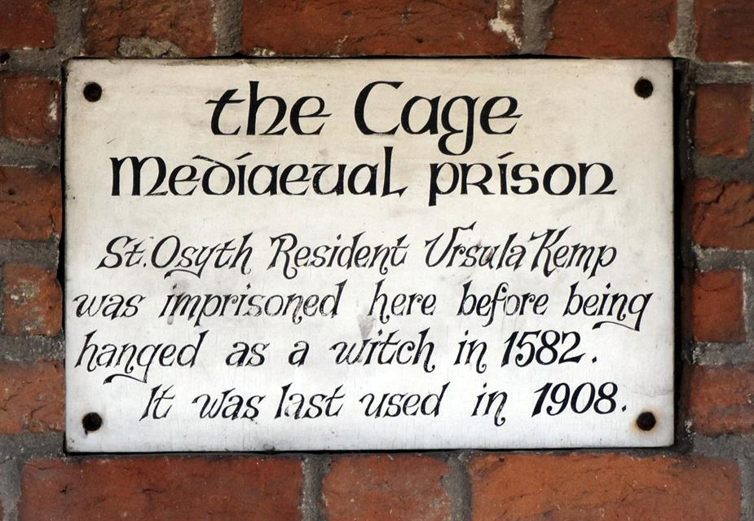
If I am a witch, then I curse you all. A plague upon your houses and a curse upon this cage.

Chink
Chink
Chink.

Kindly supported by:

Colchester Castle Prison

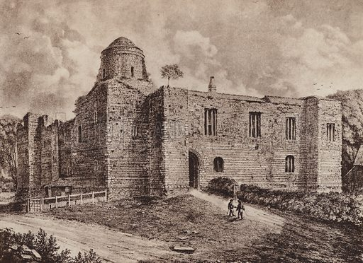

Colchester Castle was a key landmark in the Essex witch trials. In the 1500s and 1600s, hundreds of people were imprisoned inside its walls suspected of being a witch

The county became well known for its persecution of suspected witches, the first person in England to be executed under a Witchcraft Act was Elizabeth Lowys who lived in Great Waltham. Five hundred years later, many of the stories of victims like Elizabeth are at risk of being lost – overshadowed by tales of people like the famous Witchfinder General, Matthew Hopkins.

The Castle’s relationship with the Witchcraft Trials
Colchester Castle was the first of the great keeps and the largest built by the Normans in Europe. But by 1645, it had fallen into such a state of disrepair that it was only fit for one purpose: a prison.

Conditions in the gaol were dire.

Accused witches were thrown into prison while awaiting trial, and this was nothing like our modern-day idea of prison. The accused could be held for days, weeks, months and even years in some cases waiting for a trial date. Conditions were unsanitary and the prison cell was the perfect environment for disease to spread. Colchester Castle was first used as a prison in 1226, was the county prison until 1667 and was used until 1835. Many of Hopkins’ victims were held here and the Castle gives us a good idea of how accused witches were treated.

Part of the roof had collapsed a decade prior and exposed prisoners to the elements. Male and female prisoners were separated into two cells and kept shackled. They slept on straw or bare stone. Food was poor and basic cleanliness impossible. Many prisoners, including some of the women accused as witches, died of exposure, malnutrition, or disease.

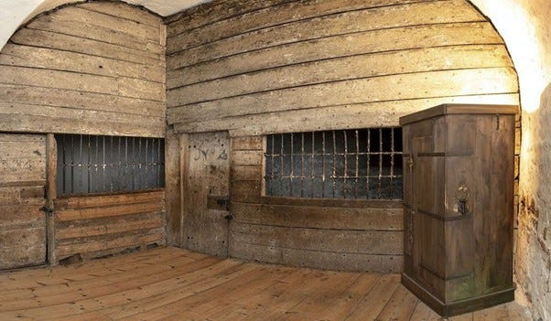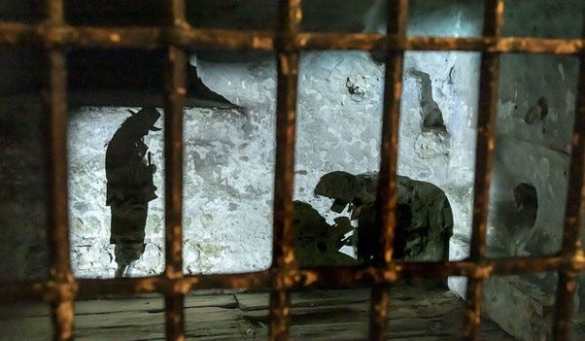

The story of Rebecca West
Whilst researching, we came across another story of one woman accused of witchcraft by Matthew Hopkins.

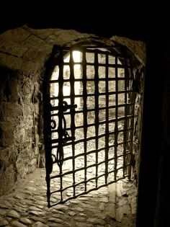
In mid-April 1645, Matthew Hopkins visited Colchester Castle. At approximately twenty-five years old, he was the most junior of a team of men who had taken it upon themselves to hunt down witches in Essex. Sir Harbottle Grimston, 1st Baronet, in his seventies, and Sir Thomas Bowes, estimated in his forties, were magistrates with a duty to investigate witchcraft and other crimes. John Stearne was a landowner in his mid-thirties who apparently involved himself in the investigation out of curiosity or civic duty. Hopkins had become involved initially through his stepsister who believed herself cursed by Elizabeth Clarke, but he soon showed an interest in pursuing witches throughout Essex. The unpleasant task of going to Colchester Castle may have been assigned to him as the youngest witchfinder or he may have eagerly volunteered for the task to prove his capability.

Hopkins’ target was Rebecca West.

Rebecca had already confessed and accused her mother, Anne, of witchcraft —Hopkins saw her as a weak point by which he might unmask the Manningtree “coven”. Hopkins isolated Rebecca from the other women and coerced a more elaborate confession from her. Rebecca now accused the other imprisoned Manningtree women of being witches and, shockingly, claimed she was married to the Devil.

Rebecca West’s coerced confession was damning for the women she accused. All the alleged Manningtree coven, including Anne West, were found guilty of witchcraft and executed, except Rebecca. She was freed due to her turning prosecution witness and her age — she was likely only in her early or mid-twenties. It is unknown what became of Rebecca West after the trials.

Kindly supported by:   

Alice Prestmary
A monologue created as part of our research in the Essex Witches Community Heritage Project supported by The Heritage Lottery Fund. The following piece is based on the story of Alice and John Prestmary from Great Dunmow who was also imprisoned at the Colchester Castle for witchcraft

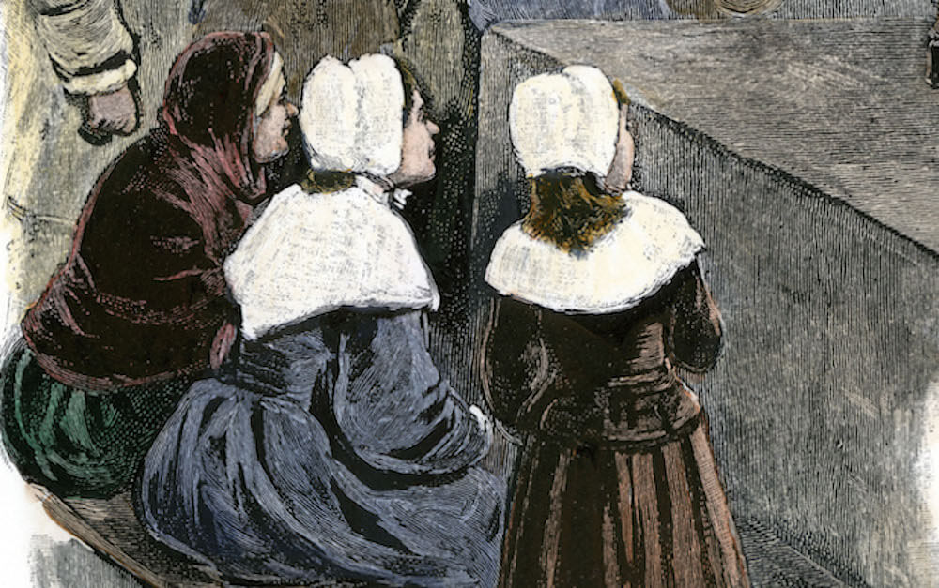
Is it raining outside?
Is it the droplets of rainwater i can feel on my face as I look up out of the tiny window of the castle prison?

I feel so cold. My body is shaking inside and out. Yet, I feel so warm at the same time. Sweat is dripping from my brow. Or is that the raindrops again? I cannot tell. My eyes are worn and battered. Maybe I am possessed like they say?

I am Alice Prestmary of Great Dunmow. And this is my story.

They said that on the 1st of February I had bewitched Robert Parkers son, Edward by putting his life in peril. It came just two days since my husband John had taken his own life. Self-murder they had called it. They said that it could only have happened if the devil had been involved. He had hung himself from the walnut tree in our garden. They say that I was the cause - but how could that be? He was my everything. Did he not think the same? Did he too think that i was capable of being a -

It was our favourite place. We'd sit under that tree for hours in the summer.

I feel so cold. Yet I feel so warm. Is that possible? A few moments ago, I closed my eyes and when I opened them, I swear that I could see John standing over me. I no longer want to eat nor drink. I can't stomach it. I have been violently ill. I'm so tired.

My husband and I have known the Parkers for over forty years. We've been close neighbours. Although they are quite considerably wealthier than we are, we have always been pleasant to one another. Then things began to sour between us. The Parkers began to have bad luck. Their crops did not grow so well whereas ours did. They began to get resentful of us and we began to quarrel. I never meant it to happen. One day I went to them for help and they refused and pushed me out quite violently. I was angry. But I never meant no harm. I was devasted when I heard about their son. The Parkers have influence and when they spoke, people listened. They said just awful things. They said that I was -

I was put on trial in Brentwood. I pleaded not guilty. I said that it had been a mistake. A misunderstanding. But they did not listen. They would not listen. I was put in prison here in Colchester. I've heard Whispers that I may still be executed. They want me to give them names of others who are witches. But I don't know of any. How would I?

I wish that I was sitting under that tree again with my John. The sun beaming down upon our heads. Did he really think that I was a witch?

Is it raining outside?
Will these raindrops be my last?

I feel so cold and yet so warm. Does that make me a witch?

Kindly supported by:
The trial of Agnes Waterhouse
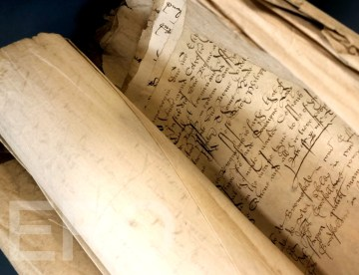
A short play

A short play created as part of our research in the Essex Witches Community Heritage Project supported by The Heritage Lottery Fund. The following story is based on the true story of Agnes Waterhouse from Hatfield Peverel who was accused of witchcraft.

Cast:
Four actors (Any gender)

1: The Assize courts were the foundation, along with the courts of quarter sessions, of the criminal court system in England and Wales up until 1971. Based in the main county towns in England and Wales, cases were only heard at the courts twice yearly, when judges from the higher courts in London visited and presided over cases.

2: Often known simply as ‘the assizes’, the courts originally dealt predominantly with property disputes, but their remit soon widened and became the home of the witchcraft trials. In Essex, these courts were held in Brentwood, Southend and Chelmsford.

3: I wanna’ tell them! This is my story, not yours.

2: But pa' said that I could.

4: It was the day of the Asizes at Chelmsford. Agnes Waterhouse was on trial.

3: Who said you could start?

4: You were taking too long!

2: The Chelmsford Asizes was an open sided building with eight oak columns supporting upper galleries and a tiled roof.

3: They were huge!

4: The galleries overlooked the piazza below.

3: The magistrates and justices sat in the open court which measured only 26 feet by 24 feet with the officers of the law, clerks, defendants -

2: Don't forget the witnesses

4: And the Jury.

3: It was a carnival atmosphere –

4: Ribs of beef and many a pie! Freshly made today.

2: Come and fetch your souvenir badge here. Made from the finest lead.

1: Mackerel, herring, lampreys, cod, eels – only a couple of shillings each.

3: Where did you come from?

4: You needed an extra voice for that one line!

3: Fleeces, sacks of wool and plenty at that!

2: Agnes was brought through the streets wearing shackles. She was wearing ragged clothes; dirty and tired. Her wrists were bruised and cut because the cuffs were too tight. She was trying to stop herself from crying out. She was terrified.

3: She was being pushed through the streets. We were throwing rotten vegetables and calling her names.

2: Witch!

3: Evil!

4: Dirty churl!

1: Naughty liar!

(Repeated 3 times)

4: The judge said that she was accused of the murdering her neighbour William Fynee by witchcraft. She would be executed if found guilty.

1: When questioned, she also admitted harming pigs, cows and geese in her village. Eventually after some questioning, she said she had murdered her own husband because they lived “somewhat unquietly” together.

3: Agnes also confessed to owning a demon spirit in the form of a pet cat called Satan, given to her by her sister Elizabeth and this cat had killed her husband and done all the harm of which Agnes stood accused.

ALL: Witch! Witch! Witch!

1: Elizabeth Fraunces and also Agnes’ daughter Joan were accused of witchcraft alongside her. Joan was just eighteen years old. She was accused of bewitching another teenager, the Waterhouse’s neighbour Agnes Browne.

3: That’s when Agnes Brown stepped forward. She said that she had sent a black dog to torment her. It brought her the key to the Browne family’s dairy and stole or damaged some of our butter. The dog tempted me to suicide by bringing her a knife.

2: And then what did this cat say to her?

3: That it was “his sweet dame’s knife” Agnes screamed at the cat to tell her who the dame was –

4: This was the best bit –

3: He wagged his head and said, Mother Waterhouse.

ALL: Witch! Witch! Witch!

1: She was executed on July 29th with the other felons convicted at the Assizes, hanged in front of the crowd gathered at the gallows in Chelmsford. The site of her death lies on the road leading towards Writtle.

3: And what happened to her daughter?

2: Joan was saved but only because her mother Agnes Waterhouse took the blame.

4: That was what the Asizes were like.

Kindly supported by:   

Brian D’Arcy: Magistrate, Sheriff and Witchfinder in Essex

D’Arcy was a magistrate, Sheriff of Essex, witch-hunter and contributor to the 1582 “A true and just recorde of the information, examination and confession of all the witches, taken at S Oses [St Osyth]”. “This argued for harsher punishments for those found guilty of witchcraft, and D’Arcy was personally responsible for a number of deaths of people accused of witchcraft.

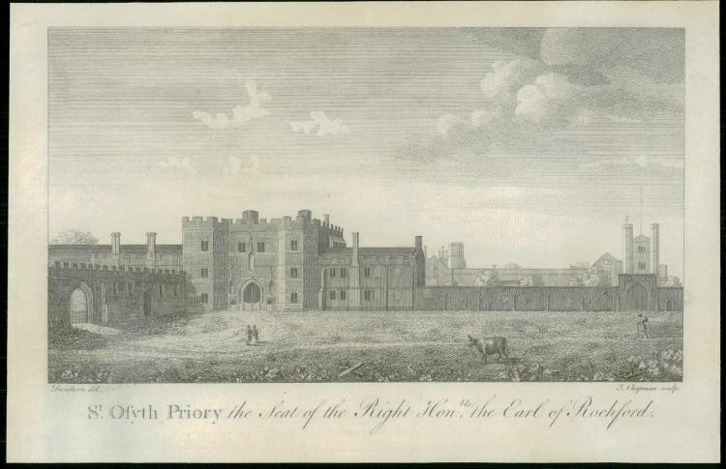
A little background information
If you live in the Maldon area, you will be very familiar with the D’Arcy name. It was this family that built the Moot Hall in the High Street in the fifteenth century. And why the village of Tolleshunt D’Arcy’s is so named – after the village’s estate that was in the hands of the D’Arcy family from the 15th century onwards. The family were a fabulously wealthy, powerful and influential family – not just in Essex, but in England too.

The D’Arcy family also became the owners of St Osyth’s Priory from 1553 and owned the Priory for the next hundred or so years. Brian D’Arcy was a lesser member of this great and powerful Essex family. He was born at Tiptree Priory sometime in the mid-sixteenth century.

By 1582, he was living in St Osyth’s Priory and “merely” the local JP/magistrate. Unfortunately for the local women of the village, he decided that he wanted to be as powerful as his famous D’Arcy relatives.

This he achieved with appalling results for the local population and by leading local witch hunts.

Witch hunts in Essex
The first witch hunt in Essex took place in St Osyth and was led by the D’Arcy family. The first person to be interrogated was the local midwife – Ursula Kemp. She immediately confessed to being a witch and confessed that she had caused the death of a baby.

This started a snowball effect with many women throughout St Osyth and nearby Great Clacton implicated in the alleged witchcraft activities. These activities had apparently taken place in the village and surrounding area.

By the end of Brian D’Arcy’s 1582 witch-hunt, at least 10 women – all from the village or the nearby area – were tried and executed in Chelmsford for murder by witchcraft. Many more were incarcerated in Colchester Castle (Essex’s county gaol) but released after being found not guilty during their trial.

It has been calculated that for the whole of the 1580s, the activities of Brian D’Arcy account for 13% of all trials for all crimes that took place in Essex that decade. That is a tremendously high number! St Osyth today is small. Back then, the population was tiny. Probably every single family or house in the village were under the shadow of this appalling witch-hunt.

After the witch trials were over, Brian D’Arcy got his wish to be all powerful. He became the Sheriff of Essex in 1585. On the back of his witch-hunting activities.

Many people have heard about Matthew Hopkins – the self-styled Witch-finder General. But few know about Brian D’Arcy. Essex’s (and England’s) first witchfinder. Who, for his own political ambitions, conducted England’s first ever witch-hunt – with devastating consequences for local St Osyth’s women.

Brian D’Arcy’s tactics in his investigations
In our research, we found that it could be argued that some of his tactics were found to be rather suspicious to say the least. Records of the investigation including interviews with those accused were tampered with where dates and times changed, questions and responses omitted and information missing. Although, it could be argued that these records have simply been lost over time. One of Brian’s personal tactics was that he would often question the children of those accused before questioning the accused. He would often mislead the children using traps to fool them into giving information and twist the meaning of their responses. The children would then be used against the parents. This was apparent in both the story of Ursley Kemp and then Cisley and Henry. In the later case, he deliberately played on heated and emotional moments within the family’s personal life for personal gain. Professor Marion Gibson highlighted that D’Arcy was particularly proud of his use of trick questions and his false promises of favourable treatment for those who confessed.

Magaret Simpson
During his investigation, D’Arcy would often call upon Maragret Simpson who so happened to be the wife of a local clergyman. (Who often did a lot of the accusing himself) Margaret’s role would be to strip search the accused looking for marks or imperfections which would indicate witchcraft. She would take specimens and notes, and the procedure was extremely traumatic for the accused. Her evidence was often used in trials.

D'Arcy’s investigations were used in detail in the publication of the pamphlet “A true and just recorde of the information, examination and confession of all the witches, taken at S Oses [St Osyth]” which was indeed written by an anonymous author “WW”. Interestingly, it was dedicated to Brian reading “To the right honourable and his singular good lord, he, lord D’Arcy WW wishes a prosperous continuous in their life to the glory of God and a daily preservation in gods fear to his endless joy.” Brian used this publication in his argument for there to be tougher and harsher punishments for those accused of witches. He believed them to be devil worshippers and wanted the punishment of hanging to be changed to burning.

Across today’s Maldon District, the legacy of the D’Arcy family is tremendous. The beautiful village bearing the family’s name. Maldon’s fabulous Moot Hall.

But less known is the legacy of Brian D’Arcy’s terrible witch-hunt of 1582.

Kindly supported by: 
Maragret Simpson
A creative writing piece inspired by the character “Maragret Simpson” from the Essex Witches Community Heritage Project

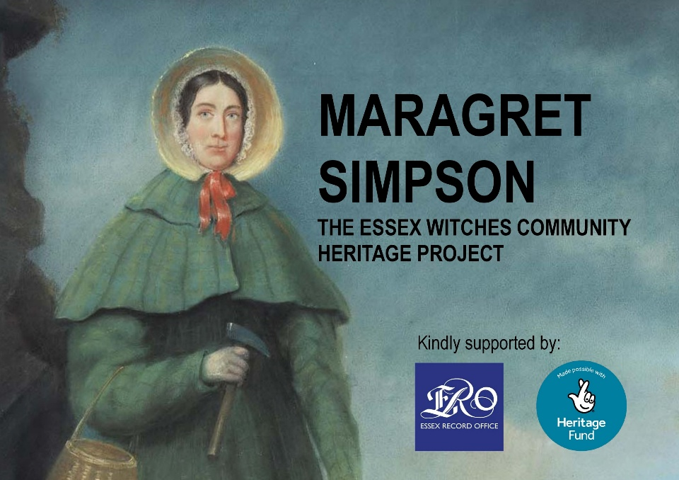

Maragret Simpson was a lady who worked with Brian Darcy, a local Magistrate living in St Osyth. During our research we found out that her role was to strip search those accused of witchcraft. Interestingly, we learnt from the Essex Records Marriage and Birth records that she was married to William Clarke who was one of the local clergymen and a key witness to at least one of the investigations into local people accused.

MARAGRET:

We’d strip search the ladies. They’d often try to put up a fight refusing at first, but I say to them. You have no choice in the matter. If the magistrate requests it, he gets it. They’d stand there as naked as the day she was born on the earth. Nothing was left covered. We three would then examine her from top to toe looking for any marks and strange imperfections. Hanging nails, moles, undeveloped features, body parts which were of unusual size or colour. Freckles, hairs, lines, bumps and bruises, limps and disabilities.

‘Hold still,’ I often would bark a few times. I had to do that, you see. An examination such as this requires attention to detail and some of the instruments used were sharp and rather intrusive. Can’t have us harming the accused, can we? Our hands would often be cold bare. We didn’t have gloves or masks back then. It was important not to speak much to them either. Get the job done quickly and thoroughly. No conversing with the accused.

We’d sometimes have to take specimens such as hairs, fingernails, bodily fluids as evidence. Quite often the women would breakdown and weep. That or cry out like wild animals. But we had a job to do. ‘No point in that crying.’ I’d have to say. ‘It’ll just make things harder and take twice as long.’

We weren’t allowed to take pity on them, you see. We had a job to do. A job to collect evidence, to protect the innocent. It was the Lords work, and we were acting as his hands ridding society of evil and devilish things. We were the women of credit.

Kindly supported by:

Matthew Hopkins
The self-proclaimed Witchfinder General

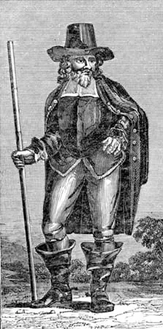
Self-styled Witchfinder General, Matthew Hopkins, and his associates were responsible for 20% of all witchcraft executions from the 15th to 18th centuries, despite only being in business for three years. He was active from 1644 to 1647 and used questionable methods to investigate suspected witches

His early life
Matthew was the fourth of six children and the son of James Hopkins, a Puritan clergyman in Wenham, Suffolk. Records are unclear on his date of birth, but it was sometime between 1619 and 1622. Little is known about Matthew before 1644 as no contemporary records for him have survived. We do know that he could read and write Latin and English, and that he studied marine law in Belgium and Holland. Some reports suggest Hopkins was a lawyer, but there is no surviving evidence for this either. It’s more likely that he was a solicitor’s clerk.

In the early 1640s Matthew Hopkins moved to Manningtree. He is linked to the Thorn Inn at Mistley, but it’s unclear whether this was as owner, co-owner or patron. Manningtree, meaning ‘many trees’, was a small parish of some twenty-two acres at the time.

The Witch hunts
In his Discovery of Witches, published 1647, Hopkins says his ability to find a witch came from his wealth of experience. Conveniently, he doesn’t really give any specifics of that experience, other than a couple of occasions where he supposedly eavesdropped on witch meetings:

“In March 1644, he had some seven or eight of that horrible sect of Witches living in the Towne where he lived, a Towne in Essex called Manningtree, with diverse other adjacent Witches of other towns, who every six weeks in the night (being always on the Friday night) had their meeting close to his house, and had their solemn sacrifices there offered to the Devil, one of whom this Discoverer heard speaking to her imps and bid them go to another Witch, who was thereupon apprehended”.

We do know that Hopkins was influenced by King James I’s ‘Demonologie’ (1597), Thomas Potts’ ‘The Wonderful Discovery of Witches In the County of Lancaster’ (1613) and Richard Bernard’s ‘A Guide To Grand Jurymen’ (1627, 1629). In fact, it’s probable that these texts formed the majority of his knowledge and experience.

Creating a perfect storm
It is difficult to see how one person could drum up such a ‘witch frenzy’. However, Matthew Hopkins was not your ordinary person; he had some education, had funds and connections, and came from a well-known, well-liked family. The political situation at the time also contributed.

From 1642 to 1651 the English Civil War raged. Essex was a backbone area for the Roundheads (in support of Parliamentarians). Hopkins was able to use the resulting tension, fear and uncertainty to his advantage - it’s much easier to scaremonger when the crowd is already unsettled. There’s also documentation stating the Hopkins used his links to the Thorn Inn for striking up conversations and sharing information – it was a prime space for gaining supporters.

Hopkins’ Associates
Matthew Hopkins may be the most infamous person from the Witch Hunts, but he didn’t work alone. Hopkins employed John Stearne, a rabid puritan, and Mary Phillips, a midwife, both from Manningtree, as searchers. They were paid one pound a day (roughly £117 today) for their troubles.

Methods
Hopkins methods for investigating those accused were pretty questionable to say the least. They included keeping the suspect awake for days on end, resulting in the suspect, now suffering from sleep deprivation, being coerced into confessing to almost anything. Another method was cutting the arm of the accused with a knife, needle or pin, and if she did not bleed, she was said to be a witch.

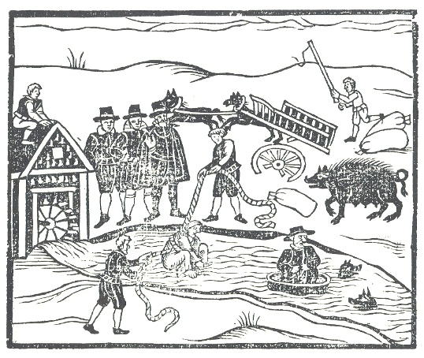
Matthew Hopkins and his team usually followed the same steps of prosecution in each case. First, they would use local rumour or suspicion to condemn a witch. Hopkins also claimed to have a “Devils List”, naming all English witches in code. Once condemned the person was tortured until they confessed, usually implicating several others as part of the confession. His reputation, together with the biased view of the majority that the accused was guilty, resulted in a very high conviction rate.

Hopkins’ favourite confessional method of torture however was the infamous “swimming test”. This unbelievably simple but effective test involved binding the arms and legs of the accused to a chair before throwing them into the village pond. If they sank and drowned, they would be innocent and received into heaven; if they floated, they would be tried as a witch.

Payment
Of course, all of this came at a very ‘reasonable’ price, said to be “twenty shillings a town”, although the records reveal that the small market town of Stowmarket paid £23 for his services. A true entrepreneur, Hopkins appears to have quickly turned his mission into a well-paid career, so much so that local taxes were even being levied in order to fund his obsession.

In general, Hopkins charged the local parish £1 (roughly £117 today) for every witch found. It is thought that he collected around £1000 in fees during the two or three years he operated. That’s about £117,546 today! Many modern works strongly suggest that pay, rather than ridding the country of witches, was a motive for Hopkins. There’s no doubt that Hopkins had a hatred for witchcraft and sought to rid it from the area, but even sources at the time suggested he had little to no evidence for some of those he charged.

Death
Hopkins even wrote a short pamphlet detailing his witch-hunting methods: ‘The Discovery of Witches’, which was published in 1647. His own end, however, is far from clear; some accounts say he drowned undergoing his own “swimming trial” after being accused of witchcraft himself.

However, he was last seen in the spring of 1647; his former sidekick John Stearne is reported to have announced, “I am certain he died peacefully in Manningtree after a long sickness of Consumption” [tuberculosis]. There is a record of Hopkins’ burial in the Mistley parish register, showing he was buried a few hours after his death at St Mary the Virgin Church in Mistley. Contrary to some portrayals in movies, he was in his mid-twenties when he died.

According to local legend his ghost haunts the area near Mistley Pond, especially on Friday nights close to witch sabbats.

Kindly supported by:

My name
A monologue created as part of our research in the Essex Witches Community Heritage Project supported by The Heritage Lottery Fund. The following piece is based on Matthew Hopkins who was known as the self-proclaimed Witchfinder General.

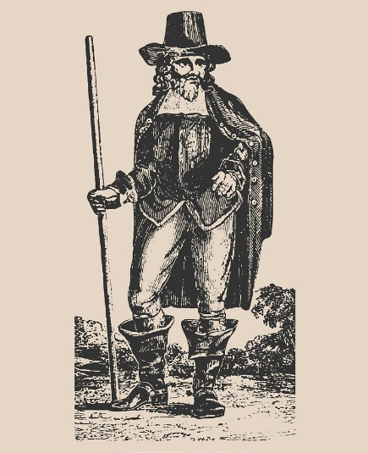
I am the Witchfinder General.

Strong men will bow when they see it!
As they'll have good reason to fear it.

Large crowds will rise when they hear it!
For they will come to respect it.

And Everybody will know
My name.

Witchcraft has become an evil plague upon our fruitful society. Each witch must be hunted and plucked out and erased from existence. It is my role to cleanse villages, towns and cities and rid all evil from our land.

A witch is a cunning and evil being that will disguise itself within society pretending to be a friend, a neighbour or even a member of one's family. Often impersonating an elderly, vulnerable woman. Yet, hidden behind that fake visage is an evil, wicked creature plotting and sucking out the good. They will cause pain. Crops will fail. Disease and illness will fester. Death will be caused. Yet, no morals or remorse will be shown. They will be close to earthly creatures such as cats, rodents which will be processed by Satan himself. And summon spirits and dark magic beyond all belief.

Yet, there is hope. I will be the hand of God for I have mastered my methods to outwit the evil that is within us and make our country pure and safe once again.

A witch can be identified using a combination of physical examinations and psychological tactics. Sleep deprivation, physical examinations where one can prick the skin of the accused for ‘Devilish marks’ where the familiars would feed on their blood. We use a blunt or retractable blade to create the illusion that certain areas of the skin are insensitive and thus exposing the witches true identity.

Another very simple test that can determine whether a woman is a witch or not is called the swimming test. A true witch rejects all Christian ceremony and ritual. Especially the ritual of baptism. The ritual of baptism involves water. Water will react in the presence of a true witch. To establish that a woman is a witch my assistant and I will tie her hands and feet together and lower her into a river, lake or a stream. If she is a witch, the water will reject her, and she will float. If that is the case, she will be handed over to the
magistrates put on trial and in all likelihood hang. If she is not a witch the water will accept her, and she will sink. In this instance we will do our best to retrieve her from the water before she drowns. We are not always successful but if an innocent woman dies in the course of an investigation, it will be of little consequence as she has gone to a better place where there is no suffering.

It is my role to rid all evil from our society. I call upon you all to stand behind me and make our country pure and safe once again. I will go down in history as the greatest, strongest and most feared witchfinder in all time.

I am the Witchfinder General.

Strong men will bow when they see it!
As they'll have good reason to fear it.

Large crowds will rise when they hear it!
For they will come to respect it.

And Everybody will know
My name.

Matthew Hopkins!

Kindly supported by:

About Marion Gibson
Author and historical consultant oN witchcraft and magic

We’re incredibly grateful for the support which Professor Marion Gobson has given to our project and for allowing us to use the stories and research in her book “The Witches of St Osyth”. Here is a little bit about her work.

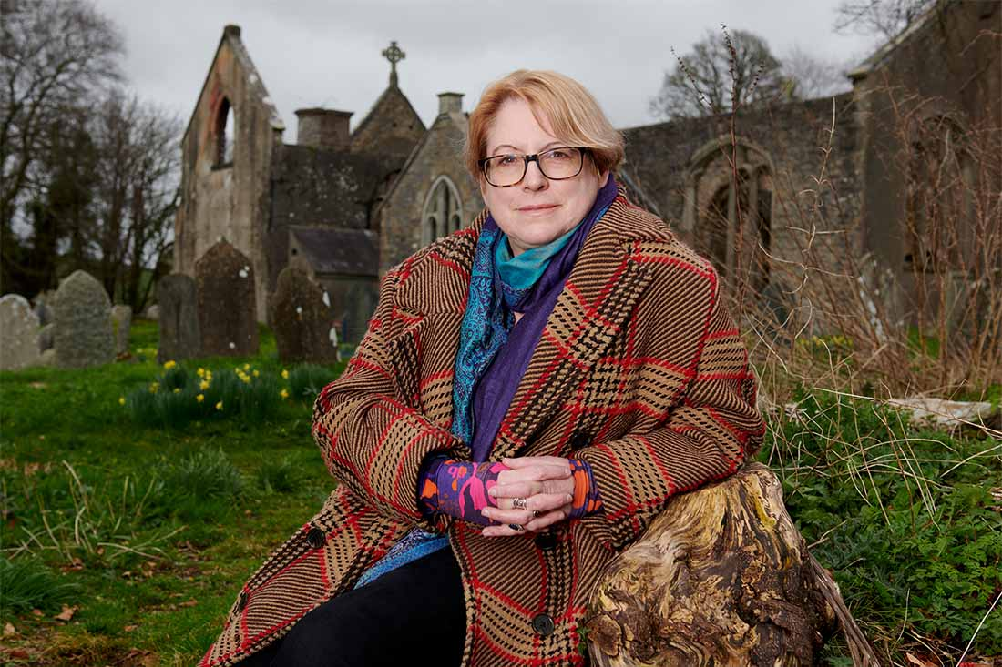
I’m a historian of witchcraft and magic. In particular, I write books about ancient and modern witches and witch-trials in Britain, Europe, America and Africa. My books tell the stories of people accused of witchcraft, their fascinating worlds – both every day and magical – and the people who feared and persecuted them.

Professor of Renaissance and Magical Literatures, Fellow of the Royal Historical Society, Director of the Flexible Combined Honours degree programme. her research is about witch trials in history from the Middle Ages to the present. Marion Gibson writes about witches and magic in history. She’s been interested in witches for over thirty years, since she read the words of women accused of witchcraft in Elizabethan England. Why were they accused of crimes they didn’t commit? And why did they confess?

Marion’s books tell the stories of these women and the men accused alongside them, and she explores the wider history of witch trials, folklore, magical and pagan beliefs and things that go bump in the night. She’s a professor and teaches at Exeter University in southwest England where her students read everything from medieval witch-hunting manuals to Gothic novels, and trial records to Harry Potter.

Marion’s book Witchcraft tells the stories of thirteen important witch trials around the world from the fifteenth century to the present day. She’s seldom happier than when she’s peering at worm-eaten parchments, wandering around old towns with her partner and dog, and imagining herself and her readers back into the past. She also has a three-legged cat, but it’s not a familiar.

Recent books: Witchcraft: A History in 13 Trials (Simon and Schuster/Scribner, 2023/2024) and The Witches of St Osyth (Cambridge University Press, 2022).

Marion is also the author of Rediscovering Renaissance Witchcraft (Routledge, 2017), Witchcraft: The Basics (Routledge, 2018), Imagining the Pagan Past: Gods and Goddesses in Literature and History since the Dark Ages. (London and New York: Routledge, 2013), Witchcraft Myths in American Culture (New York: Routledge, 2007). Possession, Puritanism and Print: Darrell, Harsnett, Shakespeare and the Elizabethan Exorcism Controversy (London: Pickering and Chatto, 2006), Reading Witchcraft: Stories of Early English Witches (London and New York: Routledge, 1999), with Garry Tregidga and Shelley Trower.

Kindly supported by:   

Ursley Kempe
The first witch of St Osyth
This short play was created as part of our Essex Witches Community Heritage Project based on our research conducted and inspired by the stories produced in the book “Witches of St Osyth” by Professor Marion Gibson. The project was supported by the Heritage Lottery Fund.

CAST:
Ursley
Grace
Annis / Thomas
John/ Brian
Storyteller

1.Young Davy

GRACE: The palms of his hands have turned backwards!

STORYTELLER: The distraught cry from Davy Thurlowe's mother echoed throughout the house as her baby son lay helpless.

GRACE: Please send for Ursley.

STORYTELLER: Grace and John Thurlowe were not well-off people, so they had to make do in these times by calling upon Ursley Kempe. She has been practicing as a healer or what was known as a 'cunning body' for about a decade.

JOHN: You know how much I dislike that woman and her herbs and magical rituals.

GRACE: This must be some kind of bewitching. I swear.

STORYTELLER: When Ursley arrived, she went to the boy’s bedside and softly uttered...

URSLEY: Ah, good child. How art thou loden.

STORYTELLER: She then left the room and went outside before returning and repeating the same line.

URSLEY: Ah, good child. How art thou loden.

STORYTELLER: She did this three times. Maybe to acknowledge the heavy load of the illness on Davy's body and attempting to transfer it to herself.

URSLEY: Ah, good child. How art thou loden. (Beat) It is a classic treatment for bewitchment where I can cast the spell away from the house.

STORYTELLER: The treatment seemed to work as the boy slept easy throughout the night. The next day, Grace bumped into Ursley in the street -

GRACE: He slept the whole night. He seems to be more at peace. God be thanked!

URSLEY: Aye, aye. Maybe it be God. Or maybe not. I warrant thee it, shall do well.

2. A keeper

STORYTELLER: Now, it is important to remember that Ursley too was not a very well-off lady either. Indeed, what happened next indicates that she was thinking ahead to other medical services she could perform for the Thurlowe family. Grace was about six months pregnant with her next child, and she was beginning to suffer from lameness as well. In those times, more rich families would take in keepers who would support the perspective mothers with their duties as well as caring for them, praying with them, being their midwives and then supporting the mothers after they have given birth.

JOHN: We simply don’t have the funds to afford a team, but we could employ one person to help take the strain from your bad legs and to do duties, assist you at the birth and do the things which you ladies do etcetera etcetera.

STORYTELLER: But something stopped her in asking Ursley. Maybe something happened to put her off. Many people were wary of her ability to do magic as it was seen as a dangerous gift. Would you want someone like that hanging about? Obviously, Ursley was rather disappointed when she found out that Grace had employed someone else.

GRACE: We were grateful for what you did. We just wanted someone a little more – a little less –

JOHN: People talk. We have our own employers to consider. The relationship between cunning magic and the Christan Trust is rather – well, confusing, shall we say.

STORYTELLER: There was also the fact that Ursley had a ‘base’ or ‘bastard’ child, born out of wedlock.

GRACE: It simply would not do. We cannot condone it.

STORYTELLER: The child was called Thomas Rabbet and was seven years old. They lived alone. His father was not around and with Ursley was known as Ursley Gray as well as Ursley Kempe, so she obviously had more than one partner in her life.

GRACE: I’m not one to gossip, but before her sister-in-law had died, folk say that Ursley and her had a physical fight in Eliot’s heath north of St Osyth. It was near to Clay Street I believe. Apparently, her sister-in-law had attacked Ursley most violently; lifting up her skirt in broad daylight, beaten her about the hips and calling her names such as witch and whore. It was most undignified. If the rumours were true about her, I couldn’t be associated with a person like that.

STORYTELLER: The decision came to a crisis when Ursley found out and was hurt by the judgment storming into the Thurlowe’s home and Grace’s bedroom -

URSLEY: I was soon good enough when you were begging for m’ help when your Davy was lying on his death bed.

GRACE: You have a reputation.

URSLEY: What gives you the right to judge when you don’t know nothing about me other than from that from Chinese whispers.

GRACE: You have no right to storm in here uninvited scaring me half to death.

URSLEY: And why should you be scared of me?

GRACE: Because of your magic and –

URSLEY: I came here to speak to you from one mother to another. Cos’ like you, I have a mouth to feed.

GRACE: If I should continue lame as I had done before then I will find the means to know how it came, and I will creep upon my knees to complain of them to have justice done upon them.

URSLEY: (Laughing) Go on then… complain to the magistrate. If you complain about someone causing lameness it’ll be a good turn for me. So, go ahead!

GRACE: (Threatening) Take heed. Ursley, thou a naughty name.

STORYTELLER: The word ‘naughty’ was a lot worse than it is regarded today. Being naughty was thoroughly wicked, without goodness. In her rage, Grace had accused her of witchcraft and Ursley could not have misunderstood.

URSLEY: (Taken back) How could you say such a thing. Though I could unwitch, I cannot witch, and I would not do harm on you or anyone. (Beat) Let me kindly make you an offer. Send your new keeper away and I will show you a most valuable magic trick.

STORYTELLER: There was a long silence between the two women. But after the moment had passed, Grace declined the offer and Ursley was sent away.

3. Baby Joan

STORYTELLER: Grace and John’s daughter, Joan was born in early summer 1581, and soon after her birth, Grace said that Ursley fell out with her again.

GRACE: She felt that she should have been offered the role of looking after Joan whilst I was at work in Lord Darcy’s place. I didn’t trust her.

STORYTELLER: Tragedy struck a few months after her birth when Joab fell out od her cradle and injured herself badly. She died three days after the fall. How could such a tragic death have occurred? Was the baby the victim of an assault? Or was her fall an accident – a cradle overturning on an uneven floor. Grace never explained.

URSLEY: It maketh no matter. For she might have suffered me to have the keeping and nursing of it.

JOHN: Such evil.

STORYTELLER: This verbal shrug seemed to the grieving mother to be a sign of great evil. Yet, she did not immediately approach the magistrate to accuse Ursley of killing Joan. Yes, that is where this story is going. It took Grace until the next February to make a formal accusation against Ursley.

JOHN: It was because she dared come to our door. Uninvited. Unsent for.

GRACE: She offered her services for just twelve pence. I agreed. But I was only playing along with her. I never intended to –

STORYTELLER: For five weeks, Grace was well again under Ursley’s care. Her lameness disappeared. It only confirmed what Grace had suspected all along. That Ursley was indeed, a witch.

URSLEY: I’ve come to ask for my money which I’m owed.

GRACE: I can’t pay you. I’m a poor and needy woman. I have no money.

JOHN: Surprisingly, Ursley accepted the excuse.

STORYTELLER: The villagers in St Osyth all knew of poverty too well and had realistic expectations. Instead, she asked Grace for a reward instead –

URSLEY: May I have some cheese instead?

GRACE: I have none.

URSLEY: You’re playing tricks with me! I trusted you again and you’ve lied again. Mark my words, I will be even with you.

STORYTELLER: Almost immediately, Grace’s lameness returned. This time it spread.

JOHN: Some days she couldn’t even get out of bed.

STORYTELLER: Davy’s sickness came back too.

GRACE: And that’s when I did it. I went to the magistrate and complained about Ursley.

STORYTELLER: Now before we continue with the story, it should be pointed out that by spealing to the Magistrate, Grace was taking a big risk What if they didn’t believe her? Or what if she started something which she couldn’t finish? There were also other factors to consider. If at times, she was unable to get out of bed, Grace would not have been able to go to work at Lord D’Arcy’s house. That must have needed explaining and employers back then were not very patient. Her lameness could have been due to arthritis. We do not know what her husband did for a living, but her income was certainly threatened by her ill health. So, it could be argued that her accusations of witchcraft were started as a way of trying to provide an accuse of her absence. Even her final statements show her eagerness to pin Ursley’s actions down to specific dates and times. It is likely that Grave worked in the kitchen at the Lord D’Arcy’s house and may have been discussing her concerns for several months before speaking to the Magistrate. She may have spoken to the Cook or the other servants too. All of which would have supported her. Although Thomas, third Baron D’Arcy was not yet ready to take over the responsibility since his father’s passing and so there was no immediate formal support. So, in came Thomas’ older cousin Brian Darcy.

4. Brian Darcy

GRACE: Brian D’Arcy was an active Justice and was a Magistrate himself looking for a mission. Something to make him known. He frequently visited St Osyth Priory, and he had a home of his own in the village. He was a man of business and had a clear head to seek out opportunity. He was also a man of the world and could easily talk the talk to persuade people to believe in his intentions.

BRIAN: You mark my words, Grace. I intend to make it my mission to get to the root of this complaint and rid this village of evil. I shall question all the witnesses in turn.

STORYTELLER: Indeed, he did question them all. With an unusual zeal.

BRIAN: It appears that you are not the only person to have considered complaining about Ursley.

ANNIS: She’s a heartless, naughty sort. The most evil being if I ever did see one! My name is Annis Letherdall. I had a falling out with that Ursley Kempe. I should have known that she was not a good person the moment I clapped eyes on her. I had that feeling, you see. You know the sort. When you go cold inside and you know something is strange about them. It was after we’d had a quarrel that it happened. My daughter, Elizabeth became sick. It was witchcraft, I swear it. And it was that Ursley which cast the spell. I’d bet my life on it. Ursley had sent her son Thomas over to our house to ask if we could spare some scouring sand. The sand was usually ground from sandstone and was used generally for scrubbing and cleaning. In return, she’d offered to dye some clothing for me. I must admit, I was rather rude. I had no interest in bartering with Ursley. She gave me that quibble inside my stomach. I said to my Richard – that woman ain’t right and she’s got a bad reputation. A naughtie beast, she is. A naughtie, naughtie beast!

I didn’t send her and sand. But I did send my Elizabeth out to give some sand to one of my other neighbours who needed some. It wasn’t my fault that Ursley saw her do it. I knew that it was witchcraft the moment Elizabeth said that Ursley had murmured something as she passed her. It was a spell, I swear. She fell ill almost instantly. Swelling around her belly and bottom. It continued all through the winter months. I confronted Ursley about it. I wasn’t the only one in the village to think it either. I found her by the spinning wheel in her house with another woman chatting all pleasant, they were. I told her like. I told her “that I had been forth with a cunning body which had told me that Ursley had bewitched my child.” She had the cheek to deny it and then accused me of lying about seeing another cunning body. But I know the truth, I know what she is.

STORYTELLER: Annis was so sure that Ursley had reacted suspiciously that she even asked the woman who had been sitting by the spinning wheel the whole time to be a witness to the conversation. Although Annis has originally lied about seeking out a cunning body; the very next day she went to see Mother Radcliffe, who ministered to the child with her skill. Although Mother Radcliffe was pessimistic about being able to help her daughter doubting that it would do any good. Sadly, by the time that Ursley was put on trial, Elizabeth had sadly died. But had she fallen victim of witchcraft, we don’t know.

ANNIS: Don’t stop there! There’s more! Whilst I was taking Elizabeth to Mother Radcliffe’s home we passed Ursley’s cottage. Each time we did, my Elizabth would cry out and point at Ursley’s window as if it was her who had bewitched her.

BRIAN: I took note of everything she told me.

STORYTELLER: Upon pausing the story for reflection, one must point out that Mother Radcliffe, who’s Christian name we don’t know, was also a mysterious figure. She may have or not have implicated Ursley Kempe herself but her skill and authority certainly empowered Annis to make her accusations. Mother Radcliffe also used herbal remedies and likely even used magic too. By the end of February, Brian had an earful of suspicious stories about Ursley from both Grace and Annis. So, the next day he sent for Ursley himself and to put the accusations to her.

BRIAN: It was my duty as a Magistrate on receipt of an information about a crime to interrogate the suspect and record their statement as an examination. As you can imagine, the prospect of questioning a witch immediately caught my attention.

5. Arrested

URSLEY: I was arrested and brought to that Magistrate Mister by the old constable. I don’t mind admitting; it frightened me to the bone. I knew he disapproved of me. I was marched out of my home in front of my boy. All the neighbours were out watching me being taken up the long lane to St Clares Hall. We arrived at Mr D’Arcy’s home where I was put inside this room and told to wait. I peered around the room. I ain’t ever seen anything like it. Proper grand with big rooms and tall ceilings and windows, Lots of paintings and candles and books. They came in and questioned me over and over again for hours. The Magistrate was there and a secretary, a clerk assistant with a funny moustache. There were a few other men that just sat there staring at me and snarling and grunting.

STORYTELLER: The actual names of those present is missing from the evidence.

URSLEY: I kept stumbling over what I needed to say, and he kept asking the same questions like he didn’t believe me.

STORYTELLER: No one recorded the questions asked.

BRIAN: No one would question the honour or a Magistrate or truth-status of the record.

STORYTELLER: Nor do we know what responses Ursley gave to the questions.

BRIAN: They were scribed by the clerk standing between her and us.

STORYTELLER: He may or may not have recorded what she said correctly, fairly and fully. Ursley’s story was complex and could easily be misunderstood. This lady was in trouble with the law, and it is always easy for law-enforcers to think that this is probably deserved. The clerks may have had previous dealings or knowledge of Ursley and aware of her having a naughty name and an illegitimate child. Finally, their opinion would have been affected by the pre-existing views. Anything Ursley said would have been heard through a background noise.

URSLEY: They thought I was guilty even before they started questioning me. They wanted to me tell them about my healing skills.

BRIAN: What did you mean when you told Grace that you can unwitch people but cannot bewitch them?

URSLEY: I tried telling him the secret of my spell against lameness.

BRIAN: Is this the secret you’d promised to tell Grace?

URSLEY: I tool had begun to be troubled by a lameness in my bones. I too had sought help from a cunning person as I could not afford a physician. It was a consultant from Weeley. The cunning person was referred to as Cocks wife.

BRIAN: And where is this woman now?

URSLEY: She’s dead now, I believe, sir.

BRIAN: Ah, really?

URSLEY: The Cock’s wife diagnosed the problem as bewitchment, and her prescription was a magic one. She told me to gather up some hogs dung. After that I was to pick some leaves pf chervil, mix them with the dung and hold this so-called ‘medicine’ in my left hand.

BRIAN: Left hand?

URSLEY: That’s right. I was to take out a knife with my right hand and prick the herby dung ball three times and then throw it into the fire. After that, I was to use the same knife to make three stabs at the underside of a table, and the knife should be left stuck in the wood,

BRIAN: And that’s it?

URSLEY: Not quite. Finally, I was to gather three leaves of sage and three of St John’s wort, put them into ale and drink it first thing in the morning and last thing at night.

BRIAN: And I suppose that cured you.

URSLEY: It did, sir.

BRIAN: You do realise that those exact same ingredients were found upon a suspected witch called Cecily Arnold at Barking.

URSLEY: I did not know that.

BRIAN: Is that right?

URSLEY: I was trying to use what I’d learnt to help others, sir. I’ve helped Gray’s wife and Page’s wife to heal them from bewitchment the same as me.

BRIAN: And you knew that bewitchment was the cause?

URSLEY: Oh, most certainly, sir.

BRIAN: And Grace?

URSLEY: I helped her too.

STORYTELLER: Sadly, some of Ursley’s neighbours were moving to take their opinion upon her.

BRIAN: A maleficent witch! A most cunning witch! Deadly! Dangerous! Naughty! No one is talking of how you saved them.

URSLEY: I’m a healer, sir.

BRIAN: You’re a witch. Admit it. Confess!

6. Brian’s strategy

GRACE: One must begin with light and humorous matters… without a court clerk, and conceal one’s desire to know all about it… inquire whether their father and mother practiced this craft… it is also necessary in order to get to the truth from those who are accused or suspected, that judges appear to have pity on them, and tell them it is not they, but the Devil who forced and compelled them to cause people’s death. So, for this reason they are innocent… one must of necessity admit that it is a vicious praiseworthy and necessary thing to lie in order to save an innocent person’s life… so must one do in justice in order to get the truth about hidden wickedness.

STORYTELLER: In other terms, Brian believed that he was allowed to use misdirection to outright falsehood so that the suspect is lulled into an illusion that they could trust him and tell him anything. This was a big turning point in the questioning of Ursley.

URSLEY: He promised that if I was to speak plainly and confess the truth then it would work in my favour. That I wouldn’t get into trouble. I thought that he was nice. I thought he cared. He gave me drinks, food and he seemed to listen. I even broke down and sobbed in front of him and he offered comfort. I told him that I had four spirits. Two of these are male and killed people. Two were female and could hurt people, especially cause lameness and kill cattle.

BRIAN: And what are the names of these spirits?

URSLEY: Tyttey, a grey tomcat, Jacke, a black tomcat, Pigin, a black toad and Tyffin, a white lamb.

BRIAN: Cats? A toad! Indeed!

URSLEY: I knew that I’d said too much. I looked straight at him. He was like a hunter that had trapped his meal. (Beat) I’m not a witch.

6. Thomas

STORYTELLER: Another strategy which Brian D’Arcy would come to frequently use was to use the accused children against them. In many cases, he did so even before he questioned the accused and then redated the evidence. In this case, he questioned Ursley’s son, Thomas Rabbet. Thomas was still a young boy. Only eight years old in fact and was probably not completely aware of the implications of his answers. He told of his mother’s spirits and named them and described their shapes.

URSLEY: You questioned my son?!

THOMAS: My mother has four several spirits. She gives them beer to drink and … and a white loaf or a sometimes a cake to eat. At night, sometimes the spirits will come and suckle on blood on her arms. She has a friend called Ales Newman who also has the same spirits.

BRIAN: Your son told us everything. So, tell me, which spirits did you send to attack Grace Thurlowe and her family and Annis Letherdall’s daughter Elizabeth?

STORYTELLER: There was a long silence as Ursley looked down to the floor broken and exhausted after hours of questioning and betrayal.

BRIAN: Speak plainly and confess the truth then it would work in my favour.

URSLEY: Tyttey went to punish Grace. Pigin to Elizabeth.

7. Guilt or contradiction?

STORYTELLER: Ursley had started accepting her questioners’ premise that she was a wicked witch and thus confessing what Brian wanted to hear. She continued to go into more and more detail.

BRIAN: Without any asking of her own free will.

URSLEY: I am responsible for the death of my brothers wife after our argument on Eliots Heath. I sent the spirit of Jacke to kill her. I sent Tyffin the spirit unto Grace’s child which laid in her cradle. I did it all.

GRACE: You killed my baby.

BRIAN: Guilty.

STORYTELLER: It was the confession which Brian Darcy wanted. However, in all the excitement no one spotted the contradiction which was made. Earlier in her questioning, Ursley had said that the she-spirit Tyffin was not able to kill… was it a minor slip or a contradiction?

(Beat)

Brian Darcy went about his business. Probably feasted upon a hearty supper surrounded by his family and servants. Ursley stewed alone in fear imprisoned in a village lock-up.

(Beat)

After his meal, Brian recalled Ursley and the witnesses that he had assembled to hear him go over the evidence which he had collected.

GRACE: I was there.

ANNIS: I was there too.

STORYTELLER: Ursley wept and knelt pleading for forgiveness. However, whilst Brian had been eating, Ursley had introduced a dramatic new refinement to her story. Instead of confirming that she herself had sent the spirits to harm her neighbours’ children, she instead said that she had caused Newman’s wife to send a spirit to both families. A clever trick it may have been. Ales Newman was her friend, neighbour and had featured in her son’s evidence. Frustrated and rather confused, Brian closed the meeting. Ursley was returned to the lock-up.

BRIAN: The next day, Ursley requested to see me once more. She spilled out a series of more accusations against her friend Ales Newman. She was arrested and I questioned her at once. But she was a far more difficult suspect to break. She refused to confess. But I used trickery to overpower her resistance. I judged her character well and set up a trap to fall into. Then seizing the opportunity and pushed her to confess her crimes.

GRACE: Both Ursley and Ales were imprisoned in the village until their trial.

STORYTELLER: Ursley remained adamant until her death that she was innocent.

URSLEY: I am not a witch.
I am not a witch.
I am not a witch.

Kindly supported by:

Cisley and Henry
A play by Alfie James for the Essex Witches Community Heritage Project. This short play is inspired by the true story of Cisley and Henry from Clacton, Essex who were accused of witchcraft.

CAST:
Storyteller
Richard Roses
Cisley
Henry
Henry Junior
Maragret Simpson
Brian Darcy
Alice Roses
Villager 1
Villager 2
Villager 3
Villager 4

ALL: (Chanting)
Ring-a-ring-o-roses
A pocket full of posies
Achoo! Achoo!
We all fall down!

The Queen has sent her daughter
To fetch a pail of water
Achoo! Achoo!
We all fall down!

The bird upon the steeple
Sits high above the people
Achoo! Achoo!
We all fall down!

The cows are in the meadow
Lying fast asleep
Achoo! Achoo!
We all jump up again!

STORYTELLER: The year was 1570. Life was hard for those living in Clacton. The land was often waterlogged; transport was difficult ad costly. Farmers working the land were particularly poorer than most especially their neighbours in St Osyth. An Epidemic swept through the Clacton’s caused by a single disease had brought further depression. By September that year, the death rate had increased by four times. The epidemic hit Clacton hard: women, husbands, children, labourers. Families were losing multiple members. Some people believed that there was a connection between the wave of bad luck and the witchcraft accusations locally. Understandably, there was an increase in anxiety and fear.

VILLAGER 1: Witches

VILLAGER 2: Witchcraft

VILLAGER 3: Evil spirits

VILLAGER 4: The devil himself.

(Repeat 4 x growing in speed and volume)

STORYTELLER: It was of no surprise that the local people invited Brian Darcy to conduct an investigation.

BRIAN DARCY: Intriguing. A very serious matter indeed. Immediately, I suspected witchcraft.

MARGRET SIMPSON: And I accompanied him. I’m an expert at strip-searching those accused and examining their bodies for marks and moles which are common for witches. I conduct a thorough and detailed search including taking note of any suspicious smells and skin textures and abnormal body features and fluids. The evidence which I provide is a crucial part of the investigations and my summaries are always used in the evidence in witchcraft trials.

STORYTELLER: There was an air of expectation as Brian and his partner trotted across the little Clacton green. Springtime was coming and you could hear the wrens and Robin's singing. Once they crossed the Pickers Ditch stream they were met by the witch accuser Richard Rose.

RICHARD: I swear it on my dear mothers grave. I know it’s not mighty Christian of one to say such things against my own neighbours, but times are hard, and I cannot standby and not speak out, like.

BRIAN: It's alright. You're among trusted friends now. Speak freely.

RICHARD: Six years ago, I’d was working the fields with my neighbour Henry. He was using one of my plough forcing the heavy blade around the field with my horses, like. I thought nothing of it. We'd completed two or three circuits of the strip of land i owned. That's when it all started.

MARGARET: What started?

RICHARD: All of a sudden two of my horses fell down in a most strange way and just died there and then.

MARGARET: Two of them at the same time?

RICHARD: One minute they were working fine. Next, they were lying their legs u in the air still as the night. Like the devil had sucked the life out of them that very instant.

BRIAN: And what did you do?

RICHARD: Well, I was shocked obviously. But I did not say anything at first. But then I started to recall like.

MARGARET: As you do -

RICHARD: A little before we'd had a small disagreement over the price of the malt. I refused to sell to Cisley two bushels at the rare she wanted to pay for them

BRIAN: Cisley?

RICHARD: Henry's wife. But she went to my wife behind my back hoping to strike a better bargain. She asked her if she could buy a bushel and a half which she could only afford. She tried to haggle the price. But my wife Alice, well she refused to compromise.

BRIAN: And so she lost her temper?

RICHARD: That she did, sir. She did.

BRIAN: I knew it!

RICHARD: So, she left without buying anything. Then one day their cattle trespassed onto our land and Alice had to drive them out. Cisley once again got angry with her and attacked my wife verbally again.

CISLEY: You leave our cattle alone. You have no business touching them!

ALICE: They were straying on my field

CISLEY: They were not! Tae another stick to my cattle again and you'll regret it

MARGARET: A deadly threat if I have ever heard one!

RICHARD: Not long afterwards some of our own cattle did die a strange and peculiar way.

BRIAN: A pattern of witchery emerging indeed.

RICHARD: Wait! There’s more, I say. About twelve months ago one of our barns caught fire. It was quite some way from our dwelling house. So, I didn’t see how it started, but it was full of corn. One hundred marks, we lost that night.

BRIAN: And did you blame your neighbours at the time of the trial?

RICHARD: I didn’t feel that I could, sir. You see I didn’t have any evidence. Apart from – well –

BRIAN: Yes?

MARAGRET: Yes?

RICHARD: I had heard their youngest son John speak of our corn of being rather favourably about the fire burning all of our corn. He said that we deserved it because our corn was always overpriced.

BRIAN: And who was he speaking to?

RICHARD: That I don’t know. But it was wrong. We’re honest hardworking people!

STORYTELLER: Interestingly, Richard did not mention one other vital piece of evidence. Why we do not know. As well as the supposed attacks on their farm, Richards maid Ales Baxter has been strangely taken ill. It took almost a month of this new piece of evidence to come to light. Before then, who did Brian Darcy insist on questioning? Yep, you guessed it: Henry and Cisley’s nine-year-old son, Henry Junior. Henry Junior was questioned alone without his parents where he spoke clearly about Richard’s maid becoming ill. (Although, still nothing was officially documented) Darcy rewarded the boy for being open and telling tales particularly about a recent nightmare experience. He said that one night, his brother John had woken up screaming.

HENRY JUNIOR: Father, father come help me, there’s a black thing as big as my sister sitting on my leg! My brother did cry. Father said he almost screamed the house down. He was as white as a ghost too. Not that I’ve ever seen an actual ghost. But he was! John said it was a spirit.

BRIAN: And what did your parents do?

HENRY JUNOR: They comforted him like they always do. But then mother and father fell out. They didn’t think that we knew. But I heard them arguing. Father was most unpleasant to mother.

HENRY: You’re a whore! Why can’t you keep your impes from my children?!

STORYTELLER: Cisley did not respond to the insult. Instead, she turned away and seemed to speak to the spirit herself.

CISLEY: Come away, come away.

BRIAN: So, your mother spoke to the spirit?

HENRY JUNIOR: I’m sure she did. She always told nasty things to go away to protect us.

BRIAN: And did it go away?

HENRY JUNIOR: I’m not sure. Because the next night, John woke up screaming again. He had such awful nightmares. But this time, mother did not comfort him. She scolded him and told him off.

STORYTELLER: Brian Darcy listened attentively and chose his moment perfectly to ask the key question. The boy was evidently upset, and he sounded angry with his mother. So, the magistrate led the nine-year-old witness by apparently assuming that his mother did keep some ‘imps’ and asked –

BRIAN: Where have you seen your mother feed her imps and where in?

STORYTELLER: Young Henry Junior fell into the trap.

HENRY JUNIOR: She feeds them from a black dish. She gives them every other day. The live outside under the broom faggots.

BRIAN: And what are their names?

HENRY JUNIOR: Thee black one has two names. Herculus and Jack. It was a boy, I’m sure. And the other one was called Mercurie. That one was white and a girl. Their eyes were like bee like and goose like.

STORYTELLER: Now it was presumed that Cisley had indeed sent the spirit Herculus to harm Richards maid and make her ill as revenge for refusing to trade with them. These incriminating words were then published and used against Cisley and Henry despite Brian promising the young boy that his parents would not get into trouble for what he had said. Indeed, it was later revealed that Brian Darcy too had arranged for clerks to rearrange ‘evidence and dates.’ Something which was becoming a regular occurrence in Darcys investigations. To add further insult to injury, Brian also questioned their other son John, whom the spirit had apparently visited in the night.

MARAGRET: The boy revealed to Mr Darcy that his father had called his mother a “stinking whore” and not just a “whore.” He said that his father had asked her why he can’t keep the imps away from children…not just one child. He too spoke of the imps being black and white. That they had been taken to Colchester in a basket to a person by the name of Wedon or Glascock. The man then gave his mother a penny. He said that his father had mocked him when he spoke of the nightmare he had. But most interestingly, and I really do like this minor point. He said that his father had also been used ti feeding the imps. So, it wasn’t just his mother.

BRIAN: I then sought further physical evidence asking others if the recognised the description of the feeding dish and I asked the young boy, John to show me his leg where the spirit had attacked him.

MARAGRET: Ooo I examined that too! The marks were consistent of that of a witchcraft scare and I noted that the nail on his little toe was imperfect. It was witchcraft indeed!

STORYTELLER: With the questioning complete, Brian Darcy summoned the boys parents Henry and Cisley. Henry was first –

MARAGRET: He confirmed –

HENRY: I had ploughed the fields with Richard.

BRIAN: And –

HENRY: Yes, two of his horses had experienced a strange taking. (Quickly) But I do not know why it happened.

MARAGRET: And the other falling outs with the Rose family?

HENRY: They were with my wife; I do not now of the details.

BRIAN: And of the child’s nightmare?

HENRY: I do not remember it.

MARAGRET: And calling your wife a stinking whore?

HENRY: I do not remember.

BRIAN: Your own son spoke of it with his own tongue.

HENRY: They’re just boys.

STORYTELLER: Henry becoming clammy under the highly personal assault, then denied all matters in general.

MARAGRET: Up next was Cisley –

STORYTELLER: She took the immediate route of denying absolutely everything –

CISLEY: I deny absolutely everything.

STORYTELLER: Although, she did say that she remembered Alice Rose had threatened her that she would see her end. Notes recovered suggested that Cisley spoken of other similar instances but these wee not fully documented. She was asked if she knew a woman called Mother Tredsall.

CISLEY: I do.

BRIAN: And did you not once tell someone that if she was a witch then she must have learnt the same way as Mother Tredsall.

CISLEY: I never said that. You have that wrong, sir

STORYTELLER: Like Henry, Brian then had a nasty trick to fool Cisley. He called in Ales Gilney, Joan Smith and Maragret Simpson who were known women of credit.

MARAGRET: We’d strip search the ladies. They’d often try to put up a fight refusing at first, but I say to them. You have no choice in the matter. If the magistrate requests it, he gets it. They’d stand there as naked as the day she was born on the earth. Nothing was left covered. We three would then examine her from top to toe looking for any marks and strange imperfections. Hanging nails, moles, undeveloped features, body parts which were of unusual size or colour. Freckles, hairs, lines, bumps and bruises, limps and disabilities.

‘Hold still,’ I often would bark a few times. I had to do that, you see. An examination such as this requires attention to detail and some of the instruments used were sharp and rather intrusive. Can’t have us harming the accused, can we? Our hands would often be cold bare. We didn’t have gloves or masks back then. It was important not to speak much to them either. Get the job done quickly and thoroughly. No conversing with the accused.

We’d sometimes have to take specimens such as hairs, fingernails, bodily fluids as evidence. Quite often the women would breakdown and weep. That or cry out like wild animals. But we had a job to do. ‘No point in that crying.’ I’d have to say. ‘It’ll just make things harder and take twice as long.’

We weren’t allowed to take pity on them, you see. We had a job to do. A job to collect evidence, to protect the innocent. It was the Lords work, and we were acting as his hands ridding society of evil and devilish things. We were the women of credit.

STORYTELLER: And so, they found –

MARAGRET: Spots. She had lots of spots which were very suspicious indeed. Some had even been sucked before too. Like that seen on Ursley Kemp, the other witch.

STORYTELLER: Ales and Joan were likely to be local women living in Little Clacton. Joan may have even been one of the other people who accused Cisley. Joan’s husband, Robert was also questioned some three weeks later by Brian Darcy over the death of their child whom they believed was the victim of witchcraft. Although he was not asked about his child’s death despite it being a crucial piece of questioning. Instead, he was only asked to confirm Richard Rose’s story. Whereas Ales was asked about how she was attacked by Herculus, Cisley’s spirit. Although the description of her attack was consistent of witchcraft, it could also argued that a more plausible reason was that she had suffered a stroke. It should also be noted that Cisley and Henry were accused of conceiving their first born before they were married. This was punishable in the eyes of the church court, and he was labelled as a ‘base’ child. Although later evidence suggests that this was untrue and an extremely aggressive act committed by the local vicar William Simpson.

MARAGRET: William was my husband.

STORYTELLER: Records show that Henry and Cisley had a number of children. Each baptisms in the local church by William Simpson. It should be argued that their sister Joyce is indeed who the two boys questioned are referring to as she matched their description as the spirit was described to be as big their sister. The two boys were aware that their mother was often referred to as being a whore by other villagers and so this use of language was known to them. Yet, despite all this, Brian felt no sign of compassion.

BRIAN: Cisley was committed to trial at the Assizes.

STORYTELLER: It is unsure what happened to her husband Henry. What is sure is that Henry and Cisley had been horribly unlucky in that as soon as they were suspected, their troubled internal dynamics of their family propelled their children into fabulating stories of witchcraft that could be easily used against their parents… and played into Brian Darcy’s hands.

ALL: (Chanting)
Ring-a-ring-o-roses
A pocket full of posies
Achoo! Achoo!
We all fall down!

The Queen has sent her daughter
To fetch a pail of water
Achoo! Achoo!
We all fall down!

The bird upon the steeple
Sits high above the people
Achoo! Achoo!
We all fall down!

The cows are in the meadow
Lying fast asleep
Achoo! Achoo!
We all jump up again!

Kindly supported by: 

Elizabeth Clarke
A short story created as part of our research in the Essex Witches Community Heritage Project supported by The Heritage Lottery Fund. The following story is based on the true story of Elizabeth Clarke from Manningtree who was accused of witchcraft.



“A swear it! That woman is a witch!”
The man was out of breath and breathing heavily as he was handed a cup of water. He drank the water down quickly and looked up the Justice of the Peace, Sir Harbottle Grimston of Bradfield Hall and once again repeated his accusation.
“She’s a witch!”
John Rivet was a local tailor. He’d walked three miles from Manningtree across the flat fields south of the River Stour to Harbottle’s fine house. It was a spring day, and the sun had been beaming down over him. He was slightly out of shape and his feet were tired from the walk. Sir Harbottle Grimston peered up at him only for a moment from his large desk in his study before continuing to scribble on a piece of paper.
“And what has brought you to that conclusion?”
John stepped forward, taking off his hat.
“My wife has been suffering violent fits since Christmas, Sir. So, I went to visit a “Cunning Woman” in a neighbouring village to try to discover whether my wife was bewitched or not – and if so, who was to blame.
Harbottle stopped. But still did not look up at him. “Go on…”
“Well…she indeed said that my wife had been bewitched. She said that she’d been cursed by two women who were near neighbours to us. That they were the one dwelling a little above our own and the other beneath. She was very particular, sir.”
He looked up at him for the first time, directly.
“And who lives in these places?”
“Elizabeth Clarke, “alias Bedingfield, is one, sir.”
Because Elizabeth’s mother and some other of her kinsfolke had suffered death for Witchcraft and murther”. This was enough to point the finger of suspicion, because witchcraft was thought to be an inheritable trait.

Sir Harbottle Grimston leapt up from his seat and called for one his servants. He issued a warrant for Elizabeth’s “apprehension” or arrest by Manningtree’s constables, preparatory to questioning her himself. Like many of the women accused of witchcraft, Elizabeth was poor lady. It’s said that she was also disabled and only had one leg. This made her an even bigger target for suspicion. Before the arrest, he authorised the conducting of an unusual experiment by local people, several of them pious men like Harbottle himself. After she had been arrested, Elizabeth was watched twenty-four hours a day for three days by these people, a team including the now well-known “Witchfinder General” Matthew Hopkins and his friend John Stearne. She was put into a small room. It was dark with very little natural light. There the men said nothing. They simply watched her hour by hour. Moment by moment. They watched every movement that she made. Listened to sound. She was then questioned for hours and hours endlessly until she could take no more.
“I am a witch.” She confessed in her disorientated frame of mind. Her eyes could hardly see the shadows of the men in front of her.
There was a long silence before one of the men stepped forward and spoke.
“You will be treated kindly if you tell us the names of others like you.”
Desperate and exhausted, Elizabeth told them of familiars – Jarmara, Sacke-and-Sugar, the soon to be famous Vinegar Tom. She then went on to tell them that she had been the devil’s lover. Satan had come to her “three or four times in a week”, she said, staying with her “half a night together in the shape of a proper Gentleman”. “Besse” he would say as he arrived, “I must lie with you” and Elizabeth “did never deny him”.

Elizabeth was an elderly woman and often went by the name Beese. This is the usual stereotype of the suspected witch, but in addition it would make Besse a likely companion for her fellow-accused “Beldam” Anne West, named by Bess as an accomplice in her witchery. “Beldam” was an insulting term for a very old woman, satirically suggesting that she was a “belle dame” or beautiful lady. Once they had linked the two women as elderly friends, other writers retelling the story of the witch-hunt went on to estimate Bess’s age: eighty, perhaps? That would mean she was born in the early Elizabethan era. If she was very old indeed, disabled by limb loss and living in wretched poverty, then scholars, novelists and scriptwriters reasoned that she was highly visible in her community as one of its most vulnerable and perhaps troublesome members. Here we see Bess as an abject crone, at whose examination inappropriate cougar fantasies emerged from her pained, wizened body.

However, later Historians have since found that in Manningtree-with-Mistley’s parish register a baptismal record from 1643: “Jane Clarke (alias Applegate) daughter & bastard of Elizabeth Clarke (by Joseph Applegate) was baptized on the 12th day of February”. So, if she was our Bess, she was a lot younger than we’d thought. And a mother. And accused by the writer of the parish register, Rector Thomas Witham, of fornication as well as bearing an illegitimate child. This would have indeed, made her a larger outcast to the rest of the society. Were they simply trying to get rid of her and was she used as porn piece for someone else’s larger motives?

Elizabeth was put on trial. July 1645. It was a hot summers day. Middle of the market town of Chelmsford in Essex. There was a carnival atmosphere. There were people selling souvenirs, food and drink. It was the day of the Assizes where the judges from London were to decide Elizabeth along with many other women accused of witchcrafts fate. There were over 50 counts of witchcraft to be heard. It was the largest witchcraft trial in the UK to this day. Elizabeth was brought through the streets in shackles facing abuse from the crowd along the way. She was dirty, ragged and terrified. Indeed, she reassembled the crowds expectations of what a witch would look like. The court room was an open space full of spectators and people shouting. The market was noisy, hot and smelly. There was a burning fire in the centre with smoke already puffing out from it. Besse Clarke was brought in front of the judges on trial for her life. She was a single mother, a disabled woman standing leaning on a wooden crutch looking like a pitiful woman. Matthew Hopkins, Sir Harbottle Grimston and John Stearne sat watching her. Three self-made witch finders. The men who brought her there. Elizabeth “Besse” Clarke was found guilty and sentenced to death.

Kindly supported by:

Annis of Little Oakley
A short play written for the Essex Witches Community Heritage Project. Annis was accused of witchcraft and investigated by Brian D’Arcy.

CAST:

Storyteller
John Wadde
Annis
Thomas Cartwrite
Bennet Lane
Anne West
Richard Harrison
Anne Harrison

STORYTELLER: Shh. Don't move an itch. I know why you're here. I know what you want. You want the truth, don't you? I saw it. I know the story, and I know what people say. But I know what really happened because I was there. But you must be quiet and still. We don't want to attract no unwanted attention. That's why I asked to meet you here. But it's still not quite safe. People might see or hear us. That's why I’m speaking to you under this single candlelight. You've got to promise me that you won't tell another soul. Can I trust you?

WADDE: (Gruff, rather bubbling) Wadde was the local church warden at Moze. He was rather large man in frame. I'm afraid he liked his food and drink a little too much and the middle-aged spread had taken over. That happens to most of us when we hit a certain age. He was rather arrogant and pompous with a large degree of self-importance. Well, I do have an important presence within the local religious community after all. Annis had come to speak to my associates and I about a predicament upsetting her.

STORYTELLER: Although it was Wadde himself who had been among those who had made the complaints about her in the first instance. But failed to tell her.

WADDE: If the shoe fits...

ANNIS: But sir, it's untrue.

WADDE: The accusations have been made, and the court hearing has been arranged.

ANNIS: But sir, if I could only ask that there could be a delay. Just until the days are longer. I find it hard to travel to Colchester you see.

WADDE: I'm afraid it's not up to me to decide.

STORYTELLER: Annis had been accused of witchcraft you see. Times had been quite harsh for the village folk. The economy was hard. People were looking for someone to blame.

ANNIS: So, they blamed me. I don't know why. They'd heard about what had happened with Cisley and Henry and the witchcraft tales from Brian Darcy in nearby St Osyth. The Little Oakley folk had recorded their accusations in a book. Thomas Cartwrite, another chap named Richard Harrison and several others who weren't named...

WADDE: I would never succumb to idle gossip myself.

STORYTELLER: Huh! Indeed!

WADDE: I’m a respectable man.

STORYTELLER: But you see that very book which had all the evidence was later suspiciously destroyed in the water so it can't be read no more. But there's more to come. But we must speak quietly.

ANNIS: I decided to go to speak to John Aldus. He was the local church warden in Ramsey. And a man with wide connections.

STORYTELLER: But Wadde felt uneasy. Soon after he drove forty sheep and thirty lambs to his eighty-acre pasture in Tendring. He appointed a shepherd to keep an eye on them. But when he returned, he was horrified at what he found.

WADDE: It was revenge! I swear it! Revenge! One was dead, one lame and a further sheep and lamb sick. They had a strange weirdness to them. A strange weirdness indeed. Not like something I’d ever seen in all my days. One of them was walking with its neck curiously tilted and the sicky ones were weak as the day they were born. But there was more, I say, I say…more indeed. Across my wider fields more than twenty sheep and lambs were found to be lame or had died too in a similar way. It was a curse, I say, I say. I curse indeed. It only happened since I complained about that woman Annis and her strange ways. Witchcraft, that’s what it is. Witchcraft as clear as the day. There's no mistaking it. It was revenge as if it were the devil's hand himself!

STORYTELLER: Or it could have simply been an illness which has spread from field to field by accident or even something he had used to spread across his pastures. Yet, his neighbour Thomas Cartwrite had also echoed his concerns.

THOMAS: (Farmers voice) I will be providing the voice of Thomas Cartwrite. He was an English gentleman. In the winter, there had been a big snowfall and one of me' big trees had lost a bough. That woman had stolen one of the branches to use as a footbridge over a wet or dirty place. Had I known that she had used it as a footbridge then I wouldn't have removed it. I am an English gentleman after all. But later I overheard her cursing me after she'd fallen into the river and got her clothes wet. She said that I did it on purpose. Said that I’d even threatened her. It was absolute nonsense! I wouldn't threaten her. An English gentleman would never threaten a lady after all.

STORYTELLER: At her trial he said that she had stolen the branch. But it was common law back then that manor tenants were allowed to gather up wood and use for all sorts. Firewood, to repair things, cook and heat their homes.

ANNIS: I did nothing wrong.

THOMAS: There's more! Not three days later there was more snowfall and two of my cows got themselves lost. I could not simply leave them out there. I am an English gentleman after all. So, I sent someone out there to find them. They could see where they had laid, but they were gone. They were finally found. One had died whilst calving. The other who I must say was the head cow and a rather intelligent animal, had fallen into a ditch and broken its neck. It was like something that I had never seen before... so, I was told. It was all because of that woman Annis. I swear it. An English gentleman is never wrong!

STORYTELLER: A freak accident in the bitter and bleak cold weather many would say. Her third accuser was Bennet -

BENNET: I can introduce myself, thank you very much. Bennett Lane is who they call me. I’m the wife of William Lane.

STORYTELLER: Now her accusation was a historical one. The daft woman couldn't even remember when it happened. In fact, when asked, she always gave a different date.

BENNET: It was when I was a widower. Before I got remarried. Or was it?

STORYTELLER: Apparently those who did see this book of evidence before it was damaged said that her statement was a very lengthy, yet famously vague one. So, I’ll give you the simplified version to save your ears from the pain.

BENNET: Now don't you get me wrong. We were friends once. Annis and me. She often came to my house to borrow things. I did my best to be a good Christian neighbour. I never turned her away. I gave her milk, butter once. I even lent her a tuppence. But something just wasn't right. Don't get me wrong, we were friends Annis and me. But once she kept one of my dishes for two weeks! Two long weeks indeed. I felt compelled to ask for it back. So, I did. I asked her daughter when she came around. Between you and I, her daughter was an illegitimate child. But I'm not one to gossip. After all, we were friends Annis and me. I said to her, 'I gave your mother butter and my dish. I want that dish back.' I had to be firm. I know we were friends Annis and me, but it was my Sunday best cutlery.

ANNIS: It was soon afterwards when her spinning wheel broke.

BENNET: It was a serious matter. It was my livelihood. The quality of my thread was vital. So, I took it to the grindstone and smoothed it. But it didn't help.

STORYTELLER: This is the part when she said that she suddenly remembers herself.

ANNIS: She remembered that bewitched items could be purified by heat.

BENNET: I heated it up as hot as I could. Made me sweat in places I’d forgotten existed. But it worked. It worked indeed.

STORYTELLER: And that's why she came to her conclusion that -

BENNET: Annis had put a spell on my spinning wheel.

ANNIS: Another time she said that I owed her a tuppence.

BENNET: I know we were friends Annis and me, but I had to pay my rent. I'm a poor woman too.

ANNIS: I told her I'd pay her back if I could, but I couldn't.

BENNET: I had to insist.

STORYTELLER: And so, Annis borrowed the money and paid the tuppence back to Bennett.

BENNET: I also reminded Annis that I owed her some milk so when she came for it, I gave her some butter too. Well, we were friends Annis and me. But then I realised that something was wrong with my milk. I tried skimming it, but the cream would not lift off cleanly. I even tried boiling it but it just burnt the pan.

STORYTELLER: Maybe it was just her cooking.

BENNET: Maybe the cows have been eating the wrong food. I scalded all my pans out. But nothing helped! So, I took out a horseshoe, heated it to red heat and put it into my milk. After that it worked. My milk did skim.

ANNIS: She thought that I'd bewitched her milk, and the hot iron had scared the spirits away. She even started gossiping with the other neighbours.

BENNET: Of course I wouldn't have done that. We're friends Annis and me.

STORYTELLER: Others started coming forward with suspicions and unconcerned stories. Andrew West and his wife were another pair.

ANNE WEST: Pigs! It was that business 'bout our pigs. One day me husband and I were out walking. We met Annis coming back from the mill. She'd been there asking for a meal but didn't get anything. My husband being the kind-hearted soul he is, he asked me to fetch her some bread.

ANNIS: And while she was gone, he questioned me about the rumours that I was a witch. He said that he'd been told that by John Wadde.

WADDE: I was compelled by duty. Nothing else.

ANNIS: And I told Mr West that I wasn’t no witch.

ANNE WEST: My husband then asked if she wanted to buy one of our pigs.

ANNIS: I did say that I said that I wasn't sure if I could raise the money to buy one.

ANNE WEST: We heard nothing after that, so we sold the pigs to Edmund Penly.

ANNIS: But then I turned up to buy one.

ANNE WEST: Sorry love, you missed your chance. Then soon afterwards I sent Annis a pound of wool to spin for me. But Annis was rather rude and abrupt to my boy suggesting that I could easily get one if my own spinners to do the job. But that wasn't it. Shortly afterwards one of our own pigs started behaving rather strangely. My husband called inn 'elp and was told to cut the pigs wars off. They or burn it alive. My husband being a kind-hearted soul decided to go with the first option. The pig recovered well. But that's when we started suspecting that the rumours were right about Annis. That indeed, she was a witch. I tried to speak to Annis, but she denied it.

ANNIS: You accused me in the street in front of everyone with your friends.

ANNE WEST: Then my brewing started going wrong.

STORYTELLER: Godlife Osborne was another person who accused her. Funny enough he was a friend of Mr Wadde too.

WADDE: I rather you didn't use that tone if you please.

STORYTELLER: And this is where the story gets deeper. But you must listen carefully and be as still as can be. Remember that all these accusations were unproven and only daft stories of heresy. Well, we also know that John Wadde was a very wealthy and popular man. Somehow, he was also related to half the village. That or they were friends. So, he had a lot if influence shall we politely say. Enough influence that certain others took his daft stories seriously.

WADDE: Duty. It was duty.

STORYTELLER: Although Annis tool had some defenders.

ANNIS: I managed to speak to John Aldus for support to rearrange my court hearing. He was very sympathetic.

STORYTELLER: Although one of Annis' other accusers Thomas Cartwrite was also a local church warden like John Wadde and John Aldus.

THOMAS: There's best of buddies in fact. It was the English gentleman's way!

STORYTELLER: And despite being key witnesses to the case, it was John Wadde and Thomas Cartwrite who led the prosecution.

WADDE: Rightfully so.

STORYTELLER: It is believed that the other witnesses in the case were muted in their statements including those defending Annis' character. Little Oakley has become a community where the wealthier tenants, connected by business, family and legal dealings were moving against a suspected witch and were pulling in others of moderate or small holdings to add to their collection of evidence against the accused. In fact, there was a surprisingly amount of detail created in this 'book of evidence'. Yet, the final nail in the coffin came in the form of Richard Harrison, a local resident in Little Oakley.

RICHARD HARRISON: My name is Richard Harrison. I am the rector of Little Oakley. I am a man of great cultural reach and spiritual authority than any of the above accusers. And I bitterly and exceptionally accuse the woman that is Annis of murder. She is a dangerous and violent woman who possesses the devil within her blood and bones. She should be feared by all. She has no compassion. No remorse. A cunning witch she is! She’s guilty of calculative witchcraft and sexual sin and theft. As the rector, I must let my thoughts be known that I strongly disapprove of every aspect of Annis' life. I cannot and will not exercise any Christian charity towards this woman even in my capacity as Rector.

ANNE HARRISON: It was after my husband Richard, and I arrived in Little Oakley. We were happily married with five children. Then whilst my husband was away, I fell out with Annis. I accused her of stealing some ducklings. I accused her outright to her face. I was very angry. Very angry indeed. Especially when she had the bare face cheek to lie and deny it. I must confess that I lost my temper.

ANNIS: You abused and insulted me with no evidence to back up your claim.

ANNE HARRISON: I knew what you'd done. I knew it. I knew it.

STORYTELLER: But Anne must have given into her own anxieties and soon after repented for her abuse.

RICHARD HARRISON: But upon arriving back my wife I heard my wife cry out one night. I rushed to her upstairs aa quickly as I could. I found her in such a state of fear. She was sweating and hysterical. I almost hand to raise a hand to bring her back to her senses.

ANNE HARRISON: Oh Lord, Lord, help me. I am so afraid. I have been so afraid while you've been away. But I daren’t tell you. It was that woman Annis. She has bewitched me.

RICHARD HARRISON: I tried to comfort her. Trust in God. He will also defeat Satan.

ANNE HARRISON: I feared that he didn't believe me.

RICHARD HARRISON: I did not want her current state of mind to damage her... our reputation. What would people say? I am the Rector.

STORYTELLER: Tension between the two widened. Months later, Anne told Richard that if he did not do something to save her then she would involve her father.

ANNE HARRISON: If there was ever love between us, as I love you, you must get rid of that wicked beast.

STORYTELLER: There was no evidence other than some kind of disliking of Annis for Anne's accusations. No farm animals becoming lame, no unskimmed milk or broken spinning wheel. Still, the Rector approached Annis in the plum orchard -

RICHARD HARRISON: I do think you have bewitched my wife, and as truly as God does live. If she continues to be troubled as she is, I will not leave a half bone in your body unmarked. I will have you hanged.

STORYTELLER: A rector threatening a young woman with no evidence other than the rambling words from his sick wife. And that’s why we must speak quietly. For even the Church are clouded to their reasoning. Come closer. For our story is almost done. And you've obviously realised that the ending is not pretty.

RICHARD HARRISON: Reasoning? My wife. My wife became sick soon after Id spoken to that woman. How could that have been a coincidence? Tell me so? She was in mortal danger.

ANNE HARRISON: I died sometime between Christmas and March.

RICHARD HARRISON: My beautiful wife. That woman Annis, she did it. She did it.

STORYTELLER: All of the accusations were heard by Brian D’arcy. Our regular feature in our stories of Essex witchcraft. And they were all played out perfectly well in accuracy and detail. They knew that deathbed words, outcry by local respected Rectors were particularly potent in witchcraft accusations.

STORYTELLER: Brian D’arcy did commit Annis to trial on 17th March 1582. Despite Richard's violent hatred towards her, the evidence was very small. The scale of witchcraft accusations and trials was widening, and Brian Darcy's methods were becoming increasingly ad hocked. Gone was the clarity of his questioning, interrogations and key admissions. Yet, she was committed to trial.

ANNIS:
I am not a witch.
I am not a witch.

STORYTELLER: She was not a witch.

Kindly supported by:   

Joan Prentice
A witch from Sible Hedingham
Sentenced to death by hanging!
Joan Prentice was hanged alongside two other women called Joan – Joan Cunny and Joan Upney – in Chelmsford in 1589.

But let us begin this story at the very start. Joan Prentice lived in poverty in the village of Sible Hedingham, near the town of Braintree. Her life was hard, and she worked long hours for very little pay. She could barely afford to feed herself. She was a woman in her mid-thirties to early forties, and she did her best to keep herself to herself. However, several of her neighbours had become rather suspicious of her quiet and rather reclusive nature and had started spreading rumours about her.

“She’s a strange being – that woman!”

“I’ve heard her talking – whispering to herself. Aye, she’s a funny sort.”

“Never looks at a person in the eye. My Grandmother used to say that if someone can’t look at you face to face then it’s a sign of guilt.”

Then one of her neighbours spotted her speaking to a creature one evening and was puzzled –

“There she was – just sitting there talking to something by her feet. I didn’t catch what she was actually saying. Nor did I see what it was she was speaking to. But mark my words. It wasn’t anything human, like. It was something earthy. Yes – earthy. It made me shiver inside.”

It wasn’t long before Joan caught the eye of Matthew Hopkins, the self-made Witchfinder General. Joan was arrested and questioned for her oddity –

“He’s perfectly harmless – he’s a ferret, you see. He’s my friend and he takes good care of me. Well, we sort of look after one another”

Her investigators immediately saw their chance. The tall man masking his face behind a long beard looked down at the small lady with a half grin on his face already dribbling at the prospect of catching a prey and continued to quiz her about her pet.

“And does this ‘pet’ have a name?”

The woman smiles, glowing with pride. She couldn’t help but to laugh at herself as she leaned forward to speak –

“Well, it is rather naughty. But I called him Satan, sir.”

The man almost jumped from his chair in excitement.

“You talk to the devil, himself!”

He leaned in closer towards her. His voice far deeper than before almost as if he is enjoying taunting his prey.

“And what does this creature look like?”

“Why he’s small for his age but very fast. He’s a dunnish coloured ferret with fiery eyes…” She replied smiling still –

“Fiery eyes, you say?”

The woman sat back and paused, almost embarrassed but continued –

“He speaks to me. He asks me for things. Food and shelter mostly. Once he asked for my soul.”

The investigator could not help himself turning to his peers sitting behind him and laughing before continuing to taunt –

“And you gave it to him?”

But this time it was Joan who laughed back at his accusers stating that she refused her soul as it already belonged to someone else. The investigator quickly asked who it belonged to.

“Why Jesus. Isn’t that who owns your soul, mister, sir?”

The man slammed his fist down on to the arm of the chair making the small woman jump in fear. Enraged by her mocking tone; he stood up and peered down at her with his full body stature.

“Look at me, woman.” He spat. But she did not. He continued to look down at his muddy boots. Her hands trembling.

“I said, look at me!” He shouted.

Joan slowly looked up towards where the man’s face was. The bright light above him stinging her eyes and making her twitch and blink in discomfort. He turned away to his peers once more –

“Do you see how the woman twitches when I change the tone of my voice. It’s as if she is a wild creature. A wild evil beast. Like the Devil himself.”

The men sitting behind him all muttered and murmured in agreement. The clerk scribbled violently. Poor Joan was shaking in fear and could not look at him any longer and looked down at the floor at his dirty boots again.

“He did suckle on my blood once.” She suddenly trembled. “I’d cut myself accidently with the knitting needle. My dress was torn, you see, and it needed repairing. Satan, he saw that I’d injured myself and he came to me.”

The man returned to his seat once more. “How sweet. And for how long did Satan drink your blood?” The woman still shaking continued –

“It was only for a short while, sir”

The investigator leaned back into his chair comfortably before asking if the woman’s pet had a name. Once again, Joan leaned forward almost smiling in comfort. She told him that she called the ferret Bidd.

“When I need his help, I can call him too. I just sing the tune –
Bidd, Bidd, Bidd,
come Bidd, come Bidd, come Bidd,
come suck, come suck, come suck".

And he comes to me.

It should be remembered that Bidd was a "familiar," or animal kept by English witches that performed evil deeds for them and was rewarded with sucking their blood from witch teats. With this information, the investigator once again rose to his feet speaking calmly and plainly –

“And gentlemen – there we have it. A witch. A witch is in our presence.” Joans eyes widened in fear as she let out a loud sob –

“But no, sir. I am not a witch. I swear it!”

“Enough!” The man bellowed down at her. The room was filled with a cold silence.

Joan Prentice's trial was on 5 July 1589. She was hanged within two hours after sentencing. During the trial, it was claimed that Satan, lord of darkness, had acted through the ferret to claim Joan’s mortal soul.

…that about six years past, between the feasts of All Saints and the birth of our Lord God, the Devil appeared unto her in the almshouse aforesaid about ten of the clock in the night time, being in the shape and proportion of a dunnish coloured ferret, having fiery eyes; and the said examinate being alone in her chamber, and sitting upon a low stool preparing herself to bedward, the ferret standing with his hinder legs upon the ground and his forelegs settled upon her lap, and settling his hinder legs upon the ground and his forelegs settled upon her lap, and settling his fiery eyes upon her eyes, spake and pronounced unto her these words following, namely: “JOAN PRENTICE, give me thy soul.”

This account of a fiendish, talking ferret was enough to secure a death sentence for Joan Prentice.

Kindly supported by:

The Tragic story of Dummy
A short play written for the Witches of Essex Community Heritage Project. This play is inspired by the true story of a man named Dummy from Sible Hedingham who was accused of witchcraft.

1: Terrible story.

2: Dreadful.

1: Heartbreaking.

2: A real tragedy for Sible Hedingham.

1: I was there when it happened. Mind you, I'm not one to gossip.

2: It wouldn't be right to speak ill of the dead.

1: He was a bit of a loner. But everybody knew him.

2: I heard that he had his tongue cut out by the Chinese whilst fighting for the French.

1: I heard that he was a spy.

2: A spy?!

1: Some say he was a convict on the run. Changed his name and everything. He was most peculiar. He wore several hats of different descriptions, all at the same time, and as many as three coats, depending on the weather at the time.

2: Stories.

1: Stories. (Beat) But I’m not one to gossip.

2: He lived on the outskirts. Always had dogs with him. Ragged looking. I used to pass him each day on my way to work. Didn't speak.

1: He was French. Everyone said so. He had that French look about him.

2: French look?

1: Wasn't from around here. You could tell.

2: But he'd lived here for as long as I could remember. Everyone knows of him.

1: No one knew his name though.

2: Couldn't speak it. He was deaf. Couldn't hear a thing.

1: He communicated by means of signs and big loud gestures in an excitable and grotesque fashion. It was most alarming to witness at times.

2: He was harmless.

1: That's why we called him Dummy.

2: It wasn't his real name though.

1: It was the name that we made up. We had to call him something.

2: Pleasant fellow. Always gave a polite nod and even a smile from time to time. I used to stop by the old thorn bush by the wooden gate by the cow field and tilt my cap at him as he passed me by. He would do the same.

1: He brought me some eggs when he did some work for one of the local farms once. I wasn't sure whether to take them from him, but I thought it best not to refuse.

2: Children used to throw stones at him and call him names. And he used to pretend to be a monster to scare them away. (Laughs) He had a nice sense of humour about him.

1: He was dirty. Always needed a bath. You could smell him from a mile off.

2: Cos, he worked hard. He was part of this community.

1: Dreadful what happened.

2: Terrible.

1: Tragic.

2: Curse Emma Smith.

1: Quite an unpleasant lady. Very emotional, excitable and highly strung. She was very superstitious.

2: Superstitious.

1: Dummy was a fortune teller, wasn’t he? She’d gone to him once.

2: Didn’t you too?

1: Well. I may have gone. (Quickly) But only to watch. I didn’t believe in all that silly stuff.

2: Half the village had gone to him at some point. I thought she was a friend of yours.

1: Merely an acquaintance

2: She was the one that started all of the trouble.

1: I always knew that there was something not quite right about her. I remember saying to my husband once that I wasn’t one to gossip, but she had that devil in her. Well, we all saw it in the end, didn’t we? She accused him of bewitching her. He was residing in the tap room at the Swan. She burst in looking for him and she said that she’d been ill for some 9-10 months and that her illness was caused by Dummy.

2: And you were there?

1: I was. But I wasn’t listening in. I’m not one to gossip as you know. But she was rather loud.

2: Obviously.

1: Samuel Stammers was there too. You know him of course as he was the local Carpenter.

2: He’d done some work for me up at the farm.

1: I couldn’t help overhearing it all. She begged him to return with her to her home at Ridgewell and remove the curse. So desperate was she that she offered him 3 gold sovereigns; but Dummy was having none of it.

2: Afraid of what might happen.

1: She wouldn’t leave him alone. Quite obsessive.

2: I heard that everyone was trying to get involved pushing him to go.

1: I don’t normally stay until closing time, but I felt utterly compelled to stay to watch. It was starting to get quite heated. At closing time, the action moved to outside The Swan. There must have been at least eighty people there – all encouraging Emma to continue pleading with him. She was becoming quite hysterical, I must say. Hysterical indeed. She’d completely lost herself.

2: Yet no one was stepping in to calm her.

1: Not at first. It wasn’t my place to. I was quite fearful of my own well-being. But then she struck him several times with a stick and dragged him towards the brook, where she pushed him in.

2: The man must have been terrified!

1: I was horrified too. Dummy tried to get out of the brook by the opposite side but was prevented by Smith who had rushed round to cut off his exit. At this point Stammers joined in, and the pair pushed the unfortunate man once more into the brook. Dummy managed to struggle out of the water and sat exhausted on the bank. He just sat there in a heap coughing and spluttering.

2: I remember he wasn’t much of a swimmer. He’d fetched me once when one of his dogs had got into tangled in the river. He pleaded with me to rescue it. Daft man almost wept when I pulled the mutt out of the water.

1: But they didn’t stop there. Emma and Stammers once again took hold of the old man and threw him back into the water where he struggled even more. At first everyone was just laughing and throwing stones at him watching him splash about in the freezing water calling him a witch.

2: Witch!

1: Witch!

2: Witch!

1: I shouted out at everyone. I told them If someone does not take the old man out, he will die in a moment. They all stopped and everyone was so –

2: Motionless.

1: That’s right.

2: I suppose that’s when Stammer decided to play hero and jump in to pull the man out.

1: He was taken home and that’s where he was left. That’s what I was told had happened. I didn’t want to ask too many questions. I’m not one to gossip.

2: Next day I’d heard what had happened. I went straight over to his place with a fresh warm pot of my missus’ stew. I found him in a bad way. A bad way indeed. He was still wet and trembling violently and very badly bruised. Black and blue, he was. He was in much pain, and he screamed loudly when I tried to take the wet clothes off him to get him warm. No one had thought to have checked up on him. I took him to the workhouse in Halstead immediately. I thought that he’d be taken good care of there. He died in that workhouse on the 4th of September, of pneumonia brought upon by the immersion and ill-treatment.

1: The courtroom was filled with people. Never seen it that busy. Emma Smith and Samuel Stammers just stood there in the dock.

2: Charged with unlawfully assault to the old Frenchman commonly called Dummy, thereby causing his death.

1: It was all over the newspapers. Talk of the village and county it was.

2: Yet people were reluctant to come forward to speak against Smith and Stammer.

1: I’m not one to –

2: They were both committed to the next Assize court at Chelmsford. On March 8th, 1864, the two accused stood next to each other once more. They pleaded Not Guilty. Smith told the court that the Dummy had come to her house, had spat at her and told her that after a time she would become ill, and she was ill. She had called a doctor twice in one night and he could not cure her. Dummy, she told the court, made her ill and bewitched her.

1: I’m not one to pass judgement, but he had played on the superstitions of the local people. He was consulted by the local girls as a recognised authority on courtship and marriage; and when police searched his home, they found numerous scraps of paper with various queries written on them. One such query read, “Her husband has left her many years, and she want to know whether he is dead or alive.”

2: Was that good reason to brand him as a witch? Set upon him? Beat him to death?

1: Oh my. There’s no need to be so – I helped him. I tried -

2: The judge, Sir William Erle, took these factors into account when he sentenced both defendants to 6 months hard labour. (Beat) I still look up on my way to work each morning expecting to him pass me by. Some mornings, I’d reach the old thorn bush by the gate, and I still tilt my cap as if he was there. I wished I’d known his name –

1: Terrible story.

2: Dreadful.

1: Heartbreaking.

2: A real tragedy. In loving memory of ‘Dummy’ the man without a name from Sible Hedingham.




Kindly supported by:

Lucky penny
By Alfie James
A short monologue story retelling the story of an elderly man from Sible Hedingham who was known as ‘Dummy’ due to his deafness and inability to talk. He was one of the final people to be accused and punished for witchcraft locally. We researched and created this retelling for our Essex Witches Community Heritage Project. Supported by the Heritage Lottery Fund and the Essex Records Office.

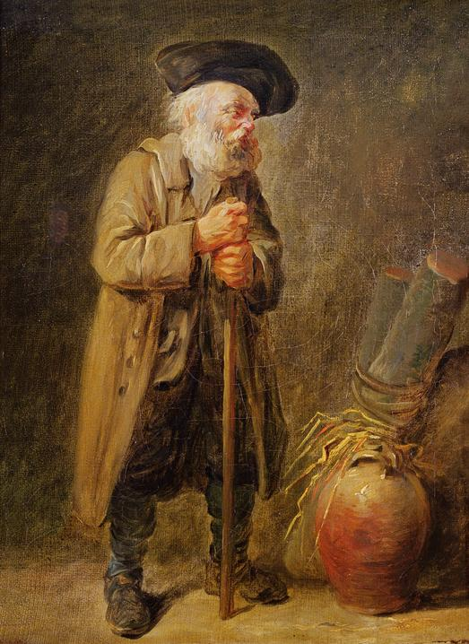
I still remember it if were yesterday. A tragic story it was. Dummy was what they used to call him. Yet, in more recent times, he's come to be referred as the Invisible man. That or the man with no name. To me, he was just my friend, Dummy.

This is his story. Dummy. The man who was accused of witchcraft.

I worked the family farm since I was able to walk and carry a bucket or hold a broom. I loved the farming life. We had a small
farm in a tiny village called Sible Hedingham in Essex. Times were pretty tough back then. There wasn't much to go around and even less when the crops failed. But we got by the best we could. I’d spend hours helping me pa’ and older brother, Thomas ploughing the fields and tending the animals we had. My Ma’ and grandma would also help. I never knew my grandpa as he had died before I was born. Apparently, I reminded my grandma of him every day.

I grew up hearing the tales of Dummy the local outsider who lived on the outskirts of the village. He'd lived here for over forty or more years so why he still called an outsider, I'll never know. Not a single soul knew his name or where he came from. Some say he had been a spy or a war hero whilst others believed he was an escape convict on the run. No one really knew for sure. He didn't speak much. He was deaf and a mute. He would talk with giant sounds and gestures like. Used to scare a lot of the folk. But it made me' ma and grandma laugh. He was harmless. My pa used to pass him each day walking the fields and tilt his hat and say good morning to him. My pa wasn't much of a speaker either. But I guess it was enough cos' they seem to get along.

When I was a boy my friends and I used to follow him and hide behind the bushes or one of the walls along the footpath. We would pretend that we were soldiers and he was the enemy. Mickey Jarvis, who was my best friend. He'd heard that Dummy had been caught by the Chinese and they'd cut out his tongue. I'm not sure if that was true though. Sometimes, Dummy would play along with us and chase us pretending that his old stick was a rifle shooting at us whist yelling like a monster. He was a funny sort. He made us laugh. Occasionally, I’d sit on the old broken wall at the edge of our farm and watch Dummy come trotting up the road. He’d stop and he’d tell me great stories. I know that he couldn’t speak, but I don’t know how, but it was as if I understood everything, he said in his sounds and gestures to me. And he knew it too. He’d show me his magic tricks and how he could make things disappear. He gave me an old little penny once. Told me it was for luck. I wish I hadn’t accepted it. I wish he’d kept it for himself. May be then – but I didn’t. I imagined that if my grandpa was alive, he’d be just like him.

There was never a Mrs Dummy. I remember asking me ma' once -

"He don't 'ave no family and we don't like to pry. He keeps himself to himself and he seems to like that best."

But one thing he did have was dogs. All stray; they were. He must have had at least eight. If not, twelve or fifteen. They followed him most places. He wore lots of different kinds of hats too. And all kinds of coats. Some at the same time. Different colours and shapes and sizes. I think he may have been in the circus. I can imagine him doing that. He was a fortune teller too. All of the local ladies would ask him about matters of the heart and grown-up stuff. He seemed to know about that kind of thing.

I was just ten years old when it happened. I was sitting outside the Swan. Me pa' wouldn't let me go inside. Said it was no place for a child. He didn’t even know my brother, Thomas had taken me there that night. I could see Dummy was sitting inside the tap room minding his own as usual when Emma Smith burst in looking for him. She was in a terrible state.

"I've been ill for nine- or ten-months Dummy. It's all because of you!" She screamed.

She wouldn't let it go either. At first everyone just laughed and Dummy tried to ignore her. But she persisted. Over and over again - screaming loudly -

"You did this to me! This is your fault!"

People started joining in. Some were just drunk and poking fun, encouraging her. She started insisting that Dummy went with her.

"I'm not asking Dummy. You bewitched me. I want you to take it away."

She even offered him payment throwing three gold sovereigns on the floor in front of him. But he just tried to look away. Then she spat on the floor by his feet. I could tell that he was starting to get scared. People started trying to push Dummy to go with her.

'Put the damn woman out of her misery."

"Go with her and do what she says!"

But Dummy was scared for his life. I've heard my pa' speak of Emma Smith before and about her temper. Grandma even said that she thought that Emma had the devil inside her spirit. She was becoming quite aggressive shouting and pulling at him to go with her. No one was stepping in to help him. I knew that Thomas was playing cards around the back. I wasn't allowed back there, and it would certainly earn me a good clip around the ear if I went to him. But I had to do something. I ran around the passage, pushing through the group of men all standing around drinking and smoking. At first, they laughed at me. As expected, Thomas’ face said it all. Especially as he had a young lady hanging on his arm.

"You gotta come quick! He's in trouble!" I shouted.

But he just told me to go away.

"Thomas! Listen to me!"

Still nothing. He pushed me to the floor telling me to stop winning. The woman he was with just laughed. That's when I heard it.

The bell.

Last orders.

It was almost kicking out time. I ran back to the street where everyone has erupted out onto the road. Dummy was trying to get away but Emma was chasing him. Still screaming at him hysterically. A few of the men were joining it. Samuel Stammers was one of them. They were stopping him from getting away. He was just an old man. Why couldn't they leave him alone?

Smack!

The noise stopped me. I almost felt it myself. She hit him with a stick. Dummy screamed out in pain. She hit him again. And again. He stumbled and fell. His fragile legs giving way to the ground. He fell. They were laughing at him. She began dragging him across the road to the brook. He tried to get away. He tried to get up, but she pushed him. She pushed him into the water.

"Ahhh!"
His screams echoed out into the night sky. His arms. His fists splashing frantically in the freezing water. I remember pa' saying that he knew that Dummy couldn’t swim well because he'd pleaded with pa to rescue one of his stray dogs when it had got into difficulty in the river by the farm once.

"Ahhhh!"

No one was helping. People were throwing stones at him. Calling him names. Calling him a witch.

"WITCH! WITCH! WITCH!"

I tried to get to him. I tried to push passed them all, but I couldn't. I was yelling, but he couldn't hear. I spun around trying to see Thomas, but he wasn't there. Where was he?

Dummy managed to pull himself up onto the bank on the other side. He was coughing and spluttering water everywhere. He had blood on his face and his hands where he had been attacked. Just then Samuel Stammer picked him up and threw him back into the brook again. Everyone laughed and cheered. I screamed.

"NO!"

But no one heard me. People were getting in front of me, pushing me out of the way. Just then a lady screamed out for them to stop.

"He's drowning!"

Everyone stopped like someone had suddenly hit the pause button. Like everyone had woken up from a nightmare. Samuel Stammer leapt into the water and dragged him out onto the bank. I screamed. I screamed as loud as I could-

"Dummy!"

I felt my brother’s hand on my shoulder. I turned and buried my face into his chest gripping my fists together in rage. How could they do such a thing? How could they? It's the only time that I'd ever hugged my brother and he me.

I hated them. I hated them all.

Thomas walked me home and begged me not to say anything to mother or father. I couldn't sleep. All I could think about was Dummy. His screams as they had beaten him and thrown into the brook. He wasn't a witch. He was just Dummy.

The next morning, I told my pa everything. He went over to Dummy's place straight away. He found him in a heap in a terrible state. He was shaking, wet, battered black and blue and crying in pain. Pa took him to the workhouse in Halstead straight away. He said that they would help him there.

But it was too late.

Dummy died soon after. Pneumonia brought upon by immersion and ill-treatment. 4th of September 1863.

Emma Smith and Samuel Stammers were found guilty of unlawful assault at the Asizes court at Chelmsford on March 8th, 1864. They tried to plead not guilty. Emma still insisted that Dummy had bewitched her. They were sentenced to six months hard labour.

No one mentions him anymore.

I sometimes sit on the old broken wall at the edge of the farm sometimes. I would look up at the road hoping to see him trotting up slowly followed by his dogs. I’d look down at the little penny he’d given me for luck. I wonder if he had a grandson like me somewhere. Someone who was more to him than just Dummy.

Kindly supported by:

Sharing what we have learnt
Applying our research to help others

Developing a lasting long-term ‘legacy’ of our community project was always part of our core aims of this project. We set out to learn about the stories of those accused of witchcraft in Essex and then to inspire others to learn more about their local heritage through sharing what we have learnt.

In this project we have:
- Created opportunities for members of our community to learn more about what why people were accused of witchcraft locally in Essex, the stories of those accused and how they were treated.
- Encouraged people to become Historians, learning more about their local heritage.
- Worked with the Essex Records Office introducing our participants to the Archives, helping them to access them and how to use them to learn more about the overall treatment of those accused of witchcraft, the motives to why they were accused and the impact of the witchcraft trials.
- Worked with local Historians including Professor Marion Gibson and the Essex Witches Museum to bring to research local stories of real people affected. We used Professor Gibson’s book “The Witches of St Osyth” as a starting point before reaching other local stories in Essex.
- Developed a free education / learning resource pack for our community to use. These materials can be accessed for free on our website at
www.alfiejamesproductions.com
A copy has been donated to the Essex Records Office.
- Created a set of dramatic audio clips accompanying our learning pack to help make our resources more accessible to all. Our audio’s have included:
-Ursley Kemp from St Osyth: A short play
-Elizabeth Clarke: A short story
-Cisley and Henry from Clacton: A short play
-Maragret Simpson: A monologue piece
-Joan Prentice Prentice from Sible Hedingham: A short story
-Annis of Little Oxley: A short play
-Matthew Hopkins: A monologue
-The Trial of Anges Waterhouse
-The Caged Bird: A monologue about Ursley Kemp in the Cage
-Alice and John Prestmary of Great Dunmow: A monologue from the Castle prison
-The Tragic tale of Dummy from Sible Hedingham: A short play
-The Lucky penny: A short story inspired by Dummy
These are available as visual ‘film’ formats on YouTube and as audio pieces on our website and have been donated to the Essex Sound Archives at the Essex Records Office for long-term preservation.
- Created a set of ‘non-fiction’ audio clips and films accompanying our learning pack to help make our resources more accessible to all. Our audio’s have included:
-Setting the scene of the Essex Witchcraft Trials
- Why were people accused of witchcraft – The motives
- How did literature influence the Witchcraft witch hunts?
- Who was accused of witchcraft? Common Traits of a Witch
- The investigations, trials and punishments
- The Cage of St Osyth
- The Castle prison & the story of Rebecca West
- Brian D’Arcy and Maragret Simpson
-Matthew Hopkins: The Witchfinder General
-A short film about the Essex Witchcraft Trials narrated by our Project Leader
These can be accessed for free via our website and have been donated to the Essex Sound Archives at the Essex Records Office for long-term preservation.
- Created a pop-up exhibition of witchcraft information banners sharing what we have learnt. These have been donated to the newly formed Essex Witches Museum for long-term use.
- Devised a small presentation sharing what we have learnt and performing some of our stories, short plays and monologues as rehearsed readings. A recording can be accessed on our website and on YouTube. An audio recording has also been donated to the Essex Sound Archives for long-term preservation.

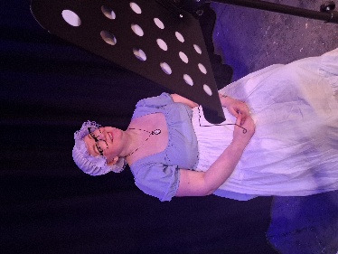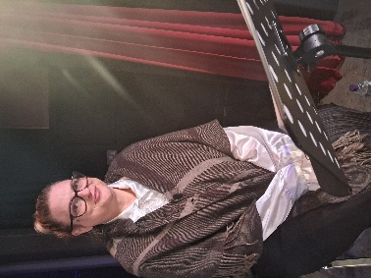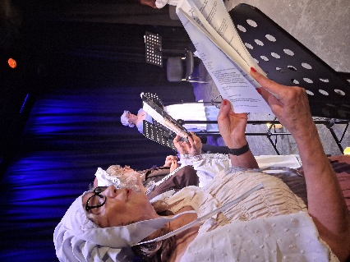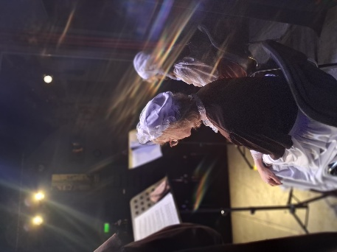

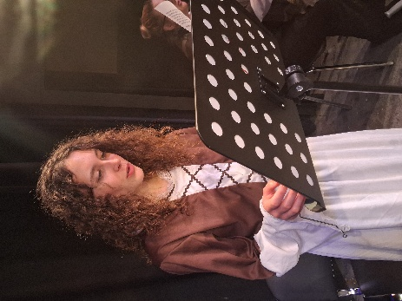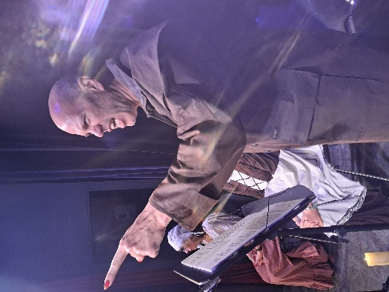

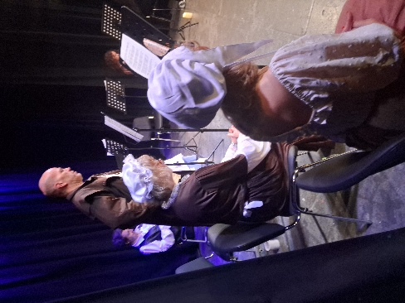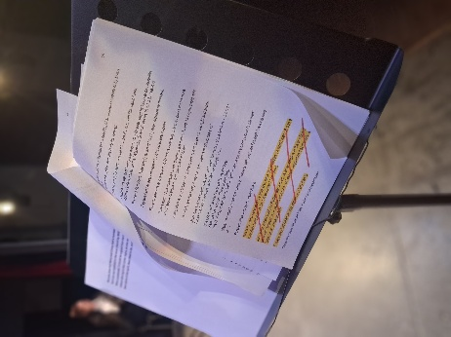

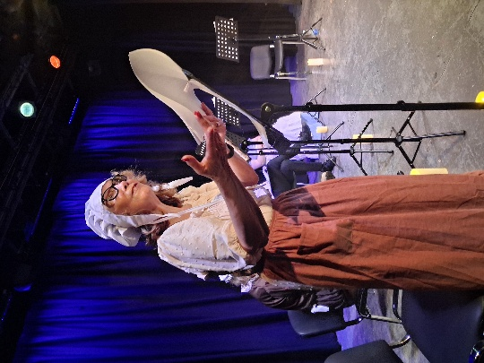
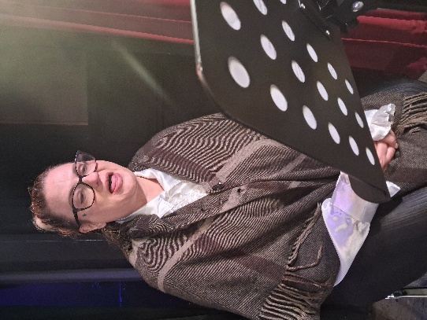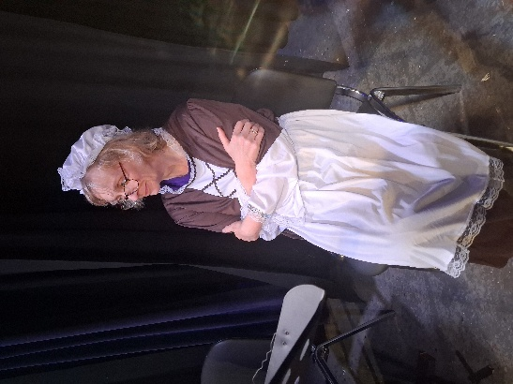

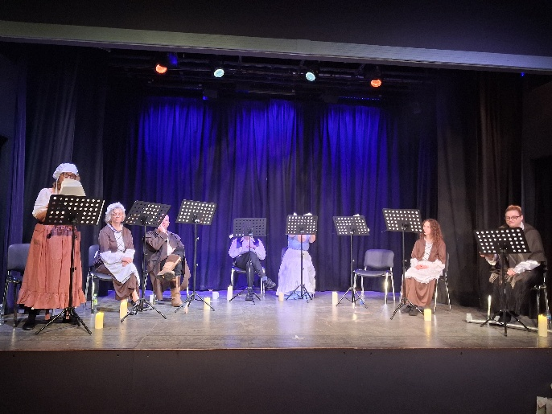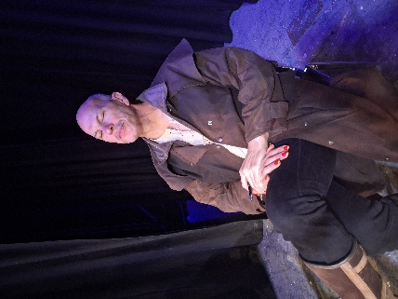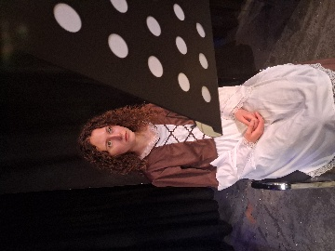

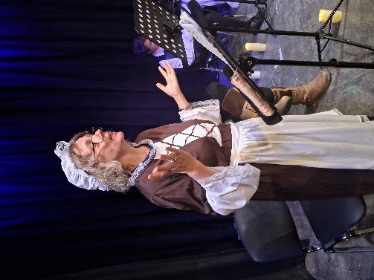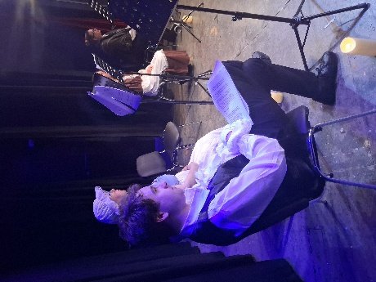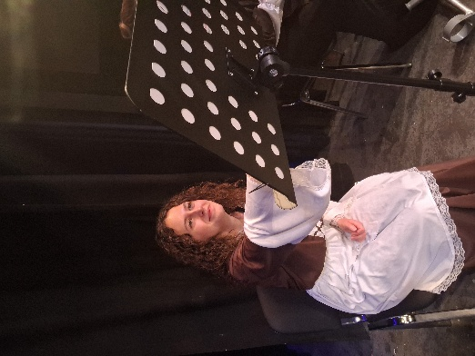

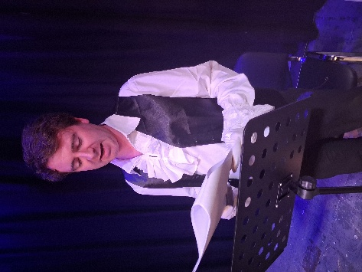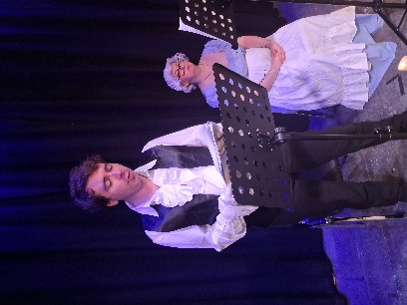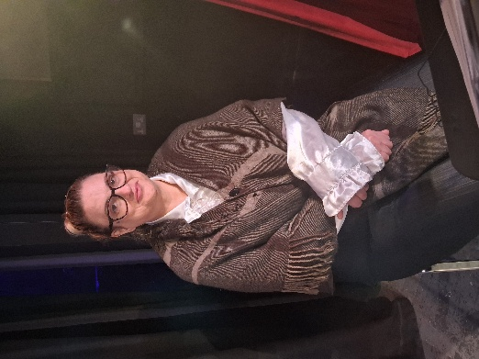

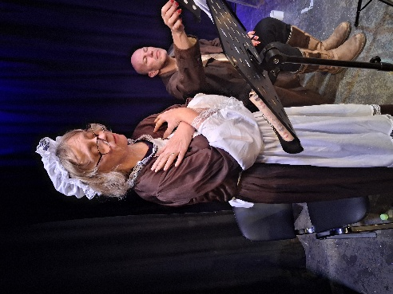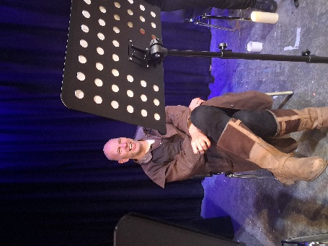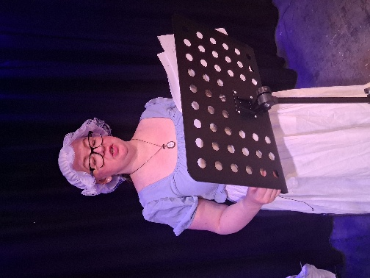

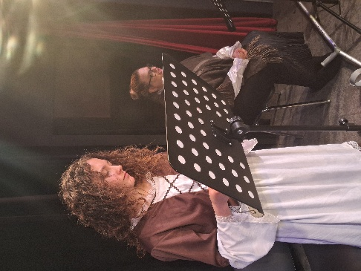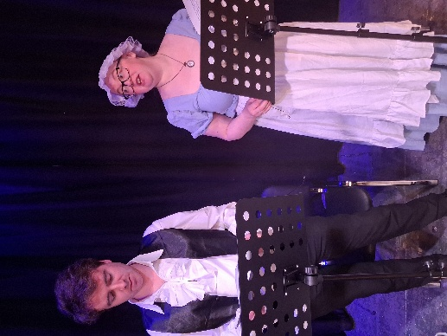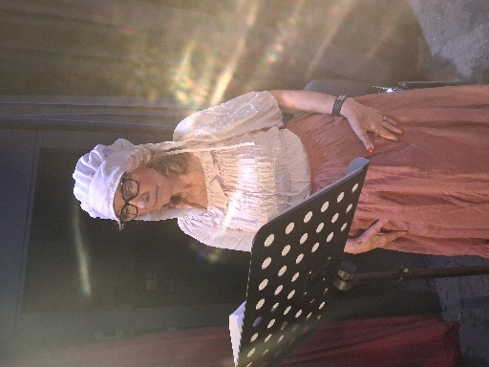

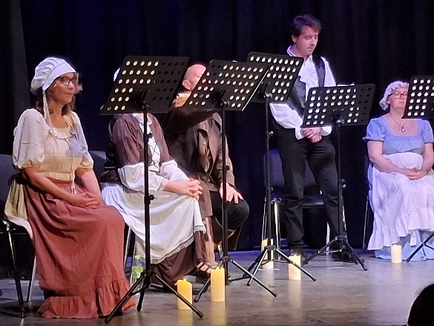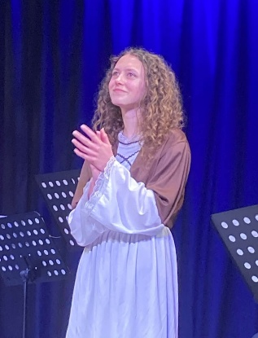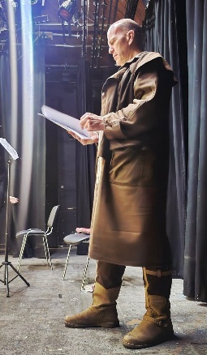
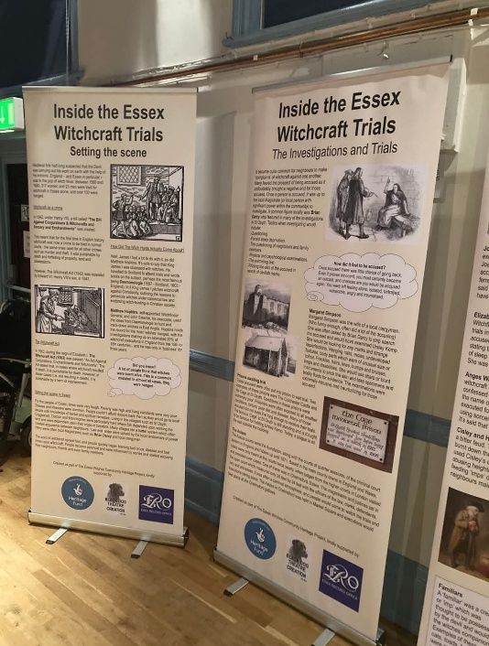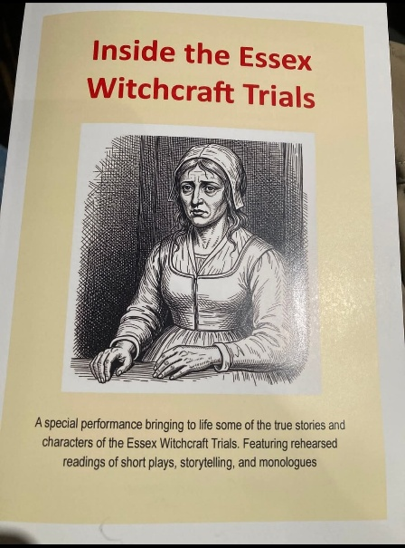

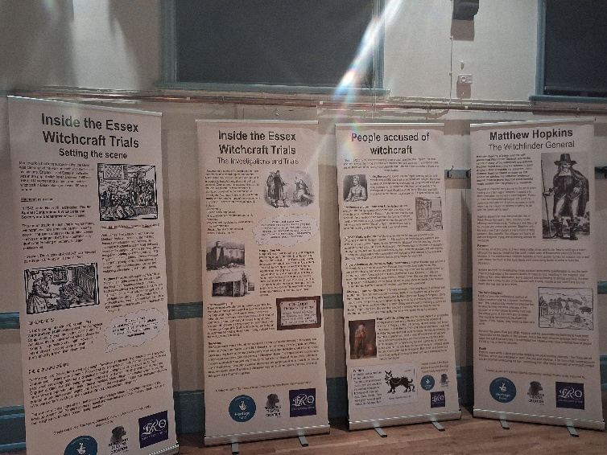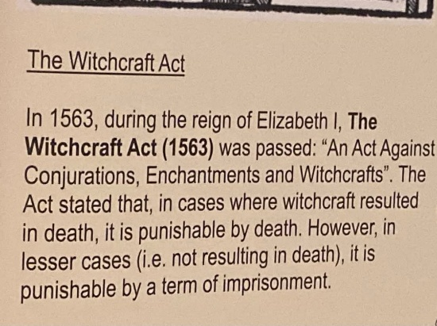

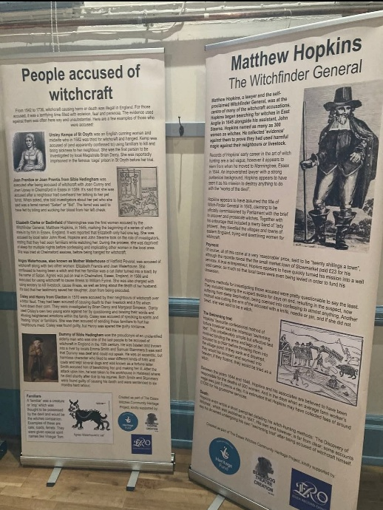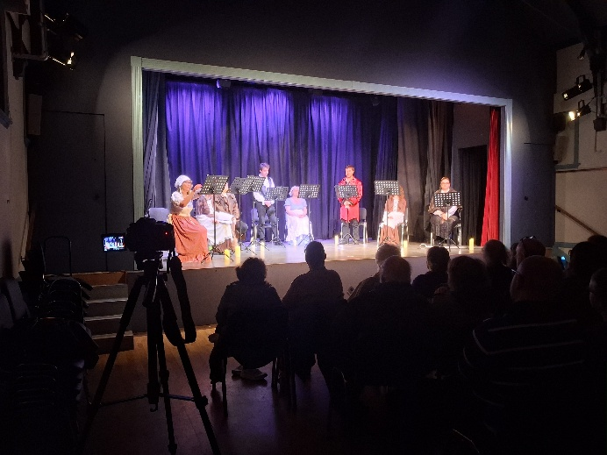

You can watch a live recording of our “Inside the Essex Witchcraft Trials” presentation here:

https://www.youtube.com/watch?v=sztxfOORIjI&t=23s

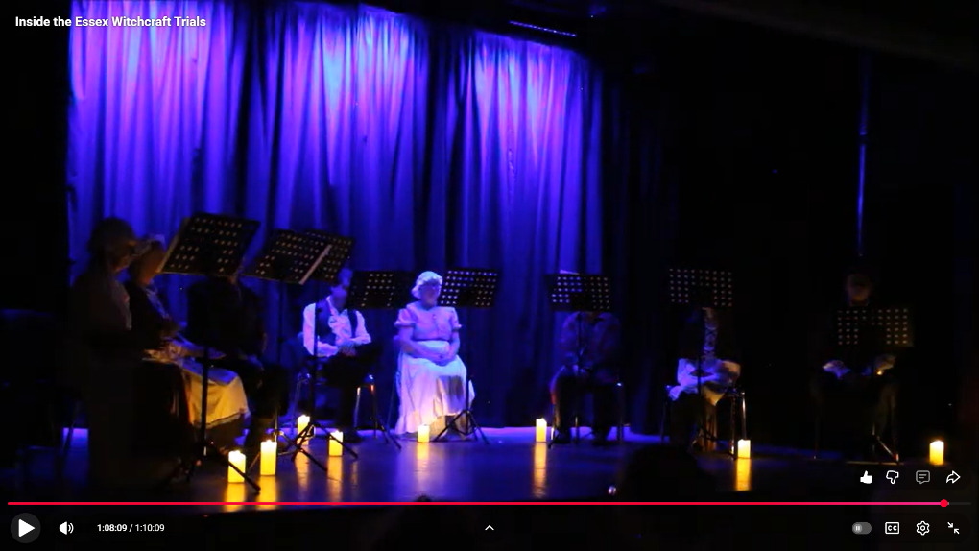

Kindly supported by:

