Participant blog
Our visit to Essex Records Office
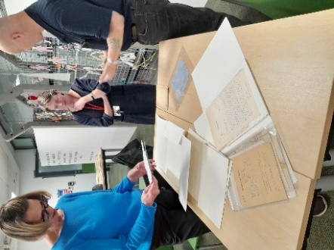
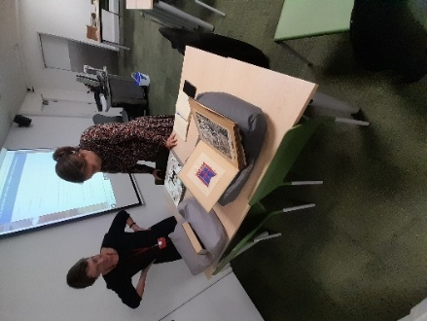
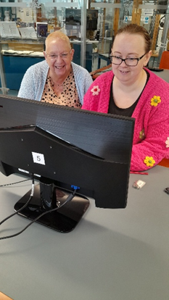
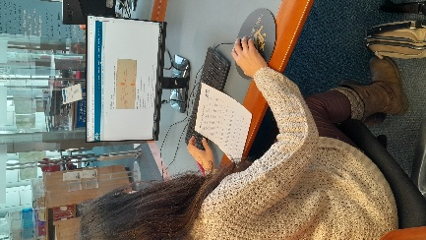

I don’t mind admitting that the thought of researching at the Essex Records Office was a little daunting! As someone who has never done anything history or research wise since they were at school, I was worried that I was going to be out of my depth. I could not have been any more wrong!

We visited the Essex Records Office for our project exploring the Essex Wildcraft stories. We were met by Vicky, one of the Archive team members who introduced us to the world of archives at the Essex Records Office. She began with a really insightful introduction and tour around the building. I particularly liked going into the vaults. It looked like something from Harry Potter! We were then shown some of the display of archives, letters, pictures and artefacts which she’d prepared for us all about the Essex Witchcraft trials. These were amazing pieces to look at. Especially some of the literature and ornaments and paintings. Vicky then gave us a really interesting background talk setting the scene of what life was like here in Essex during the time. She showed us maps and spoke about the illnesses, hardship particularly in the villages such as St Osyth and Manningtree and Clacton. This gave us a really good feel for what life was like and an introduction to why people may have been accused of witchcraft by their neighbours.

Vicky then showed us how to access the archives online through the computers using the search engines on their website and how to pin-point and narrow down our search by using specific key words and phrases. I was able to look up the story of Elizebeth Clarke and the three ‘Joans’ who were put on trial in Chelmsford Market Square and hanged. Accessing the archives was a lot easier than I first thought it would be. Vicky was amazing and really supportive. It’s something which I’m pleased to say that I will be doing again. I’d love to return to do more research in my own time and even look up my own family tree.

Kate then showed us the sound archives and wow! Just wow! I loved listening to some of the examples of people talking about what Chelmsford and Essex used to be like in the past. The radio recordings were a favourite of mine. Although they weren’t specific to our study theme, they were really useful to give us great ideas of how we can create our own sound archive recordings to share what we have learnt about the Witch Trials. Kate also showed us how to create transcripts and the details which go into making them. It was an eye opener but a really positive experience. I’m quite excited to have our own sound archives added once we are finished.

Both visits were really interesting and worthwhile, and I thoroughly enjoyed coming along. The staff are incredibly helpful and encouraging. You never feel like a wally like me!

Kindly supported by: 