Why were people accused of witchcraft – The motives

There are many reasons as to why people were accused of witchcraft. Some were due to personal reasons including arguments amongst neighbours, fear or even acts of revenge. While other reasons were more generalised across the whole country and Europe. In our research, we set out to identify some of these motives.

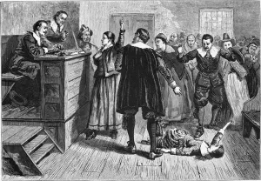
The Monarchy and the church
Medieval folk had long suspected that the Devil was carrying out his work on earth with the help of his minions. England – and Essex in particular – was in the grip of witch fever. We know that there had also been a heavy influence from other countries across Europe and the world. Both the monarchy and the church were strong believers in the fight against what they perceived as evil. It also posed as a great way of manipulating others, spreading fear and then gaining control and power. Laws such as the Witchcraft Act were passed, King James even wrote the Daemonologie book about witchcraft and clergymen would regularly give sermons.

Literature and word of mouth
One of the biggest contributors to the increase in persecutions of suspected witches was the development of mass printing. This technology allowed new ideas to be spread far and wide, with those able to read being exposed to a whole new world of ideas. It also created stories and rumours which were then spread from word of mouth throughout towns and villages.

Looking for someone to blame
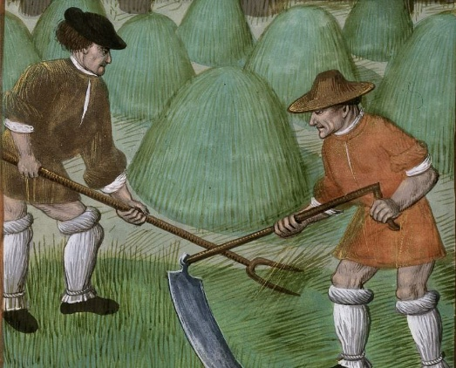
Much of the local villages depended upon working the land. Poverty and disease were ripe amongst the villages and towns. Sanitary conditions were poor. Money was scarce and barter systems were part of everyday life. Disagreements often erupted among neighbours, and law and order was upheld by local estate owners such as Brian Darcy, the clergymen and magistrates. One way of getting back at your neighbours was to start vicious rumours about them being a witch or even put in a complaint to the local Clergyman or Magistrate.

Morale was often low particularly when disease outbreaks and poor harvests caused further hardship. Often wiping out families. People were often looking for something or someone to blame. Professor Marion Gibson highlighted this area in her book “The Witches of St Osyth” when writing about the story of Cisley and Henry. Many thought that disease and bad luck was caused by the devil himself or by wrongdoing. Who better to blame than someone who appeared to be in touch with spirits.

Manipulation and self-gain
Another common reason as to why someone would accuse another person of witchcraft was because they were looking to gain something for themselves. This could be social status within the community, power or financial / land ownership gain. Indeed, it is strongly argued that both Brian Darcy and Matthew Hopkins motives were simply to climb the social status and financial wealth.

Kindly supported by:   

