Matthew Hopkins
The self-proclaimed Witchfinder General

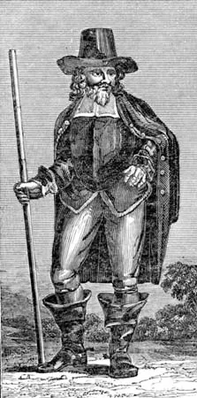
Self-styled Witchfinder General, Matthew Hopkins, and his associates were responsible for 20% of all witchcraft executions from the 15th to 18th centuries, despite only being in business for three years. He was active from 1644 to 1647 and used questionable methods to investigate suspected witches

His early life
Matthew was the fourth of six children and the son of James Hopkins, a Puritan clergyman in Wenham, Suffolk. Records are unclear on his date of birth, but it was sometime between 1619 and 1622. Little is known about Matthew before 1644 as no contemporary records for him have survived. We do know that he could read and write Latin and English, and that he studied marine law in Belgium and Holland. Some reports suggest Hopkins was a lawyer, but there is no surviving evidence for this either. It’s more likely that he was a solicitor’s clerk.

In the early 1640s Matthew Hopkins moved to Manningtree. He is linked to the Thorn Inn at Mistley, but it’s unclear whether this was as owner, co-owner or patron. Manningtree, meaning ‘many trees’, was a small parish of some twenty-two acres at the time.

The Witch hunts
In his Discovery of Witches, published 1647, Hopkins says his ability to find a witch came from his wealth of experience. Conveniently, he doesn’t really give any specifics of that experience, other than a couple of occasions where he supposedly eavesdropped on witch meetings:

“In March 1644, he had some seven or eight of that horrible sect of Witches living in the Towne where he lived, a Towne in Essex called Manningtree, with diverse other adjacent Witches of other towns, who every six weeks in the night (being always on the Friday night) had their meeting close to his house, and had their solemn sacrifices there offered to the Devil, one of whom this Discoverer heard speaking to her imps and bid them go to another Witch, who was thereupon apprehended”.

We do know that Hopkins was influenced by King James I’s ‘Demonologie’ (1597), Thomas Potts’ ‘The Wonderful Discovery of Witches In the County of Lancaster’ (1613) and Richard Bernard’s ‘A Guide To Grand Jurymen’ (1627, 1629). In fact, it’s probable that these texts formed the majority of his knowledge and experience.

Creating a perfect storm
It is difficult to see how one person could drum up such a ‘witch frenzy’. However, Matthew Hopkins was not your ordinary person; he had some education, had funds and connections, and came from a well-known, well-liked family. The political situation at the time also contributed.

From 1642 to 1651 the English Civil War raged. Essex was a backbone area for the Roundheads (in support of Parliamentarians). Hopkins was able to use the resulting tension, fear and uncertainty to his advantage - it’s much easier to scaremonger when the crowd is already unsettled. There’s also documentation stating the Hopkins used his links to the Thorn Inn for striking up conversations and sharing information – it was a prime space for gaining supporters.

Hopkins’ Associates
Matthew Hopkins may be the most infamous person from the Witch Hunts, but he didn’t work alone. Hopkins employed John Stearne, a rabid puritan, and Mary Phillips, a midwife, both from Manningtree, as searchers. They were paid one pound a day (roughly £117 today) for their troubles.

Methods
Hopkins methods for investigating those accused were pretty questionable to say the least. They included keeping the suspect awake for days on end, resulting in the suspect, now suffering from sleep deprivation, being coerced into confessing to almost anything. Another method was cutting the arm of the accused with a knife, needle or pin, and if she did not bleed, she was said to be a witch.

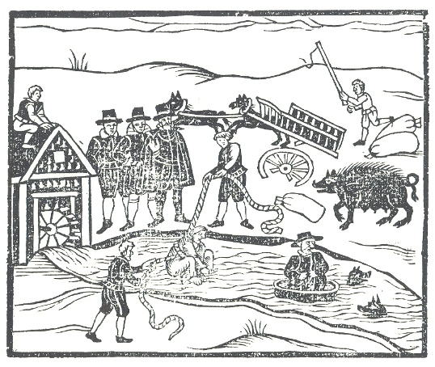
Matthew Hopkins and his team usually followed the same steps of prosecution in each case. First, they would use local rumour or suspicion to condemn a witch. Hopkins also claimed to have a “Devils List”, naming all English witches in code. Once condemned the person was tortured until they confessed, usually implicating several others as part of the confession. His reputation, together with the biased view of the majority that the accused was guilty, resulted in a very high conviction rate.

Hopkins’ favourite confessional method of torture however was the infamous “swimming test”. This unbelievably simple but effective test involved binding the arms and legs of the accused to a chair before throwing them into the village pond. If they sank and drowned, they would be innocent and received into heaven; if they floated, they would be tried as a witch.

Payment
Of course, all of this came at a very ‘reasonable’ price, said to be “twenty shillings a town”, although the records reveal that the small market town of Stowmarket paid £23 for his services. A true entrepreneur, Hopkins appears to have quickly turned his mission into a well-paid career, so much so that local taxes were even being levied in order to fund his obsession.

In general, Hopkins charged the local parish £1 (roughly £117 today) for every witch found. It is thought that he collected around £1000 in fees during the two or three years he operated. That’s about £117,546 today! Many modern works strongly suggest that pay, rather than ridding the country of witches, was a motive for Hopkins. There’s no doubt that Hopkins had a hatred for witchcraft and sought to rid it from the area, but even sources at the time suggested he had little to no evidence for some of those he charged.

Death
Hopkins even wrote a short pamphlet detailing his witch-hunting methods: ‘The Discovery of Witches’, which was published in 1647. His own end, however, is far from clear; some accounts say he drowned undergoing his own “swimming trial” after being accused of witchcraft himself.

However, he was last seen in the spring of 1647; his former sidekick John Stearne is reported to have announced, “I am certain he died peacefully in Manningtree after a long sickness of Consumption” [tuberculosis]. There is a record of Hopkins’ burial in the Mistley parish register, showing he was buried a few hours after his death at St Mary the Virgin Church in Mistley. Contrary to some portrayals in movies, he was in his mid-twenties when he died.

According to local legend his ghost haunts the area near Mistley Pond, especially on Friday nights close to witch sabbats.

Kindly supported by:   

