Spotlight on: Wilfred Owen
War Poet 1893-1918

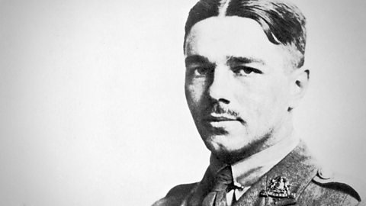

Owen was an English poet whose work was characterised by his anger at the cruelty and waste of war, which he experienced during service on the Western Front.

Wilfred Edward Salter Owen was born 18 March 1893 in Oswestry, Shropshire. After school he became a teaching assistant and in 1913 went to France for two years to work as a language tutor. He began writing poetry as a teenager.

In 1915 he returned to England to enlist in the army and was commissioned into the Manchester Regiment. After spending the remainder of the year training in England, he left for the western front early in January 1917. After experiencing heavy fighting, he was diagnosed with shellshock. He was evacuated to England and arrived at Craiglockhart War Hospital near Edinburgh in June. There he met the poet Siegfried Sassoon, who already had a reputation as a poet and shared Owen's views. Sassoon agreed to look over Owen's poems, gave him encouragement and introduced him to literary figures such as Robert Graves.

Reading Sassoon's poems and discussing his work with Sassoon revolutionised Owen's style and his conception of poetry. He returned to France in August 1918 and in October was awarded the Military Cross for bravery. On 4 November 1918 he was killed while attempting to lead his men across the Sambre canal at Ors. The news of his death reached his parents on 11 November, Armistice Day.

Edited by Sassoon and published in 1920, Owen's single volume of poems contain some of the most poignant English poetry of World War One, including 'Dulce et Decorum Est' and 'Anthem for Doomed Youth'.

Research taken from http://www.bbc.co.uk/history/historic_figures/owen_wilfred.shtml

