Witches and their imps and familiars

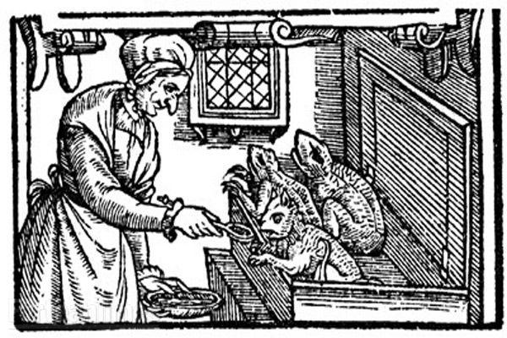
Familiars are mystical companions often associated with witches, serving as guides, protectors, and assistants in magical practices, with a rich history that spans folklore and modern witchcraft.

In 1604, James I introduced a new Witchcraft Act that included “the occult rituals of diabolic witchcraft” (Voltmer 2017: 110). This made working with evil spirits a capital offence. The act also referenced familiars, believed to be “the witches’ helpful demonic companions” (Voltmer 2017: 110). The Act really made an effort to clarify types of witchcraft. It also turned communicating with spirits and practicing magic with body parts into capital offences (Voltmer 2017: 110).

By the time we reach the witch hunts of the 17th century, these familiars were more “popularly referred to as ‘imps'” They manifested as small animals and a witch’s power could pass to another person through the familiar.
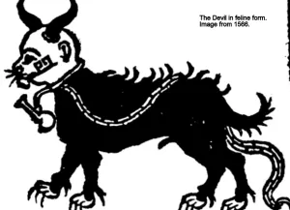
Familiars in our Essex Witchcraft stories
They were mentioned as key pieces of evidence against many of those accused in the Essex witchcraft trials. Joan Prentices was said to have a ferret named Satan or Bid while Cisley of Clacton was reported to have familiars who would feed upon her blood. In many of the stories, those accused were said to have used their familiars to cast nasty spells upon their victims often resulting in death. Many of the accounts came from this area thanks to the activities of Matthew Hopkins, the self-proclaimed witchfinder general. In East Anglian folklore, witches either got their familiar direct from Satan, or they inherited them from someone else. Surprisingly, these imps still appear in court records in the area as late as the early twentieth century.

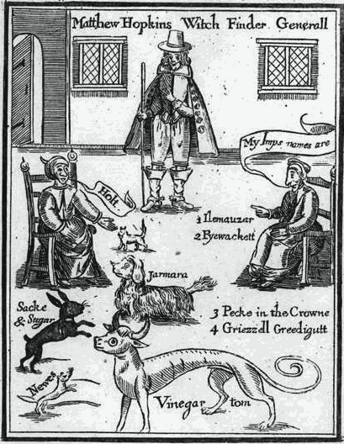
People believed familiars were evil spirits.
They fed on the blood of ‘their’ witch and acted as servants. Many think the word comes from famulus, a Latin word for servant. The famed ‘witch’s mark’, sought during investigations, was believed to be the teat where the witch suckled her familiar.

Familiars also taught witches how to do magic and dispensed advice. Witches used them as spies thanks to their shapeshifting abilities. Cats, dogs, owls, toads, and mice all fell under suspicion.

Examples of familiars
Paddock  Toad Companion | Harpier  Owl Guide | Grimalkin  Cat ally | Holt  White kitling
Farmara  Spaniel helper | Vinegar Tom  One-headed greyhound | Sack and sugar  Black rabbit | Newes  Polecat spirit
Elimanzer  White dog | Pyewacket  Cat companion | Peckin the crown  Unknown | Grizel Greedigut  Unkbown
Pygine  Mole familiar | Russol  Grey cat | Dunsott  Dun dog | Minny  Red and white dog
Tyffin  White lamb | Elva  Dog ally | Robin  Black dog | Sathan  White cat
Gille  Black cat | Ginnie  Kitling spirit | Philip  Rat familiar | Tyttey  Grey cat
Pigine  Black toad | Lacke  Black cat | Robbin  White colt | Robbyn  Toad ally
Tom  Toad spirit | Lierd  Red lion | Lightfoot  Cat companion | Lunch  Toad ally
Makeshift  Weasel spirit | Inges  White spotted cat | Gibbe  Black cat | Tewhit  Yellow bird
Fillie  White cat | Hoult  White dog | Jarama  White dog | Wynowe  Black kitling
Jeso  Black kitling | Panu  Black kitling | Jesus  Unknown | Jockey  Unknown

Kindly supported by:  