Focused character workshop: What were people’s views of witchcraft in the 1500-1600s Essex and how did it feel to be accused?

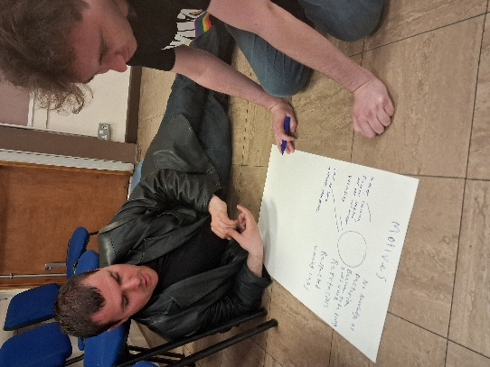
As part of our research application work, we used our research from the Essex Records Office and Professor Marion Gibson to explore the attitudes towards witchcraft in Essex during the 1500-1600s particularly in rural communities. This helped is to set the scene as a starting point in our research. We knew that there were many external factors which affected people’s views and making them far more suspicious and easily persuaded in their conclusions. These included:
-Economic hardship
-Disease and death rate
-Problems in farming and land
-Religious influence
-Expanding literature and reporting. (Media and scaremongering)
We also used from our visits to the Essex Records office where they gave us an introduction to what life was like living locally during this time period and living conditions were especially for the working-class families in rural areas of Essex.

During our workshop we used group work, discussions and performance techniques to explore societies attitudes towards witchcraft in the community at the time. We quickly realised that these attitudes were heavily influenced by external beliefs and opinions. We set out to answer the following key questions:

1.What were societies views towards witchcraft at the time?
2. Why were people accusing their neighbours of witchcraft?
3. How did it feel to be accused of witchcraft?
4.What were the possible motives behind the investigators and how did this affect the outcomes of the accusations?

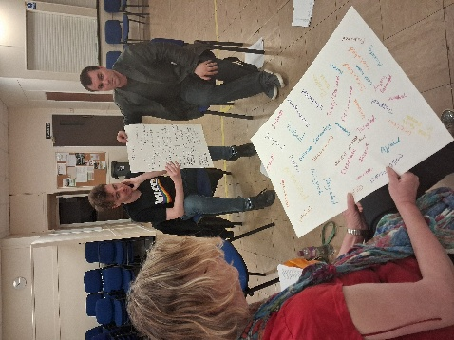
We knew that times were hard, and many local people were living on the breadline in poverty. Disease and illness were poorly treated and living conditions were tough. Communities were governed by a strict religious influence, and people’s views were being affected by the growing literature print which often spread bias and misinformed views which were often uneducated. Still, people were believing what they were being told which led to innocent people being blamed for things which weren’t their fault.

We used roleplay activities to re-create some of the stories and characters featured in the stories written by Professor Marion Gibson’s book “The Witches of St Osyth” as well people and events from research collected from the archives and newspaper stories to explore how it felt to be accused at the time and why people were turning against their own neighbours. We used hot-seating and improvisations to better understand. We discussed the common language used to describe and, in some cases, bully those accused. Common words such as “naughty” appeared in many cases in evidence.

In smaller groups, we created charts to mind-map feelings and emotions to describe how it felt to be accused, why neighbours were accusing one another and the possible motives behind the investigators at the time. We split into small groups recording our ideas. We then shared these to create a large chart which generated positive discussions about how people were feeling in the Witchcraft Trials. These included:

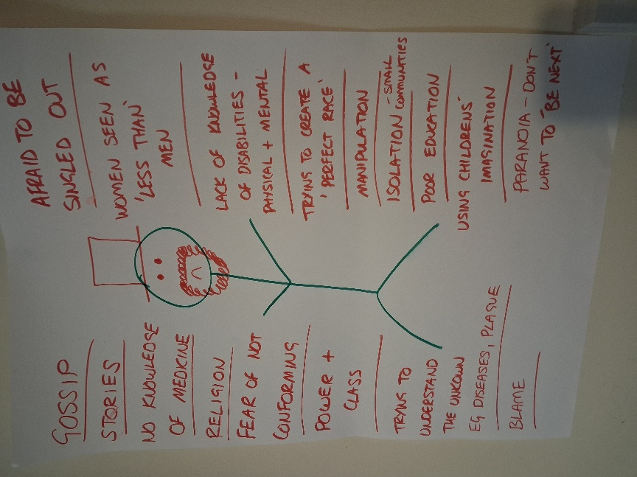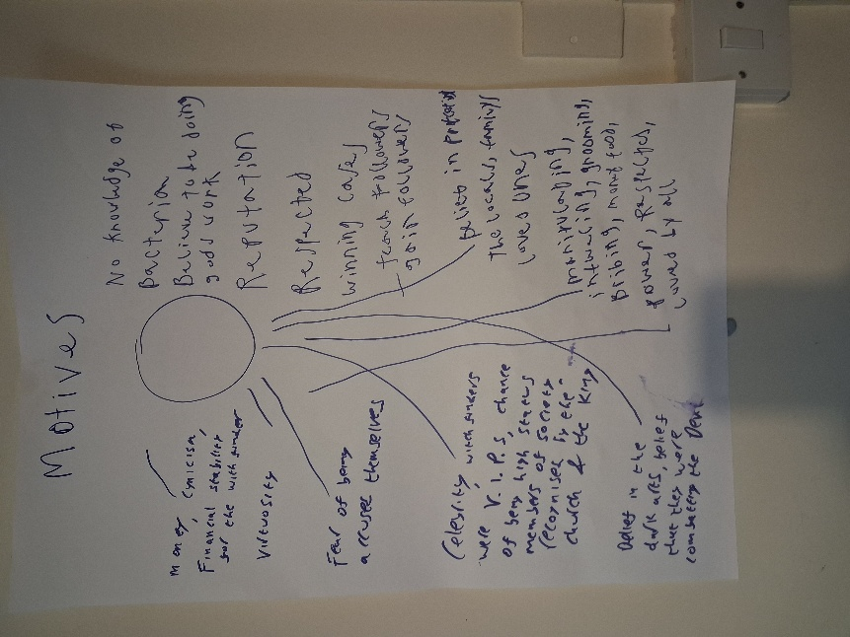

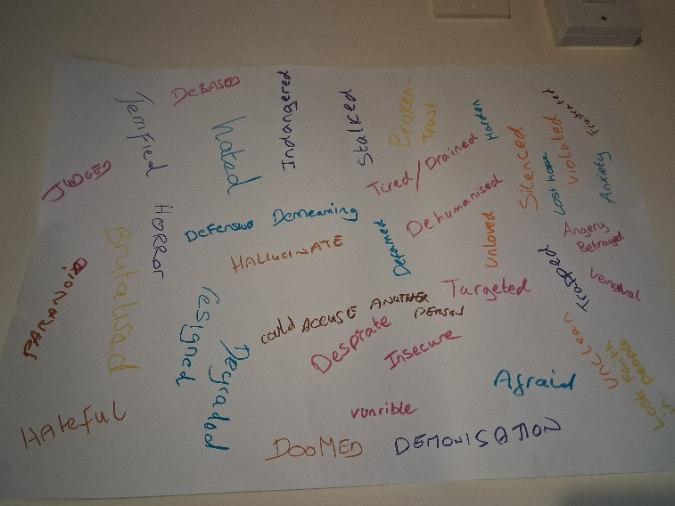

Common words which came up to why people were accusing others included:
-Fear
-Frustration
-Anger at their hardships
-Lack of understanding / misinformation
-Revenge / breakdown of relationships

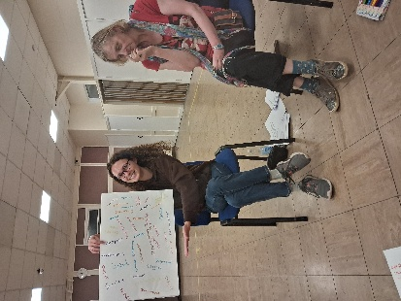
We found that there were common traits in those being accused of witchcraft. Many were poor, had children out of wedlock, had disabilities, were spiritual or creative women. We compared this to how society is today and asked the question of whether we have made any progress or whether we are still prejudice towards people who are different or vulnerable in the community.

People were accused of witchcraft were made to feel more vulnerable, afraid, defensive, isolated, paranoid, desperate, angry and judged. They were investigated unfairly and often tortured until they gave in to believing what their investigators wanted. It was clearly an unfair and unjust society. It some ways, it still mirrors parts of our own society today. It gave us an insight into how it felt to be one of those people accused which helped us to gain a stronger sense of empathy whilst re-creating their stories for our learning resources.

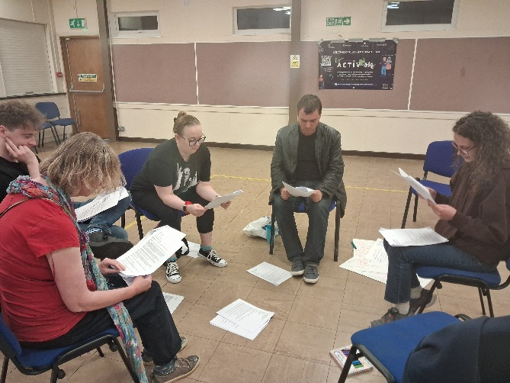
Probably the most interesting discussion point was exploring the possible motives behind those doing the investigating. Greed, power and corruption were the common words which arose straight away. Followed by the talk of fear of being investigated themselves. It is clear that many of these investigators possessed narcissistic traits and enjoyed playing their roles as vile bullies and acting out their fantasies in being God-like creatures. One of our members commented out loud with a sigh of disbelief… how on earth did these people get away with it and why didn’t anyone question their behaviour...indeed?!

Kindly supported by:  