Who was accused of witchcraft?
Common Traits of a Witch

Typically, those accused of witchcraft were predominantly women, often marginalized individuals such as the poor, elderly, or those who did not conform to societal norms.

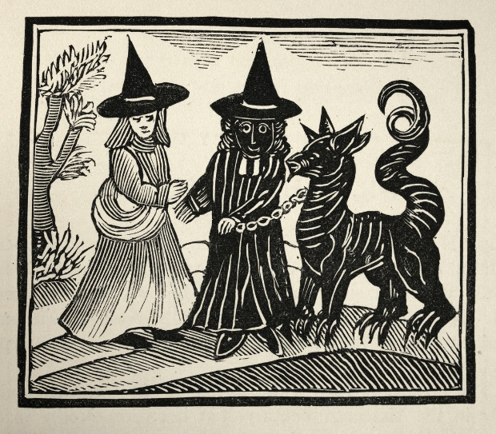
In Europe as a whole, more than 70% of those accused of witchcraft were women. In Essex, between 1560 and 1680, 317 women and 23 men were tried for witchcraft and over 100 were hanged. To begin with our research began pointing towards the following common traits of those accused:

1.Most were women
The facts and numbers do indeed speak for themselves. Most of those accused were women. They were often labelled as ‘witches’ due to their non-conforming attitudes. Often those accused had lived hard lives and had born illegitimate children which was seen as a sin in the eyes of the church. The wives or families of those whose husbands strayed the field would happily see the other parties accused of witchcraft as an act of revenge.

2.Vulnerability and disability
We found that in many of the stories about those accused, they were vulnerable people. They lived either alone, elderly or in poverty or were one-parent families. They often did not have the knowledge or the money to seek legal defence. Some did not have the confidence to fight back. We also found that there were several cases such as that of Elizabeth Clarke and Dummy who had disabilities and this was seen as a weakness and an ideal opportunity to take advantage of them by fooling them into making confessions for things they had not done wrong.

3.Social outcasts
Those who were marginalized or lived on the outskirts of society. People like Ursley Kemp who were believed to have lived ‘colourful lives’ against the norm of the church. It could even be as simple as that they lacked confidence in social situations, were homeless, poor, elderly or just lonely. Professor Marion Gibson highlighted that the fear of witchcraft often intensified during times of social upheaval such as wars, famine or disease. People were often looking for someone else to blame. Joan Prentice was hanged because she had a pet ferret!

4. Ordinary people
Some people were just ordinary folk trying to mind their own business. Many accusations stemmed from family feuds or arguments between neighbours. We found this to be a common factor in many of the stories read. Both Cisley and Henry and Anges Waterhouse were prime examples. These arguments could be about livestock, money owed or even as daft as feuds over who borrowed a jug of milk to who. This reflected how the local dynamics could lead to witchcraft accusations.
However, the further we researched, we did find that there was a general misconception amongst common belief that all women accused were from poor backgrounds. In fact, 64% of those accused in Scotland alone were from middle class backgrounds. This was mirrored across Europe.

What is clear, is that those in power believed that women were weaker and more easily tempted than men. In the bible story of Adam and Eve, it is Eve who is tempted by Satan to eat the forbidden apple. Woman are considered more of a risk of being influenced by the Devil.

Examples of those accused
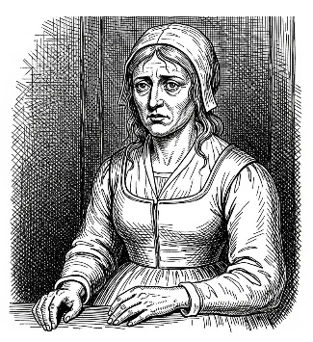
Ursley Kempe of St Osyth was an English cunning woman and midwife who in 1582 was tried for witchcraft and hanged. Kemp was accused of (and apparently confessed to) using familiars to kill and bring sickness to her neighbour. She was the first person to be investigated by local Magistrate Brian Darcy. She was reportedly imprisoned in the famous ‘cage’ prison in St Osyth before her trial.

Joan Prentice or Joan Prentis from Sible Hedingham was executed after being accused of witchcraft with Joan Cunny and Joan Upney in Chelmsford in Essex in 1589. It’s said that she was accused after a neighbour had overheard her talking to her pet ferret. When asked, she told investigators about her pet who she said was a ferret named "Satan" or "Bid". The ferret was said to have fed by biting and sucking her blood from her left cheek.
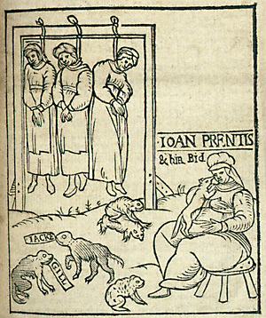
Elizabeth Clarke or Bedinfield of Manningtree was the first woman accused by the Witchfinder General, Matthew Hopkins, in 1645, marking the beginning of a series of witch trials in by him in Essex, England. It was reported that Elizabeth only had one leg. She was accused by local tailor John Rivet. Hopkins and John Stearne took on the role of investigators, stating that they had seen familiars while watching her. During the process, she was deprived of sleep for multiple nights before confessing and implicating other women in the local area. She was tried at Chelmsford assizes, before being hanged for witchcraft.

Anges Waterhouse, also known as Mother Waterhouse of Hatfield Peverel, was accused of witchcraft along with two other women: Elizabeth Francis and Joan Waterhouse. She confessed to having been a witch and that her familiar was a cat (later turned into a toad) by the name of Satan. Agnes was put on trial in Chelmsford, Essex, England, in 1566 and executed for using witchcraft to cause illness to William Fynne. She was also charged with using sorcery to kill livestock, cause illness, as well as bring about the death of her husband. It’s said that her testimony saved her daughter, Joan from being executed.

Cisley and Henry from Clacton in 1570 were accused by their neighbours of witchcraft over a bitter feud. They had been accused of causing death to their livestock and a fire which burnt down their corn. They were investigated by Brian Darcy and Margaret Simpson. Darcy used Cisley’s own two young sons against her by questioning and twisting their words and abusing heightened emotions within the family. Cisley was accused of speaking to spirits and feeding ‘imps’ or familiars. She was then accused of sending these familiars to hurt her neighbour’s maid. Cisley was found guilty, but Henry was spared the guilty sentence.

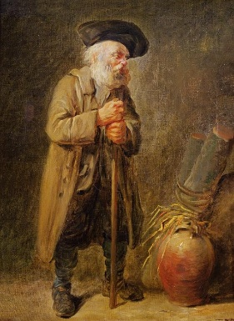
Dummy of Sible Hedingham was an unidentified elderly man who was one of the last people to be accused of witchcraft in England in the 19th century. He was beaten and thrown into a river by locals Emma Smith and Samuel Stammers It was said that Dummy was deaf and could not speak. He was an eccentric, but harmless character who liked to wear different kinds of hats and coats and kept several dogs and was known as a fortune teller. Smith accused him of bewitching her and making her ill. After the attack upon him, he was taken to the workhouse in Halstead where he died shortly after due to his injuries. Both Smith and Stammers were found guilty of causing his death and were sentenced to six months hard labour.

Kindly supported by:   

